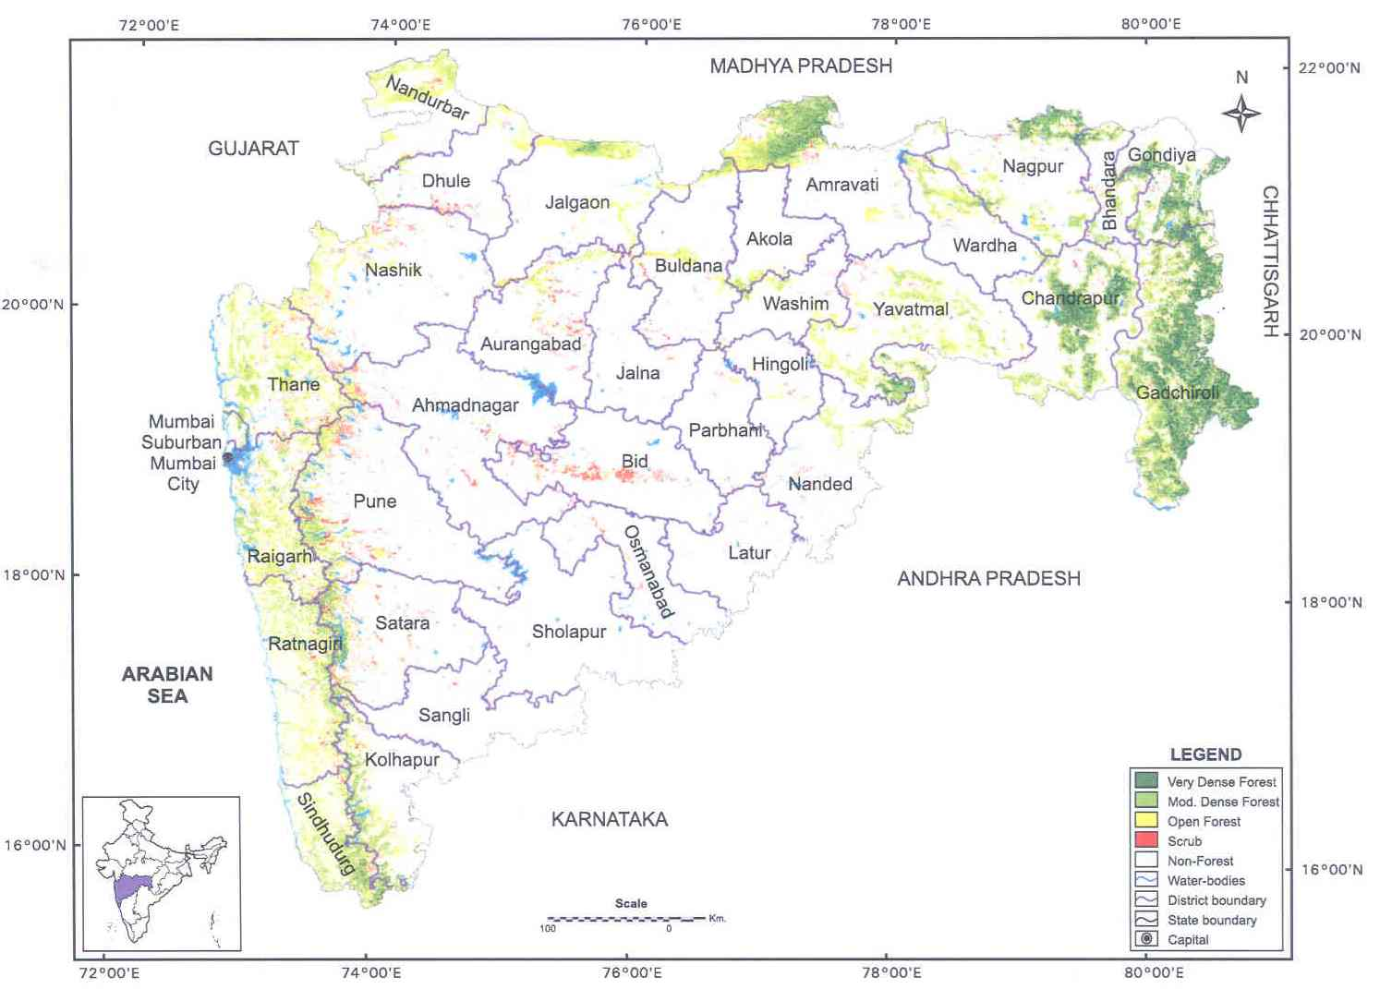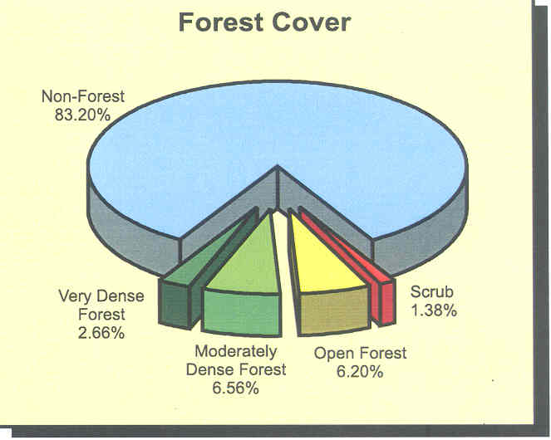
MAP-1: FOREST COVER IN MAHARASHTRA
Project Area

