FIGURE-1

TYPICAL PLAN OF TRANSMISSION LINE TOWER FOOTINGS

X
Y
T
R
A
N
S
M
I
S
S
I
O
N

L
I
N
E
INDICATIVE MEASURES

X & Y = 10-15 METERS

a = 300- 450 mm
a
a

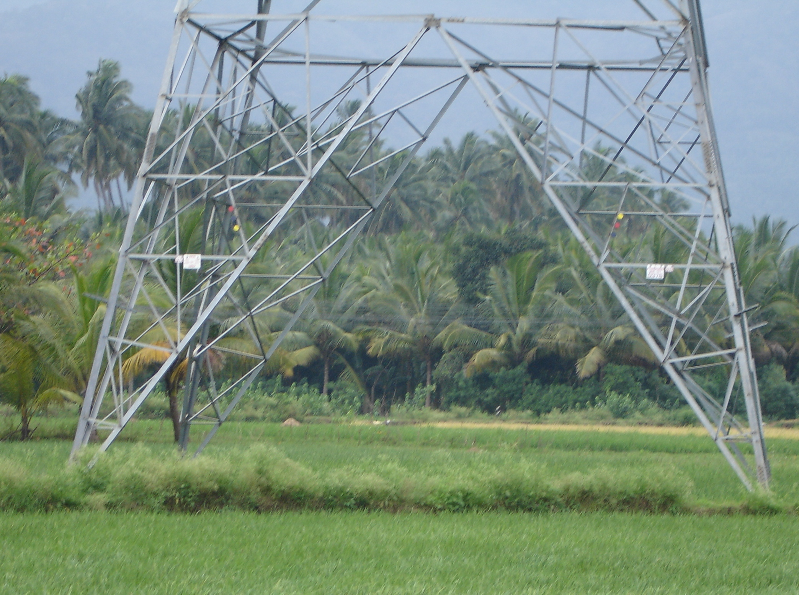
ACTUAL POSITION ON GROUND

