#### IMPACT ASSESSEMENT OF IMPLEMENTATION

#### OF

#### REHABILITATION ACTION PLAN (RAP)

#### OF

#### +500 KV HVDC TERMINAL

#### AT BHIWADI (RAJASTHAN)

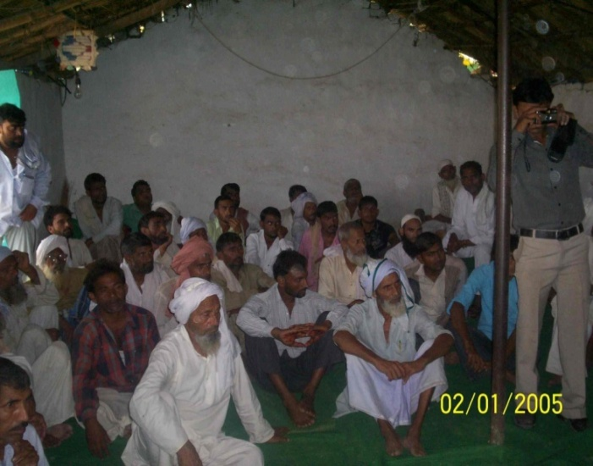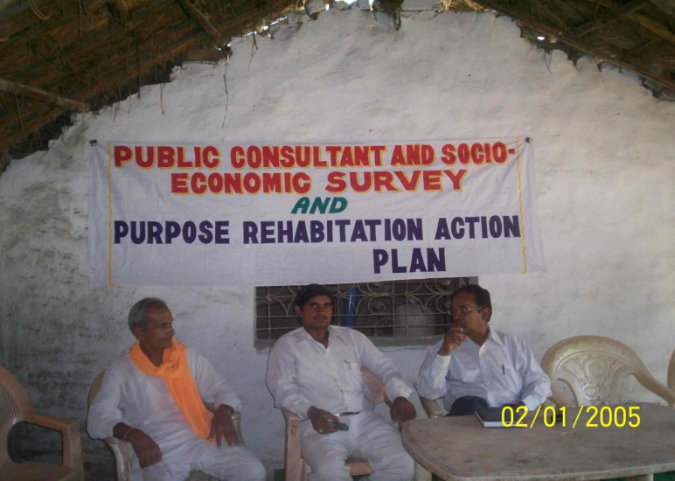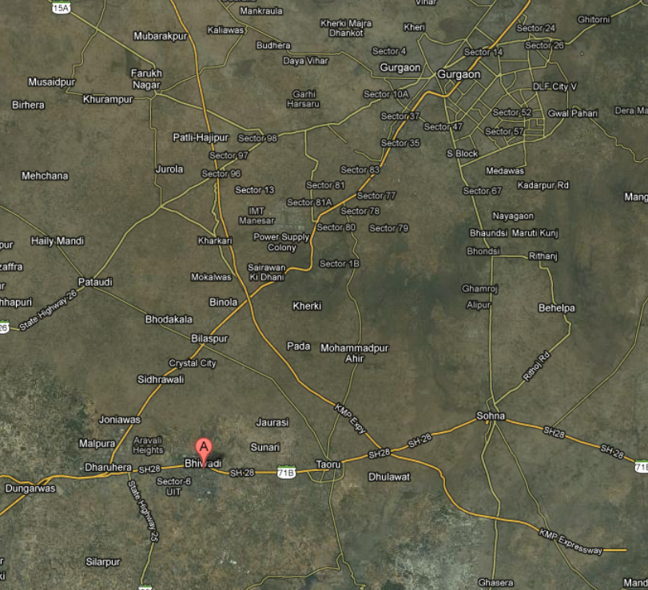



## ENVIRONMENT AND SOCIAL MANAGEMENT DEPARTMENT

## POWER GRID CORPORATION OF INDIA LTD.

## (A GOVERNMENT OF INDIA ENTERPRISE)

## PGCIL/ESMD/Final IA/Bhiwadi/2014 Oct'14