ASSESSMENT OF IMPLEMENTATION
OF RAP BY POWERGRID
AT KOLAR, KARNATAKA

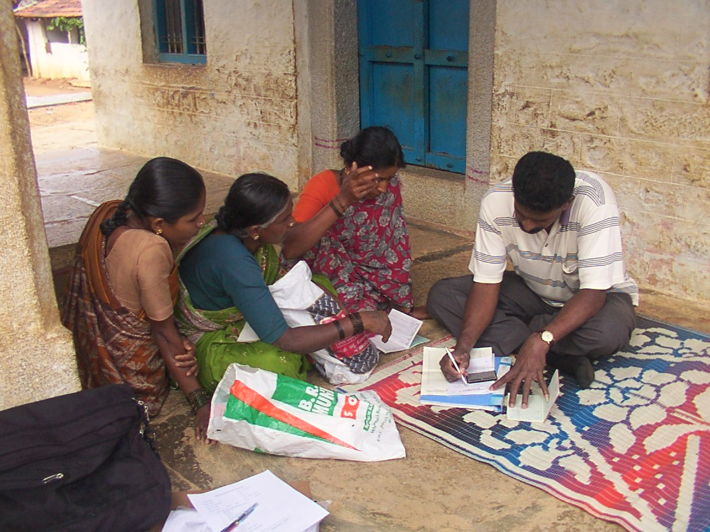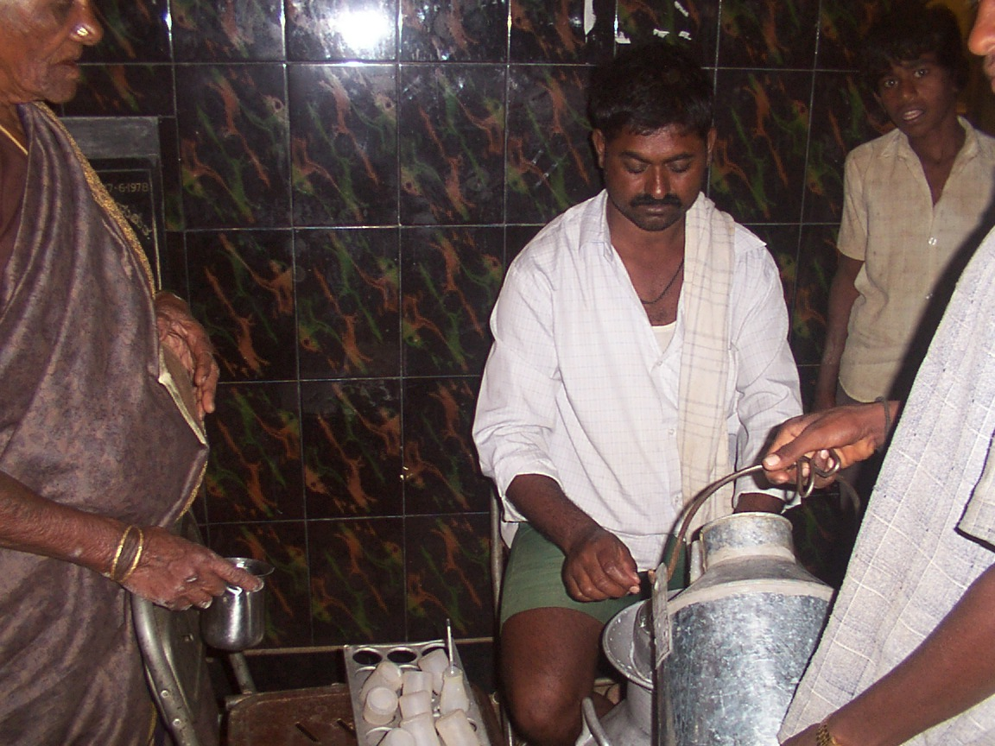

Foundation for Ecological Research, Advocacy and Learning
Pondicherry
Abbreviations
BRAES – B R Ambedkar Education Society
CBO - Community Based Organisation
GRC - Grievance Redressal Committee
HVDC - High Voltage Direct Current
IGS - Income Generation Scheme
IIM - Indian Institute of Management
KOMUL – Kolar District Co-operative Milk Producer Societies Union Ltd.
LPC - Land Purchase Committee
MYRADA - Mysore Resettlement and Development Agency
NABARD – National Bank for Agriculture and Rural Development
NGO - Non-Governmental Organisation
PAF - Project Affected Family
PAP - Project Affected People
R&R - Rehabilitation and Resettlement
RAP - Rehabilitation Action Plan
SHG - Self Help Group

Executive Summary
POWERGRID, the Central Transmission Utility of the country and one of the largest transmission utilities in the world, is playing a strategic role in the Indian Power Sector. As part of strengthening the regional grids and to support the generation capacity addition program of about 100,000 MW during the X and XI plans, a new converter station located at Kolar has been constructed and is owned by POWERGRID. Since the number of bays are more due to handling of around 2000MW of power through HVDC and AC lines to different states the land requirement for the HVDC terminal and 400/220 kV station is larger than conventional substations.
Construction of the HVDC terminal station resulted in the acquisition of 125 acres of private land and 20 acres of Government land in the villages of Arahalli and Huvahalli, Kolar District, Karnataka in the year 2000. A total of 64 households were affected due to this acquisition. POWERGRID, in accordance with the requirements of the social assessment process entrusted the socio economic surveys to IIM Bangalore to determine the socio-economic condition of people who would be affected by the land acquisition for the construction of the sub-station at Kolar. Based on the outcome of the socio economic survey a detailed Rehabilitation Action Plan (RAP) was prepared according to the social entitlement matrix provided in the ESPP by Environment and Social Management department for proper rehabilitation of affected households.
This study attempted to assess the long-term effect of losses of land and livelihood and corresponding mitigation measures listed in the Rehabilitation Action Plan (RAP) implemented by the POWERGRID Corporation at Kolar, Karnataka. The specific objective was to determine whether welfare levels of those affected were restored and sustained and if not, why.

Findings
The findings showed that while welfare levels of affected persons were restored, these were not sustained for all families. This was primarily for reasons extraneous to the R&R package itself and more to do with the manner in which the affected families made financial investments. The overall efficiency, effectiveness and impact of the policy of land acquisition were good and translated into an overall attractive relief and rehabilitation package. Vulnerable groups were identified earlier on by the RAP and specific programmes were launched to support them over a long term. The participation of stakeholders and their consultation and involvement in the rehabilitation approach was high. The involvement of the stakeholders and that of an external NGO ensured transparency in the rehabilitation package. Institutional mechanisms were established by way of an external NGO facilitating the formation and functioning of women self help groups. These continue to flourish and have greatly contributed to the success of the R&R programme.

Organisation of the report
The report is organised into four chapters. Chapter One Background covers the aims of the study and provides necessary background information required for the study. The Background provides the necessary background information required for the study. The Objectives section briefly discusses the objectives of the study and is followed by the Methods section which details the methods adopted in the collection and analysis of data.
Chapter 2 of the report covers the present status of the rehabilitation action plan and comprises of three sections. The introduction provides an overview of the RAP and a background to the activities. The second section, Process of Implementation, covers the status of implementation of the RAP up to the date of the study and the final section discusses the welfare measures that have been taken up in coordination with other govt. departments.
Chapter 3 of the report presents the observations, analysis and conclusions of the study. The first section, Evaluation and Assessment of the impact of rehabilitation assistance, presents observations regarding the modes of acquisition and amount of compensation paid. Observations on the manner in which compensation was utilised in terms of restoration of livelihoods are presented in the second section. The third section presents observations on the rehabilitation and resettlement efforts including income generation schemes, awards of petty contracts and training. The fourth section deals with observations regarding development works carried out under the RAP and the fifth presents observations on the institutional frameworks and participatory approaches followed. Chapter 4 concludes the presentation with analysis of the observations followed by suggestions and recommendations.
- Background

Introduction
POWERGRID, the Central Transmission Utility of the country and one of the largest transmission utilities in the world, is playing a strategic role in the Indian Power Sector and is considered as the nerve centre of the Power Sector. As of now it operates about 48,000 ckt km of transmission lines and 82 substations with a transformation capacity of 47,000 MVA.
POWERGRID has planed to create a strong and vibrant National POWERGRID in a phased manner to ensure optimum utilisation of generating resources, conservation of eco-sensitive right of way and for having flexibility to accommodate uncertainty of generation plans. Towards this, a perspective transmission plan has been evolved for strengthening the regional grids and to support the generation capacity addition program of about 100,000 MW during the X and XI plans. As a part of strengthening of national grid, POWERGRID has developed series of High Voltage Direct Current (HVDC) inter-regional links between Northern, Eastern, Southern and Western regions of India’s power system.
Project Description:
Power is one of the most essential infrastructural facilities required for accelerating the economic development. It may be observed that India’s power system is already imposing a constraint on industrial development. Power cuts, unscheduled shut down, and severe restrictions on industrial usage during summer months, are order of the day in our country. In this context, Power Grid Corporation of India is involved in a long-term plan for the development of an Indian National Transmission Network to make efficient usage of generating capacity. As a part of this strengthening of the national grid, POWERGRID has developed series of High Voltage Direct Current (HVDC) inter-regional links between North, East, South and Western Regions of India’s power system.
National Thermal Power Corporation Limited (NTPC) has expanded the existing Talcher Super Thermal Power Project (2 X 500 MW) by another 4 X 500 MW units. The entire power generated from Talcher-II has been allocated to the states of Andhra Pradesh, Karnataka, Kerala, Tamil Nadu and Pondicherry. The work of transmitting the 2000MW power to the southern states has been carried out by POWERGRID. The transmission system for the proposed project consists of the following transmission lines and substations.

Transmission line:
Talcher – Kolar 500KV, 2000 MW HVDC bi-pole
Kolar – Hoody 400 kV D/c
Kolar – Madras 400 kV S/c
Kolar – Hosur 400 kV D/c
Hosur – Salem 400 kV S/c
Salem – Udumalpet 400 kV S/c
LILO of Cuddapah – Somanhalli (Bangalore) 400 kV S/c at Kolar

Substations:
Talcher Converter Station: A new converter station has been constructed and is owned by POWERGRID. This station is located adjacent to the generation switchyard at Talcher.
400 kV / 220 kV substation at Hosur: A new substation at Hosur has been constructed and is owned by POWERGRID.
Salem 400/220 kV substation: Bay extension of existing 400/200 kV POWERGRID’s Salem substation has been completed.
Udumalpet 400/220 kV substation: Bay extension of existing 400/200 kV POWERGRID’s Udumalpet substation has been completed.
Kolar 400/220 kV substation: A new converter station located at Kolar has been constructed and is owned by POWERGRID. Since the number of bays are more due to handling of around 2000MW of power through HVDC and AC lines to different states the land requirement for the HVDC terminal and 400/220 kV station is larger than conventional substations.
Project Area:
The two affected villages, Viz, Arahalli and Huavahalli, are located in the Kolar district and just 4 kms. away from Kolar town which is the district headquarters. This district is bounded by the districts of Bangalore and Tumkur on the west and on all other sides of the district is the adjoining states of AP and TN. There are no natural boundaries such as rivers, mountains etc.which separate this district from other districts or other states. The rivers of the district are small and seasonal. The district owes its prosperity and development to the existance of thousands of ancient irrigation tanks. This is a characteristic feature of the landscape of the district. More than 99% of gold produced in India comes from the mines at Kolar gold fields which are now under closure because mining of gold is not economically viable.

Minerals, Rivers, Forests and cultivable lands are the main natural resources of this district. Of the above the forest resources in the district are very meagre. Soils are either rocky gravelly or shallow and are not capable of bearing better types of vegetation in view of the low rainfall. The rainfall is often meagre and unseasonal, thereby rendering agriculture to almost a gamble. Since rain fall is low, the district adopt only dry farming practices. Ragi is the main crop. To sum up the main characteristics of agriculture:

- Considerable scope for reclamation and expansion of cultivable area.
- Low percapita land availability
- Low productivity of land
- Predominance of small and marginal farmers with low land holding size
- Low level of irrigation and that too by wells and tanks

Kolar is renowned for its sericulture industry which provides employment to a large number of people. Besides, it assumes considerable importance in the overall economic development of the district.

Land Details:
Land measuring about 800x700 m or 55 ha. is required for setting of HVDC station. POWERGRID in general requires around 30 – 40 ha of land for setting up of their substations. In the case of Kolar, the handling of around 2000 MW of power through HVDC and AC lines to different states meant setting up a larger number of bays. Thus acreage required was around 145 acres. Site selection by POWERGRID is carried out keeping mind three basic principles : Avoidance, Minimization and Mitigation. Various parameters are studied and given due weightage. Parameters such as infrastructure facilities, availability of corridors for incoming and outgoing lines, soil type, ownership of land etc. are assessed. Social impacts in terms of no. of families affected, costs of compensation and extent of rehabilitation required is also studied.

Site Assessment
In the case of Kolar Substation, four alternative sites were identified. Site I located in village Sadanhalli, comprised only of private land. It was estimated that small and marginal holdings of 65-75 families would be affected. There were no infrastructure facilities in the near vicinity and the nearest administrative center was Bangalore city. Site II was again private land located about 10 km from Kolar. No. of families likely to be affected was around 60-70. Land was deemed unsuitable as it was undulating with shallow boulders and a large amount of land leveling/filling work would have top carried out. Access to the site was also problematic as acquiring an existing kuchha road would have affected the common approach to the village. Additionally, infrastructure facilities were not available nearby. Site III was a combination of government and private land located at a distance of 4 km from Kolar. No. of families likely to be affected was around 50-60 from two village, Arahalli and Huvahalli. It was dry land, mostly unfit for cultivation, with only a single crop of ragi grown during the rainy season. Given its proximity to Kolar, access to infrastructure facilities was also good. Site IV was located 10 km from Kolar by the side of the national highway from Kolar to Chennai. Land sloped to one side and this meant extensive leveling work. Around 70 families having small to marginal holdings were liekly to be affected. While part of the area was under eucalyptus plantations the rest was under mango orchards. The heavy traffic on the highway made the area prone to noise and dust pollution.
Site III was selected as it met the POWERGRID land acquisition criteria most closely. Least number of families would be affected and it was close to Kolar town. An important factor was that this land had been allotted to landless and poor people around 10-12 years ago on a patta/lease basis which had been regularized over the years. Thus less emotional attachment was expected as compared to acquisition of hereditary land.

Land acquisition Status
Private land was acquired under the provision of Land Acquisition Act,1894 as amended in 1984. Accordingly, Section-IV notification under the LA Act, for 117.24 acres of private land was issued on 14.01.99 and section – VI notification issued in July 99. After the measurement and marking of land under section 7 & 8, the Section-IX notification along with individual notices to interested person was issued on 5.11.99. An inspection/spot verification by Asst. Commissioner (AC) Kolar was completed on 13.01.00 for fixing of rate of compensation. Section-XI i.e., award by AC was made on 5.6.2000 and possession was handed over to POWERGRID on 26.06.2000. A plot of 7.23 acres previously considered govt. land was discovered to be private and was acquired under a separate process of acquisition following the above mentioned steps..
The new converter station was constructed at Kolar in the year 2001. POWERGRID has acquired 145 acres of land for the project, of which 85.5% (125 acres) is privately owned land and 14.5% (20 acres) is Government owned land. As a result, 64 households were affected due to land acquisition. Infrastructure projects like this often involve involuntary displacement of people from areas where they live and work. This displacement could result in economic and cultural disruption to the affected individuals and therefore there is a need for programmes that support them both economically as well as through social mechanisms.
In order to assess the basic socio-economic condition of the area and the resultant impact of land acquisition for Kolar HVDC s/s on the local population and to develop a meaningful Rehabilitation Plan for restoration of affected peoples livelihood as per the provisions of ESPP’98, socio-economic survey study was awarded to M/s Indian Institute of Management (IIM), Bangalore with the following objective:

- To collect base line demographic and socio-economic characteristics of affected household whose lands are being acquired.

- To categorise the project affected persons under different categories for various benefits and entitlements as per Powergrid’s Social Entitlement Framework.

- To assess the people’s reaction towards the project and ascertain their preferences for resettlement and rehabilitation, and

- To suggest an appropriate rehabilitation action plan for improving/restoring the living standards of affected families.

Compensation:
Since POWERGRID’s policy provides compensation at prevailing market price/replacement value, Deputy Commissioner (DC), Kolar was approched by POWERGRID officials with a request to take all possible steps for calculation of land cost at market price. In order to assess the market price many meetings/discussion were held in the presence of Asstt. Commissioner (AC), Kolar for finalisation of land price. After many interactions consensus was arrived on land price which was finally fixed at Rs. 2.00 lacs per acre for so called good land and Rs.1.00 lacs for bad land or P.K.land having boulders/stones. After adding 30% solatium and 12% interest it is coming to around Rs. 2.90 lacs per acre for good land and Rs.1.50 lacs for P.K. land which is more than what people of villages were expecting/demanding, in fact it is the highest ever compensation awarded for such type of land in the near vicinity as informed by the villagers. Total compensation towards land and trees/crop is calculated to be the tune of Rs. 4,00,00,000/- approximately.
Over and above, all eligible PAPs including the affected person of associated with land under advance stage of acquisition are getting Rehabilitation Assistance to the tune of Rs.5000/- to Rs.15000/- based on the loss of land/left over land and family size etc
R&R Policy/Entitlement:
In the absence of any National/State policy on R&R the only governing factor is The Land Acquisition Act, 1894 as amended in 1984. However, POWERGRID has articulated a social entitlement framework in its corporate policy- ESPP applicable for the affected families due to acquisition of land/assets for the substation. The abstract of Social Entitlement Framework under which the RAP was developed is as follows:

POWERGRID’S SOCIAL ENTITLEMENT FRAMEWORK*
TYPE OF ISSUE/IMPACT | BENEFICIARY | ENTITLEMENT OPTIONS
1. Loss of land  a. Homestead  (i) with valid title, or customary or usufruct rights | (i) Family | (i) equivalent area of land subject to availability (State Govt./ Voluntary sellers at existing rate) within a radius of 25 km.  or cash compensation + rehabilitation assistance**
b. Agricultural land  (i) with valid title, or customary or usufruct rights  (ii) tenants, sharecroppers, leaseholder, Squatters | (i) Titleholders  (ii) Individual | (i) alternative land of equivalent production potential subject to  - agriculture based PAPs (rendered landless by project or left with landholdings that are not economically viable)  - availability (State Govt./Voluntary sellers at existing rate) within a radius of 25 km  - maximum limit is land ceiling limit  or cash payment + rehabilitation assistance**  (ii) local standard for min. economic land holding (if not claimed by owner) or cash payment and reimbursement for unexpired lease+ rehabilitation assistance
c. Shop/ Institutions  (i) with valid title, or customary or usufruct rights  (ii) tenants, leaseholder | (i) Titleholders  (ii) Unit | (i) cash compensation + rehabilitation assistance**  (ii) reimbursement for unexpired lease, transition allowance equivalent to 1 year average income as finalised by land purchase committee
2. Loss of structure  a. House  (i) with valid title, or customary or usufruct rights  (ii) tenant, leaseholder  (iii) squatters | (I) Family  (ii) Family  (iii) Family | (i) cash compensation + rehabilitation assistance**  (ii) lumpsum payment equivalent to 6 month rent to re-establish residence as finalised by land purchase committee  (iii) Cash compensation for structure+ lumpsum payment equivalent to 6 month income finalised by land purchase committee to re-establish residence + rehabilitation assistance and transition allowance as per category-6.
b. Shop/ Institutions  (i) with valid title, or customary or usufruct rights  (ii) tenants, leaseholder  (iii) squatters | (i) Unit  (ii) Unit  (iii) Unit | (i) cash compensation + rehabilitation assistance**  (ii) transition allowance equivalent to 1 year income as finalised by  land purchase committee  (iii) Cash compensation for structure+ lumpsum payment equivalent to 1 year income as finalised by land purchase committee to re-establish structure + rehabilitation assistance and transition allowance as per category-6.
3. Loss of livelihood/trade / occupation  a. Wage/ Self employment  (i) agriculture/ commercial | (i) Individual | (i) package for starting a income generating enterprise and transition  allowance equivalent to 1 year income as finalised by LPC
4. Loss of access to common resources and facilities  a. Rural common property resources  b. Urban Civic amenities | (i) Household/ Community  (ii) Household/ Community | (i) replacement CPRs/amenities or provisions of functional equivalence  (ii) access to equivalent amenities/services
5. Loss of standing crops/trees  a. With valid title  b. Tenant/lessee | (i) Family  (ii) Family | for either category, only the cultivator will get compensation at market rate for crops and 8 years income for fruit bearing trees
6. Losses during transition of displaced persons/ establishments  a. Shifting/Transport  b. Maintenance  c. Construction | (i) Family/unit  (ii) Family/unit  (iii) Family/unit | (i) provision of transport or equivalent cash  (ii) cash payment to be finalised by the LPC  (iii) cash for transport of materials
7. Losses to Host Communities  a. Amenities/Services | (i) Community | (i) augmentation of resources of host community to sustain pressure of PAPs
* The proposed entitlement framework will be applicable only in the case of land acquisition for substation
** POWERGRID will provide adequate compensation as required under Indian law and will compensate at replacement cost. POWERGRID if required, will complement (i.e. top up) this with rehabilitation assistance and other measures to ensure that PAPs are not made worse off by their operations.

Summary of Impacts and Action Plan:
As established by the socio-economic survey 64 household were affected due to acquisition of agriculture land. However taking into account the heirs/dependents, family unit as defined in the Environmental and Social Policy and Procedures (ESPP) of the POWERGRID has increased to 133 (81 in Arahalli and 52 in Huvahalli ). No homestead/structure has been acquired . POWERGRID in consultation with PAFs and as per the suggestion of consultant had prepared an plan which includes economic rehabilitation measures like allotment of Income Generating Schemes (IGS) based on the apptitude and skills of PAFs. Following is the summary of assessment and amount of RA provided to each families:

Severity of Impact  (NOs. of Families) | Rehabilitation Assistance Provided  Full 90% of Cash Training  i.e Rs.15000/- IGS cost |  |  |  | NO  RA | Remarks
Severe (75) | 48 | 27 | -- | -- | -- | These families have lost their entire land hence majority has been given full RA however many of these families are doing their traditional occupation like dairy, sericulture or some other work at Kolar town because the land acquired is not a fertile land and in the absence of irigation facility its productivity is further reduced. Only one crop i.e. ragi is sown which is cultivated during monsoon. Therefore although thery are losing their entire land its impact on their income is restricted to cost of one crop. Taking above into consideration and taking due consideration of loss of land (area) maximum or full RA of Rs. 15000/- has not been paid to all PAFs who are living as joint family. However it has been kept in mind that atleast one family from such joint families are given maximum possible RA to maintain uniformity.
Moderate (46) |  | 46 | -- | -- | -- | These familis have lost part of their land and the remaining land is 1 acre or less. The above statement regarding suppli-mentary income also hold good for these families also. But taking into consideration their left over land and family size they have been included in the moderately affected families and are offered 90% of IGS cost as RA..
Minor (11) |  | 9 | 2 |  |  | All these families have lost only part land holding and leftover land is also economically viable and loss of income is also negligible. Some of the hamilies are having well established buisness hence two such families have been given RA in cash for augmentation of existing buisness.

Goal and Objectives of Present Study:
This present study has been conducted by the Foundation for Ecological Research, Advocacy and Learning, Pondicherry on behalf of the POWERGIRD Corporation of India Pvt Ltd. It assesses and evaluates the implementation of the Rehabilitation Action Plan (RAP) by POWERGRID at Kolar in Karnataka.
The specific objective of this study was to assess the long-term effects of the project on the livelihood of PAFs and to assess the extent to which the project has been successful in compensating and rehabilitating the affected people. The specific parameters taken into consideration were:
- Whether welfare levels of those affected were restored and sustained after land acquisition and rehabilitation activities were completed. If not identify reasons.
- The overall efficiency, effectiveness, impact and sustainability of the policy and practice of land acquisition and R&R
- How well social issues and impacts on vulnerable groups have been identified and addressed through the RAP and other programs
- To what extent a participatory approach has been followed with adequate stakeholder consultation and involvement.
- Whether the project has contributed to local economic growth and development in the surrounding area with special emphasis to economically backward groups.
- The adequacy and functioning of organisational and institutional framework established for project implementation.

Methodology:
The methods adopted for the study utilised a mix of participatory and non-participatory tools. The former involved focused group discussions with families from the project area (both affected and non-affected). Informal discussions were also held with officials from the POWERGRID Corporation (Picture 7), BRAES and NABARD. These discussions provided a wider assessment of the effectiveness of the rehabilitation process.
A comprehensive review of available literature and reports regarding the project was conducted. The documents reviewed included the RAP and reports from POWERGRID including impact assessment reports of the RAP. Documents were also downloaded from various web sites and included various World Bank guidelines for R&R. The choice of methods used for collection of field data was dictated largely by the nature of background materials and methods used to collect these. Via these documents individual PAFs were identified as also the amount of payment made in lieu of acquisition of land. However, these details were limited to the household level and the mode and details of sharing this amount within a family are not known. Thus, the sampling unit continued to be each household.
None of the project-affected families were relocated to other villages, and consequently most households could be contacted directly, with the exception of those who have migrated to other towns and cities. This facilitated the use of structured questionnaires for field data collection (Pictures 5, 6 & 8). These were designed on the basis of earlier studies and a reconnaissance survey carried out prior to actual data collection. Inputs from these visits contributed to designing the rest of the data collection methods and standardise protocols for sampling project-affected households. The household schedule thus designed was used for the collection of data regarding changes in economic activity, incomes and other social conditions of individual households. Owing to the relatively small sample size, a total census of the households was conducted. Additionally, equal numbers of questionnaires were filled with non-affected households to serve as a basis for comparison.
A reconnaissance survey for Kolar was carried out on June 1st 2005. Officials from POWERGIRD Kolar Substation were met during this trip and the current status of the rehabilitation process was discussed. The meeting also yielded details of activities that had been completed as of 1st June 2005. Site visits were also made to establish contact with Project Affected Families. The team was informed about the Income Generation Programme initiated through women SHGs of PAFs during the intervening discussions. Subsequent surveys were taken up during the month of July and August, which yielded detailed and comparative information about the R&R programme of the POWERGRID Corporation.
- Status of Rehabilitation Action Plan

Introduction
The POWERGRID’s policy on Resettlement and Rehabilitation (R&R) is to provide the affected / displaced people means to improve or at least restore their former living standards, earning capacity and production levels through a process in which they participate through their own social and cultural institutions. Therefore, the process of Resettlement and Rehabilitation of the displaced / affected is participatory oriented with emphasis on the need to ensure that the development fosters full respect for their dignity, human rights and cultural uniqueness.
To achieve this, POWERGRID developed a Rehabilitation Action Plan (RAP) for the affected people listing various measures for restoration of their livelihood / losses and the same were implemented during project execution of setting up the Kolar substation in the revenue villages of Arahalli and Huvahalli Panchayats, Kolar. Prior to acquiring land, a socio-economic survey of the project-affected people was carried out by IIM, Bangalore and results from this were incorporated into the RAP prepared by the Environment and Social Management Department of the POWERGIRD Corporation.

Status of Implementation
The formalities for land compensation were completed by June 2000 in the two villages, Arahalli and Huhalli. Two households in Huhalli had approached the court to settle disputes between family members with respect to partitioning of property. Thus they did not make use of the land compensation. Money for the IGS was handed over to four SHGs of the Project Affected People, and this process continues.

Linkages with Government Programmes
One of the major issues confronting R&R packages is the tendency of project-affected persons to spend the money on non-productive assets and goods. Recognising this danger, POWERGRID adopted the innovative approach of routing the payment through women Self Help Groups instead of handing over money directly to the PAPs. Thus four women Self Help Groups in Arahalli and three SHGs in Huhalli have been functional since July 2004. POWERGIRD is implementing this activity in consultation with NABARD, with the help of local NGOs, MYRADA and BRAES and credit linkage through Kolar Grameen Bank.

Community Welfare Measures
The following development works were completed by July 2004:
- Construction and improvement of black topped roads (3 km)
- Construction of deck slab culverts.
- Construction of four shops.
- Water supply scheme consisting of a bore well and eight cisterns.
- Construction of school building.
- Construction of toilet block.
- Construction of storm water drain (600 m).
- Construction of bus shelter.
- Installation of bulk chilling plant and associated facilities at the milk cooperative.

Individual Welfare Measures
A number of measures taken as part of the R&R package were targeted at individual households. These included:
- Cash for land acquired.
- Income generation schemes including:
  - Dairy
  - Sericulture
  - Sheep breeding
  - Poultry
- Vocational training
  - For youth
  - For women SHGs
- Cash assistance for augmenting existing business activities
- Labour and petty contracts.
The subsequent chapter deals with the status of the R&R package vis-à-vis the rehabilitation action plan.
- Evaluation and Assessment

Process of RAP followed
The resettlement action plan was arrived on based on the studies conducted by IIM Bangalore in 2000. These identified a total of 133 (64 H/h) families in 2 village being affected by the project implementation. A total of 125 acres land belonging to 64 persons was also identified as being acquired and therefore requiring compensation. Consultation were held with the Government, local bodies to devise the rehabilitation package and the Land Purchase Committee and the Grievances Redressal Committee were formed to ensure transparency and proper execution of the RAP. The PAFs identified were surveyed to assess the extent to which they received the benefits due form the RAP and also to examine their change in status if any.

Demographic profile of project affected families
A demographic profile of the project-affected families was done and compared with a control group – randomly selected households from within the village who were not affected by the project. This allowed us to compare the status of the PAFs in relation to others.
The tables below provide the age groups before and after R&R and that of the control group.
Table 1 Demographic comparison of project-affected household in the two villages
 | Arahalli |  | Huvahalli |  | Total
Age Group | 2000 | 2005 | 2000 | 2005 | 2000 | 2005
Less than 6 | 15.10 % | 21.30 % | 09.49 % | 17.90 % | 12.31 % | 19.61 %
7 – 19 | 26.85 % | 20.00 % | 28.81 % | 15.28 % | 27.82 % | 17.65 %
20 – 59 | 44.63 % | 47.39 % | 48.14 % | 55.90 % | 46.37 % | 51.63 %
Above 60 | 13.42 % | 11.30 % | 13.56 % | 10.92 % | 13.49 % | 11.11 %
Table 2 Demographic comparisons of project affected and non-affected households
Age Group | Project affected households | Non affected households
Less than 6 | 19.61 % | 18.33%
7 – 19 | 17.65 % | 21.02%
20 – 59 | 51.63 % | 51.21%
Above 60 | 11.11 % | 09.43%
Table 3 Comparisons of work force among project-affected villages
 | Arahalli |  | Huvahalli |  | Total
Work force | 2000 | 2005 | 2000 | 2005 | 2000 | 2005
Students | 26.85 % | 15.65 % | 28.81 % | 20.96 % | 27.82 % | 18.38 %
Workers | 44.63 % | 48.70 % | 48.14 % | 47.16 % | 46.37 % | 47.93 %
Unemployed | 13.42 % | 12.61 % | 13.56 % | 12.66 % | 13.49 % | 12.64 %
Table 4 Comparisons of work force between project affected and non-affected households
 | Project affected households | Non affected households
Students | 18.38 % | 30.73 %
Workers | 47.93 % | 47.98 %
Unemployed | 12.64 % | 15.63 %

Discussion
There is increase in the working age category (20-59) in both villages over the last five years. There was very little difference among the project-affected households in working and unemployed categories between the two villages, but there was considerable difference in the percent of students. The differences in the age groups or workforce among the project affected and non-affected persons was not large. However it was found that the total number of persons unemployed in non-PAFs was higher than the project affected families. Also number of students in project-affected families is substantially low.

Housing status
The housing status was compared before and after rehabilitation and between the PAFs and non-PAFs after rehabilitation. The observations are as follows:
Table 5 Housing status prior and post R&R in PAFs
 | Arahalli |  | Huvahalli |  | Total
House Type | 2000 | 2005 | 2000 | 2005 | 2000 | 2005
Pucca | 44.44 % | 96.43% | 46.15 % | 71.43% | 45.11 % | 85.71%
Semi-Pucca | 46.91 % | 03.57% | 51.92 % | 04.67% | 48.87 % | 04.08%
Katcha | 08.64 % | 00.00% | 01.92 % | 23.81% | 06.02 % | 10.20%
Table 6 Housing status between project affected and non affected households
House Type | Project affected households | Non affected households
Pucca | 85.71 % | 90.32 %
Semi-Pucca | 04.08 % | 03.23 %
Katcha | 10.20 % | 06.45 %
Table 7 Comparison of housing conditions before and after project implementation
 | Arahalli |  | Huvahalli
No. of rooms | 2000 | 2005 | 2000 | 2005
One | 64.5 % | 17.2 % | 69.7 % | 57.1 %
Two | 16.1 % | 27.6 % | 09.1 % | 28.6 %
Three | 06.5 % | 03.4 % | 0.61 % | 09.5 %
Four | 12.9 % | 37.9 % | 15.1 % | 04.8 %
More than four | 00.0 % | 13.8 % | 00.0 % | 00.0 %

Area
< 1000 sqft | 67.8 % | 86.2% | 57.6 % | 71.4 %
1000-2000 sqft | 18.2 % | 10.3 % | 30.3 % | 23.8 %
>2000 sqft | 04.0 % | 03.4 % | 12.1 % | 04.8 %
Table 8 Housing conditions between project affected and non-affected households
 | Project affected households | Non affected households
Average area (sq ft) | 778.08 | 1010.72
Average no. of rooms | 2.48 | 1.91
Houses with Toilets | 36.00 % | 35.48 %
Houses with bathrooms | 58.00 % | 58.06 %
Houses with kitchen | 98.00 % | 91.93 %
Houses with cowshed | 42.00 % | 54.83 %

Discussion
The data collected shows that there was a substantial increase in the number of pukka houses and a small increase in the number of Kuttcha houses in Huvahalli. The increase in Kuttcha houses in Huvalli is due to those staying in semi-puckka houses converting to Kuttcha houses. Although they have converted the house type they have added more floor area under the same house. The number of semi-pukka houses decreases substantially in both villages. The number of pukka houses remained below the non-affected group after R&R. The reduction in floor area needs to be looked into taking into consideration the present house type. Most of them now stay in puccka houses, the cost involved in constructing a small puccka house will be comparable to building a large kutctha house. This also indicates that there is no adverse impact on living standards of project-affected people when compared to non-affected households. In terms of size, it was found that on average the size of houses was higher in the control group, however a higher proportion of houses had toilets, kitchens and bathrooms among the affected household. This again indicates a higher standard of living in the rehabilitated houses.

Livestock
The table below shows details of livestock ownership before and after the R&R
Table 9 Number of households with livestock before and R&R
 | Arahalli |  | Huvahalli
 | Before | Present | Before | Present
Bulls | 9 | 0 | 23 | 1
Cows | 17 | 17 | 20 | 25
Buffaloes | 5 | 2 | 15 | 2
Goats | 12 | 9 | 16 | 4
Poultry | 15 | 0 | 15 | 1
Table 10 Percentage household owning livestock
 | Affected household | Non affected households
Bulls | 2 % | 9 %
Cows | 81 % | 47 %
Buffaloes | 8 % | 17 %
Goats | 25 % | 27 %

Discussion
There is a substantial drop in the total number of livestock owned except in the case of cows. This may be a direct result of decreasing agricultural lands as agricultural residue forms a major component of fodder and also the need for draught animals. The decrease in poultry might be due to the IGS undertaken by the households, all of them are engaged in dairying, thus there may be a strong preference to own cows rather than poultry. When compared with the non-affected households it is noticed that the percent households owning cows is substantially larger among the affected households, although there is a slight decrease in other types of livestock. The number of households owning cows is bound to rise further due to the IGS provided by POWERGRID.

Annual Income, Expense, Indebtedness and Asset
As has been noted during the previous socio-economic surveys, it is quite difficult to collect data pertaining to income and expenses. The following tables present the current economic conditions in the project affected families and compares their status with non-affected households.
Table 11 Number of households in different income groups before and after project implementation
 | Arahalli |  | Huvahalli |  | Total
Income Groups | 2000 | 2005 | 2000 | 2005 | 2000 | 2005
<=10000 | 82.7 % | 15.2 % | 67.3 % | 21.7 % | 76.7 % | 17.9 %
10001-20000 | 12.3 % | 15.2 % | 23.0 % | 39. 1% | 16.5 % | 25.0 %
20001-30000 | 01.5 % | 15.2 % | 02.0 % | 08.7 % | 01.5 % | 12.5 %
30001-40000 | 02.0 % | 21.2 % | 02.0 % | 13. 0 % | 02.3 % | 17.9 %
40001-50000 | 01.5 % | 03.0 % | 03.7 % | 04.3 % | 02.3 % | 03.6 %
>50000 | 0.00% | 30.3 % | 02.0 % | 13.0 % | 00.8 % | 23.2 %
Table 12 Number of households in different income groups among project affected and non-affected households
Income Groups | Project affected | Non Affected
<=10000 | 17.9 % | 9.7 %
10001-20000 | 25.0 % | 17.7 %
20001-30000 | 12.5 % | 11.3 %
30001-40000 | 17.9 % | 4.8 %
40001-50000 | 03.6 % | 19.6 %
>50000 | 23.2 % | 37.1 %

Table 13 Average income, expenditure and indebtedness among project-affected households
 | Arahalli |  | Huvahalli |  | Total
Average | 2000 | 2005 | 2000 | 2005 | 2000 | 2005
Gross income | 8433 | 42551 | 16358 | 61442 | 12396 | 50310
Agricultural income | 15180 | 4483 | 22990 | 24565 | 19085 | 13037
Expenses | 12200 | 59353 | 17500 | 200152 | 14850 | 129752
Indebtedness | 15000 | 14000 | 22000 | 90238 | 18500 | 52119
Table 14 Average income, expenditure and indebtedness among project-affected and non-affected households
Average | Project affected | Non affected
Gross income | 50310 | 99613
Agricultural income | 13037 | 13366
Expenses | 129752 | 10464
Indebtedness | 52119 | 28042
Table 15 Percentage of households investing in assets over the last five years
Average | Project affected | Non affected
Farm assets | 00 % | 02 %
Household assets | 14 % | 19 %
Vehicles | 08 % | 23 %

Discussion
The data indicates an overall increase in average incomes. In terms of number of families, the lowest income groups appear to have reduced substantially in both the villages. The decrease in average agricultural income is largely due to the fact that a large percentage of the households with land are not cultivating their lands. There is also substantial increase in annual expenditure and annual indebtedness. Average indebtedness in the case of Arahalli has decreased. The reason for the observed indebtedness is most households have borrowed money to conduct marriages in the family. The increased incomes and expenditure indicate an overall economic improvement from their earlier state. But when compared to the non-affected people the average income levels are substantially lower.
In the previous socio-economic surveys only farm assets were taken into consideration. It was observed that none of the households invested money over the last five years to improve their farm asset ownership. This is similar to control group, only one household had invested in purchasing a tractor. But there was considerable difference between the affected and non affected households if one took into consideration household and vehicular assets.

Land Acquisition and Compensation
Out of the 64 affected households, 55 households continued to stay in their respective villages, the rest were either residents of Kolar or Bangalore, thus they were not contactable. Approximately 125 acres of land was acquired from 64 households in Kolar. This included 66 acres in Arahalli and 58 acres in Huvahalli village. About 85% of the land that was acquired was dry land and more importantly about 60% of the acquired land was barren due to presence of boulders (Picture 1). 50% of the households lost 100% of their landholding and 17% were left with land sizes less than 1 acre.

Discussion
It is clear from documents and discussion that an attempt was made to identify land as compensation for the area acquired. However the Land Purchase Committee was unable to find any suitable land within 25km radius from the village and cash compensations was resorted to. A sum of Rs.2,90,000/- per acre was fixed as the price for good land and Rs.150,000 for bad land or putta karab (P.K.) land. The award was determined by the Deputy Commissioner of Kolar under section 11 of the Land Acquisition Act of 1894. The compensation was decided after public discussions. Although more than 60% of the surveyed households felt that they had received lower compensation amounts, focused group discussion with non-affected people, revenue officials and people who had purchased land indicate that the compensation paid by POWERGIRD was fair and appropriate and better than market rates were given for both good agricultural and putta karab land.
During the land acquisition process a mango grove adjoining the POWERGRID substation was avoided thus making the land acquired irregular in shape.

Restoration of Livelihood
The objective of the rehabilitation package was to restore livelihood levels of the project affected people. Table 15 summarises how the people actually spent the money.
Table 16 Utilisation of compensation
 | Proposed | Actual
Asset improvement | 65.0 % | 60.7 %
Land purchase | 68.8 % | 28.6 %
Social functions | 25.6 % | 50.0 %
Unspent | 0.00 % | 05.4 %
Savings | 0.00 % | 03.6 %
Other | 12.5 % | 00.0 %

Discussion
Half of the affected households invested the compensation amounts into asset improvement, mostly improving their living conditions. Nearly 30% of the households invested their money on purchasing land. Five households in Arahalli purchased about 15 acres of land and in the case of Huvahalli nine households purchased about 18 acres of land. It needs to be noted that many of these houses used to own dry-lands or P.K. lands but had purchased agricultural land from the compensation paid. Given that the primary occupation of most PAF was agriculture this investment seemed prudent both from the standpoint of immediate incomes as well as long-term value of the land. A small percentage of the households saved the money received in the process of land acquisition.
To estimate how efficiently the rehabilitation package addressed the restoration of livelihood was we used the total compensation money received by the household, and computed an estimated compensation they should have received. The estimated compensation took into consideration farm size, proportion of family members working on their own farm, levels of indebtedness, average agricultural income per acre and cost at which land was purchased. Results indicated that irrespective of percent land lost the overall procedure used to arrive at compensations had addressed issue of restoring livelihoods.
Socio economic surveys carried out prior to implementation of the RAP showed that the primary source of income was from agriculture. About 50% of the households had lost all their landholdings and an additional 17% were left with land holdings too small for viable agriculture. We assessed the present primary source of income for only those who were previously dependent on agriculture as a primary source of income. Results indicated that all of the PAPs had found alternative sources of income. Details of the same are given in figure 1
Figure 1 Present primary source of income among project affected people who were previously dependent on agriculture.
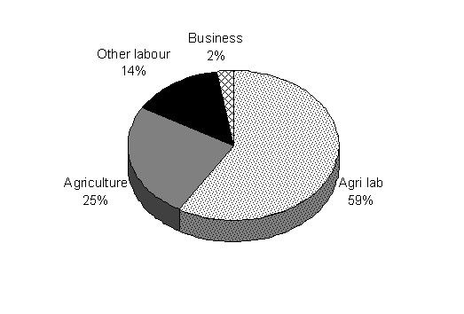
25% of the household continued to depend on agriculture as a primary source of income, this percentage was similar to the percent of households who invested money on purchasing land.
POWERGRID constructed a channel to feed a pond near Huvahalli which facilitated 2-3 seasons of cropping. This provided additional work for PAFs who were agricultural labourers. The majority of those categorised as ‘other labour’ worked as masons. Labour rates and number of days employment was higher for masons than agricultural labourers.

Income Generation Schemes
Based on the previous socio-economic surveys, financial viability, employment potential, availability of natural resources, skills available and sufficient market avenues the following income generation schemes were offered to the project affected families
Table 17 Proposed income generation schemes
Sl. No. | Name of ISG | Estimated cost (Rs.) | No. of PAFs identified
A | 1 cow + 100 birds poultry | 9000 | 11
B | 1 cow + 5 sheep | 8000 | 21
C | Sericulture –500 DFLs | 6000 | 19
D | Dairy (2 cows) | 15000 | 34
E | Poultry (500 birds) | 10000 | 3
F | Sericulture –1000 DFLs | 12500 | 11
G | 1 cow + 500 poultry birds | 13500 | 14
H | Poultry (750 birds) | 15000 | 18
 | Cash assistance | 8000-12000 | 2
 | Training | 15000

Discussion
The above schemes were decided taking into consideration extent of land acquired, proportion of land left over and aptitude / skill of the PAFs, with a maximum of Rs.15,000 for any Income Generating Scheme. This was higher at a household when seen in conjunction with bank loans and thus the households appeared to be better off than earlier.
A total of Rs.1,500,000 was earmarked for the IGS and the same was channelised through the Kolar Grameen Bank. An innovative approach of routing the money through women Self Help Groups of the PAFs was adopted in the two villages instead of directly handing over money to the PAPs,. Table 17 gives the details of the Self Help Groups formed. The SHGs have been functional since July 2004 and release of funds through Kolar Grameen Bank was initiated in June 2005.
Table 18 Details of women SHG formed to carry out IGS
Village | Name of SHG | No. of members
Arahalli | Chandrodaya | 18
 | Kitturu Rani Chennamma | 20
 | Suryodaya | 8
 | Arunodaya | 16
Huvahalli | Jai Karnataka | 13
 | Jai Bharath | 16
 | Rukmini Devi | 20

While NABARD’s role was advisory in nature, MYRADA, as lead NGO, trained and guided the frontline NGO (BRAES) to form the SHGs. KGB’s role was to financially link the SHGs once they attain maturity. POWERGRID deposited the IGS fund of Rs. 15 lakh with KGB in March 2004, which was kept as special deposit to be released to the concerned SHGs on advice of POWERGRID, as per the share indicated in the RAP report.
Only one group had been formed in Arahalli by April 2004. Because of the countrywide elections and the follow through, the process was further delayed. NABARD and Powergrid officials visited the villages and convinced the PAPs to form the SHGs. By July 2004, 7 SHGs in had been formed with 119 out of 137 PAPs comprising 87 % of PAPs. It was ensured by NABARD that authorization letters were collected from the PAPs ensuring participation of women members of the family in the SHGs.
While emphasis was given on working of SHGs, at the behest of Deputy Commissioner, Kolar District, POWERGRID financially assisted the KOMUL (Kolar Milk Union) project of augmentation of their collection cum chilling unit at Arahalli Village by way of bearing the 50% of the total cost of modernisation of plant including computerised billing. In turn KOMUL, in consultation with NABARD, agreed to take the entire quantity of milk produced by the villagers, specially the PAPs who showed preference for dairy activities.

Training programmes conducted
The PAPs had been given training in the following fields of activities:
- Basic training on SHGs
- On the job training through MYRADA/BRAES
- SHG management, Leadership and Book writing
- Exposure visit to MYRADA Project area
- Dairy management through Animal Husbandry department and KOMUL

SHG- Bank linkage
At the behest of the Project Management Committee, the members jointly examined the SHGs and rating was conducted. It was decided to release funds from KGB to the SHGs only after all SHGs had matured with rating more than 75 in a scale of 100. The share of each PAP was worked out for the purpose. KGB sanctioned funds (i.e. Rs. 30,000/- to each PAP) to PAPs for purchase of animals to be released in two instalments as the second animal was to be purchased after six months of the first.
IGS Fund deposited at the Kolar Gramin Bank was kept in the Reserve Account as a back ended subsidy and no interest was charged by the bank on the portion of the IGS fund in the loan component. Further the Bank kept the IGS fund in the reserve account after clearing the loans by the SHGs. The interest of Rs. 65,000, generated by this deposit was credited to a special account to cover the insurance cost of assets generated while implementing the IGS.
The status of the SHGs was evaluated to see how well they were equipped to carry out these activities. Figure 2 clearly shows that most of the members joined the group for economic reasons.
An assessment of needs (figure 4) indicated that members of the Huvahalli SHG groups saw a clear economic rationale for the role of the SHGs while members of the Arahalli groups (figure 3) appeared to consider SHGs as means of general rural development. Thus 66% of the Huvahalli members had suggestions for income generation programmes (Figure 5) where as none of the Arahalli members had identified income generation activities. The need for training programmes to function efficiently is was also identified (figure 6).
Figure 2 Reason for joining SHG
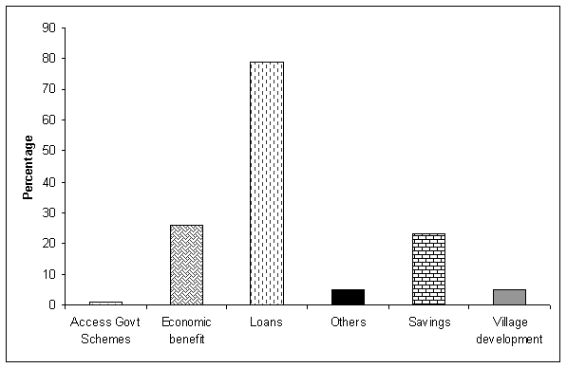
Figure 3 Needs as perceived by SHG members in Arahalli
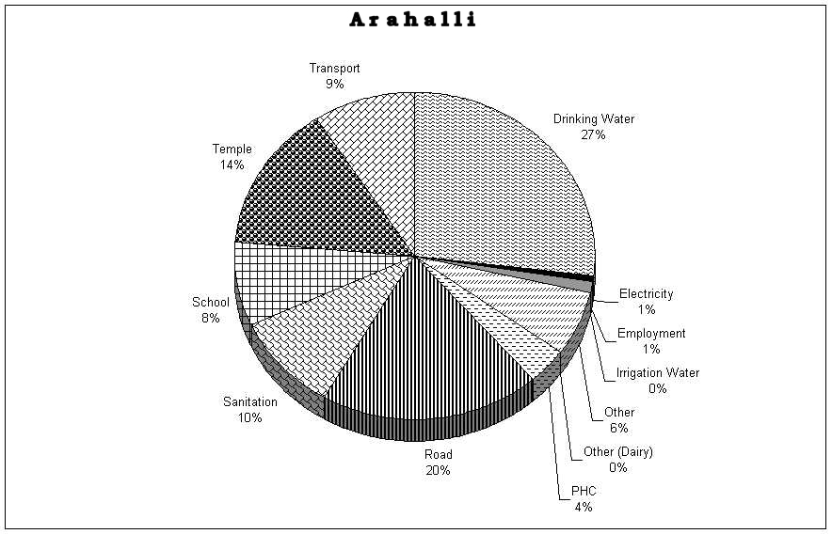

Figure 4 Needs as perceived by SHG members of Huvahalli
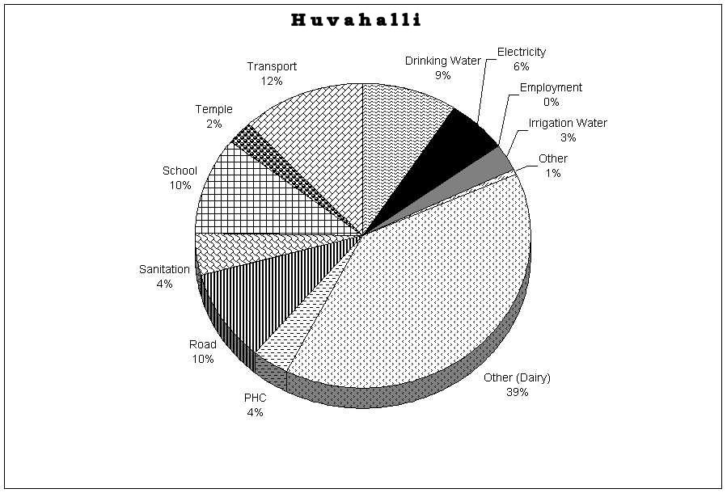
Figure 5 Income generation activities identified by SHG members of Huvahalli
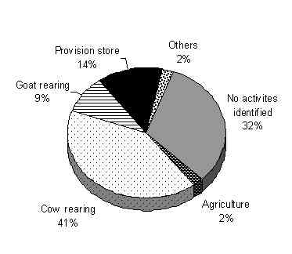
Figure 6 Assistance required to sustain group functioning
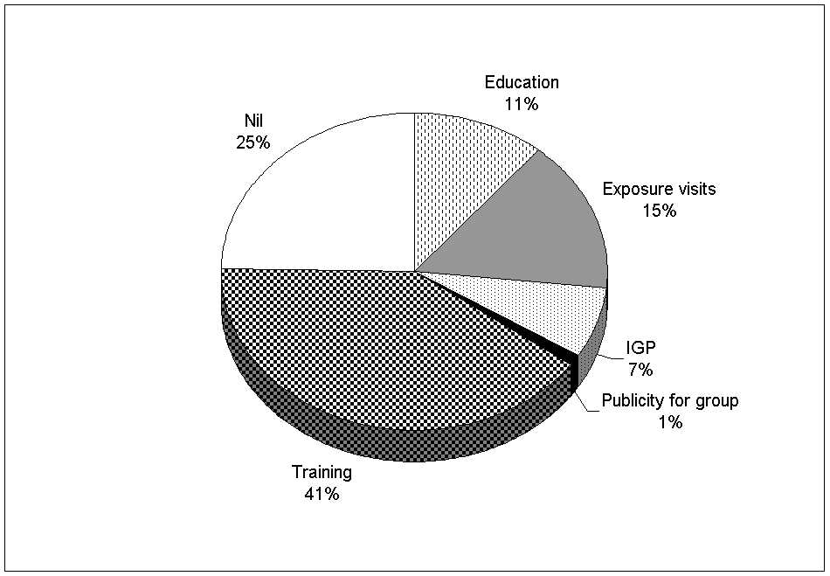

Award of petty contracts
The R&R package did not envisage creation of long-term jobs opportunities for local residents. However, in line with the policy to provide work to eligible PAFs, contractors engaged by POWERGRID had to give preference to unskilled and semi-skilled labourers during the construction phase as per conditions specified in their contract agreement. Day to day needs of POWERGRID families were being sourced from projected affected villages thereby providing constant market and income.

Training
As a part of the Rehabilitation programme a sum of Rs.100,000 was allocated for interested PAFs to undergo vocational training. However none of the project affected families opted for this training. The allocated amount was utilised to provide training for the women Self Help Groups.

Developmental works
Under the implementation of RAP village developmental works worth Rs 60 lakhs was carried out to enhance the living conditions in the village. The activities were carried out in two phases. In first phase the following activities were carried out after a MOU was signed with District Authorities for execution of works:
Table 19 Community development work undertaken in phase one
Activity | Cost in Rs lakh
 | Arahalli | Huvahalli
Improvement of roads | 9.00 | 13.58
Construction of culverts | 1.83 | 2.56
Construction of school | 1.50 | --
Construction of toilet block | 1.20 | --
Water supply system | 4.80 | 3.96
Construction of storm water drains | 4.37 | 7.20
Augmentation of milk co-operative | 4.40 | 0.60

In the second phase the following activities were undertaken:
Table 20 Community development work undertaken in phase two
Activity | Cost in Rs lakh
 | Arahalli | Huvahalli
Construction of shops | 2.25 | 2.25
Construction of bus shelter | 0.50 | --
An assessment of how beneficial these were to the affected village was done. There were no requests for additional facilities which indicated high levels of satisfaction in the general community. The development works undertaken not only improved the standard of living of the project-affected household, but also raised the living standards of the rest of the community. The provision of clean drinking water and drains (Picture 2) led to an improvement in hygiene levels in the village.
Construction of the school gave an opportunity to the largely illiterate local population to improve literacy levels. The same building could also be used as an adult night school and provide illiterate adults an opportunity to learn to read and write. During discussions with the affected people it was highlighted that there was a requirement of additional rooms in the school as the number of students has increased over the years. It is suggested that additional rooms for the school be provided by POWERGRID as a welfare gesture.
A Note needs to be made of the improvement of the milk co-operative. Dairying is an economically viable activity in and around Kolar, as there is Milk Processing Unit very close to the project-affected villages, owned by the Kolar Milk Union Federation. The provision of chilling unit and other facilities at the village ensured that large quantities of milk could be stored at the village before being sold to KOMUL (Pictures 3 & 4). This would also be useful as most families chose dairying as the IGS provided under the RAP.
POWERGRID constructed a channel to feed a pond near Huvahalli which facilitates 2-3 seasons of cropping. Other than providing irrigation water this provides additional work for those in the agricultural labour category. POWERGRID has also established a rainwater harvesting system on its own campus. These measures have helped in improving the ground water table as reported by the villagers.
In most parts of rural India such village development activities are undertaken by the ministry of Rural Development under its various schemes. The policy adopted in the RAP demonstrated how a public sector company could contribute effectively to improving the living standards in rural India. It is to be highlighted that such development works had previously only been undertaken where people were resettled from their original homes. POWERGRID provided additional benefits even when people were not displaced and made a significant contribution towards long-term and overall development of the villages.

Institutional Framework and Participatory Approach
A major issue in land acquisition and resettlement implementation and management is the appropriate institutional framework for the executing agency. The organisational structure adopted by POWERGIRD for monitoring of RAP is given in appendix1.
To implement the RAP, POWERGRID constituted an Environmental and Social Management Team with the AGM, Kolar as its in charge. Other members of this wing included the chief manager and one engineer. The roles played by the E&S team were:
- Overall responsibility of implementation of R&R activities.
- Land acquisition and R&R activities in the field.
- Ensure availability of budget for R&R activities.
- Liaison with district administration for support in land acquisition and implementation of R&R.
- Participation in the district level committees.
In order to inform public about the project and land acquisition public consultation meetings were organised with representation of various departments involved and the project affected people. IIM, Bangalore, who was involved in carrying out the socio economic surveys, had also informed people about the project and its resultant benefits along with POWERGRID’s R&R policy and other community development activities.
The institutional framework for land acquisition was largely with the state Revenue Department with a liaison from POWERGRID. The District Revenue Officer and the District Collector were responsible for indicating the intention of the Government to acquire land or other property with a notification under sec. 4(1) of the Land Acquisition Act 1894 and the same was published in the official Gazette.
After sec. 4(1) notification was issued, it was the responsibility of the District authorities to clear any doubts regarding the compensation award, land price etc. among the project affected people. The procedure dictates that any objections from the affected people need to be filed before the Collector. Base on the report submitted by the collector the Government published the declaration made under sec. 6 in the official Gazette.
As per the social entitlement framework a land purchase committee was formed to identify / arrange alternate land from voluntary sellers for the PAFs who opted for land for land compensation. The members of the LPC include the Assistant Commissioner, Kolar, nominee of the District Authority; the Chairman of the Gram Panchayat, nominated by the Gram Panchayat; the Chief Manger, nominated by POWERGRID and two representatives, one from each village, of the project affected families. The LPC was not only involved in finding voluntary sellers but contacts were made with district Authorities to find suitable land with in 25 km of the project site.
To address the problems of the PAPs during the implementation of the RAP a grievance Redressal Committee (GRC) was constitiuted through nomination from different bodies like local administration, PAPs, Gram Panchayat and POWERGRID. People in the village were asked to approach the Chairman and Convenor, in this case the Assistant Commissioner, Kolar, or POWERGRID in the case of any grievance. In such a case a meeting of the GRC was to be convened within 15 days of receiving the grievance for discussion. The roles of the GRC were:
- To provide support for the PAPs on problems of RAP implementation;
- To record the grievances of the PAPs, categorize and prioritise the grievances that need to be resolved by the Committee;
- To report to the aggrieved parties about the development regarding their grievance and decisions of the committee.
- In case the PAPs were unsatisfied with the decision of the committee they could approach the District Collector or Court for solution.
For the disbursement of amounts related to Income Generation Schemes a team was constituted consisting, officials from POWERGIRD, NABARD, MYRADA, BRAES and Kolar Grameen Bank and the amount is be channelled through women self help groups of PAFs. The two NGOs MYRADA and BRAES were and continue to be involved in all aspects of group formation, capacity building, training and evaluation of the women SHGs. The funds for these activities were released by Kolar Grameen Bank. This framework of utilising local NGOs, Rural development agencies, and lead banks to implement the IGS was an innovative step and it has been highly successful in Kolar.

- Conclusions
This study was an assessment of the R&R package and thus focuses both on the learnings and issues raised during implementation of the RAP by the POWERGRID at Kolar. The efforts made in identification of PAFs, committees formed for implementation and involvement of different stakeholders at the various stages is commendable. The success in collaborating with local NGOs and ensuring good community level rapport has been an innovative approach followed by Kolar. However, an acknowledgment of lessons learned would both help POWERGRID to improve its ongoing efforts as well as help design a better R&R package for future substations.

Salient features of the findings
- None of the project-affected households were relocated to other villages due to land acquisition.
- All the PAPs who lost their land have received monetary compensation and the same was accomplished without any pilferage.
- Income Generation Schemes are being implemented by forming women Self Help Groups of the project affected households; so far 4 out of the 7 groups have received financial assistance and two are in the final stages of receiving assistance.
- More than half the households have spent the compensation amounts received on improving their housing conditions and on social functions.
- The average annual income of the affected households has increased when compared to the base line surveys, but their present average annual income is lower than those reported by non affected households.
- There has been significant improvement in the housing conditions of the households, 85% of them live in puccka houses as compared to 45 % before.
- The livestock holding among project-affected households is similar to non-affected households; the number of affected household with cows is much higher than non-affected households.
VIII Results indicate that the overall living standard of the project-affected households has significantly improved.

Innovative approaches followed by the POWERGRID
One of the major achievements of the R&R package for Kolar has been the successful formation and facilitation of Women Self Help Groups from the project affected families. Documentation on the process of formation and achievements of these groups clearly demonstrate the seriousness of POWERGRID in providing PAFs sustainable livelihood opportunities. Among the highlights of the approach, which could be emulated in other R&R packages were as follows:
- Consultations with agencies, both government and non-government who had experience in formation and facilitation of self help groups. These included the Kolar Grameen Bank, NABARD and MYRADA.
- Discussions and consultations with the local representatives, the Programme Implementation and Monitoring Committee. These enabled POWERGRID to overcome their initial hesitation to the idea of SHGs and convinced the PMC to support the initiative.
- Identification of a local "frontline" NGO, BRAES, to take up the formation of the groups. Support from MYRADA was provided for the purpose.
- Formation and facilitation of SHGs with members from 87% of the PAFs.
- Creation of a large financial pool for the SHGs with a bank, access to which was linked with performance of the SHGs.
- Identification of income generation programmes and intensive training and exposure visits to build capacities of the SHG members in their chosen IGP (dairying).
- Identification of supporting banks and establishing credit linkages between the bank and SHGs.
- Linkages with govt. programmes and banks for continued support and subsidies to the ventures and, importantly, with a marketing agency (KOMUL) for sales of produce.

Suggestions and Recommendations
- More exposure visits may be considered for project-affected people to places where similar resettlement programmes have successfully implemented to strengthen cooperation and participation from the affected people. This will also help in clearing any doubts that they might have and will also provide them an opportunity to understand the Rehabilitation Action Pan and other development works proposed by POWERGRID.
- When land acquisition is involved, it is suggested a land for land compensation mode be adopted. If finding land with similar productivity is not possible, it must be insisted that the affected people reinvest in land.
- To ensure long-term sustainability of the Income Generation Schemes it is suggested that the present maximum ceiling of Rs.15,000/- be raised.
- Although training has been provided if required the affected people also need to be provided with adequate additional training to successfully carryout income generation schemes. In all cases, in order to accommodate women's work overload and multiple responsibilities, their training should be offered at the village level and should be practical, on-the-job training, well adjusted to women's reality.
- Training in poverty and gender issues should be extended to all project officers, as well as to NGOs.
- All training activities and particularly the quality of training offered to all target groups and especially to beneficiaries needs to be carefully monitored by the project.
- As dairying is one of the IGS undertaken, it is suggested that high milk-yielding cows be identified and housed in a common cowshed, maintained by the community, rather than at individual houses.
- An important training aid to be developed is a video documentary of the behaviour and interactions between women members in a well functioning group, illustrating successful group dynamics, active participation and democratic decision-making. The video should also include a contrast with a group that is not functioning well. Specific funds should be allocated for these and other documents that can be used as training material for both project facilitators and target beneficiaries.

Appendix

Organisational structure

Questionnaires
Rehabilitation Action Plan Questionnaire

Date: 23.6.05 Name of Respondent: Muniappa

Village Name: Huvahalli Name of Head of HH: Hogrimuniappa

Relation of respondent to head of HH: Son Name of Surveyor: Murugan

1. How many members are there in your family?
Age | Numbers | Students | Working | Unemployed
<6 | 0 | 0 | 0 | 0
7-19 | 0 | 0 | 0 | 0
20-59 | 3 | 1 | 2 | 0
>60 | 0 | 0 | 0 | 0

2. House type:
(a) Tiles + Mud wall (b) √ Concrete + Brick wall (c)Thatch + Mud wall
(d) Sheet + Mud wall (e) Sheet + Brick wall (f) Tiles + Brick wall

Area (sq ft) | No. Rooms | Bath room | Toilet | Kitchen | Cattle shed
675 | 1 | √ Yes/No | √ Yes/No | √ Yes/No | Yes/No√

3. What new equipment have you purchased in the last 5 years? Nil
Farm | Household | Vehicle
Tractor | TV | Cycle
Trailer | Radio | TVC
Implements | Fridge | Bike
 | VCD | Bajaj

4. Major Expenses:
Social (annual) | Domestic(daily) | Education(annual) | Travel(month) | Agriculture  (season)
200000 | 100 | 25000 | 600 | 30000

5. Do you borrow money from outside? Y/N
If yes,
Amount | Source | Interest per month | Reason
100000 | Money lender | 2% | marriage

6. Land acquisition

6.1. What was the procedure for purchase of land ? (tick the appropriate)
Through committee √ Direct Sale Through Broker
Acquired

  - .What area of land was sold ? 4.01 (ac)

6.2.1 What percentage of your total land did you sell?
<25% 25-50% 50-75% >75% 100%√

6.2.2 What was the the previous land use on the sold property?
Wet land(Cropped / Fallow ) Dry land (√ Cropped / Fallow)

Horticulture (Wet land / Dry land) Silviculture

(Wet land / Dry land)

6.2.3. How many people were employed on this land ?

Family Members: Men 1 Days 240

Women 1 Days _____240______

Labourers:Men Nil Days

Women Nil Days________ .

7. What Price did you receive (per acre) ? 2.8 lakh
7.1. Any prof of the above? Y_____√ ____, N____________

Details: Money was deposited in the Bank

7.2. How does this compare with prevalent prices at time of sale ?
Give percentage.
At market rate_________ Higher_________ Lower___√ ____
7.3. Did you negotiate the deal? Yes_____√ _____ No _____

7.4. If Yes, did you get a better price through negotiation?
Yes__________ No___√ ________
Was the purchase committee involved in the above?
Yes__√ ____ No ____________

8. Status of Rehabilitation

8.1 Completed:
Land deal Completed Y___√ _____, N____________
All formalities of cash handover completed Y___√ _, N______

  - How was the cash used ?

8.2.1. Purchase of land.

    - Invested in new business.

    - Deposited in a bank

    - Purchase of other assets

    - Improvement on existing assets ( Repaired the house)√

    - Gave loan to other person.

    - Social function:
Marriage________ ,Funeral________,Temple
Festival__________ Other___________

    - √ Payment of old loans, give details:(tick the item)

Loan Type: Jewel redemption________, Marriage_________

Funeral ________, Festivals________Education__________

Land Purchase_______,Health___√ _______

Other (list)

9. Present Land status:
  - Have you sold land after acquisition? Y/N, if no means, Cultivating/Fallow(Not Applicable)

  - If yes means, Area sold---------------------- Area retained-----------------(Not applicable)

  - Did you cultivate it prior to sale Y/N(Not applicable)

  - Have you purchased additional land? √ Y/N

  - If yes means, Purchased area 1.5 acres Type: √Wetland/ Dry land
Status: √Cultivating/Fallow

10.Income levels:
List name or relation of each of the persons |  |  | Current Primary annual income |  |  | Current Secondary annual income
Name | M/F/C | Relation | Source | Days (Yr) | Income/Day | Source | Days (Yr) | Income/Day
Muniappa | M | Self | 2 | 240 | 75 | 1 | 30 | 5000/season
Radhamma | F | Wife | 2 | 240 | 35 | 1 | 30
 |  | 240*75=18000 + 240*35=8400 + 5000 = 31,000/yr family income
Code: 1.Agri. 2.Agri.Lab 3. Pvt.Co. 4. Govt. 5. Business 6. Others.

List name or relation of each of the persons |  |  | Past Primary annual income |  |  | Past Secondary annual income
Name | M/F/C | Relation | Source | Days (Yr) | Income/Day | Source | Days (Yr) | Income/Day
Muniappa | M | Self | 1 | 240 | Rs.10000/season | 2 | 50 | 45
Radhamma | F | Wife | 1 | 240
 |  | 2 season*4.1acres* Rs.10000= Rs.82000/ year family income
Code: 1.Agri. 2.Agri.Lab 3. Pvt.Co. 4. Govt. 5. Business 6. Others.

11. What were the main requirements of your village during the rehab?
Name of facility | Met | Not met
Free electricity |  | √
Employment |  | √
Road facilities |  | √

12. Were you employed by the project at any time? No
What kind of work | How many months of employment | Salaries paid during work

13. Efficiency
  - How soon was the rehabilitation process completed (in months)? 24 months

  - Do you think this exercise was:
Impartial and fair-------√-------, Unfair and Partial----------------------

14. Were there any committees formed to ensure fair rehab? Y--√--------- N-------------- If yes, list them out:
Name of Committee | Level of participation | Respondent was a member
Land purchase(1)  Grievance redressal committee(2)  Don't Know(3)  Other(note down) | High (1), Medium(2), Low (3) | Yes, No
1 | 1------√----,2------------,3--------- | Yes---√-----, No----------
 | 1----------,2------------,3--------- | Yes--------, No----------
 | 1----------,2------------,3--------- | Yes--------, No----------
 | 1----------,2------------,3--------- | Yes--------, No----------

14.1. Who were the members?
1.Jayappa
2.Chandra
3.V.Muniappa
4.Venkatachalapathy

14.2. Were they helpful? Y------------------, N-----√-------------
Describe how they helped or why they did not.
They had struggled a lot to get better price and facilities for the villages , the could not manage to achieve it .

15. Effectiveness
15.1 Has the rehabilitation package provided you with adequate compensation? Y/N√

Give details: Employment, Road facilities and Free electricity was provided.

16.Behavioural responses

16.1Are you happy with the rehabilitation package, Y----------, N-------√------ Why?
Status: Lowered-----√-------, Improved---------------, No Difference-------
Incomes: Decrease-----√----, Increase--------------, No Difference

Asset ownership: Decrease-----√-------, Increase-------------, No Difference-------------

Employment: Worse--------√-----, Better-----------------, No Difference------------

Indebtedness: Increased---------------, Reduced--------√------, No Difference

Questionnaire for Non-affected Families

Date 24.06.05 Name of Respondent: Nagaraj

Village Name: Arahalli Name of Head of HH: Venkataramanappa

Name of Surveyor: Murugan Category: √Landless/Small/mediumlarge

- How many members are there in your family?
Age | Numbers | Students | Working | Unemployed
<6 | 2 | 0 | 0 | 0
7-19 | 0 | 0 | 0 | 0
20-59 | 2 | 0 | 1 | 1
>60 | 0 | 0 | 0 | 0

2. House type:
(a) √/Tiles + Mud wall (b) Concrete+ Brick wall (c) Thatch + Mud wall
(d) Sheet + Mud wall (e) Sheet + Brick wall (f) Tiles + Brick wall

Area (sq ft) | No. Rooms | Bath room | Toilet | Kitchen | Cattle shed
800 | 1 | Yes/No√ | Yes/No√ | Yes/No√ | Yes/No√

3.What new equipment have you purchased in the last 5 years? Nil
Farm | Household | Vehicle
Tractor | TV | Cycle
Trailer | Radio | TVC
Implements | Fridge | Bike
 | VCD | Bajaj

4. Major Expenses:
Social (annual) | Domestic(daily) | Education(annual) | Travel(month) | Agriculture  (season)
1000 | 100 | 0 | 100 | 0

5. Do you borrow money from outside? Y/N If yes, No
Amount | Source | Interest per month | Reason
 |  |  | .

- How much of land do you own?Nil
a. Status of land: Cultivated/Fallow
b. Wetland/Dryland

7. Income levels:
 |  |  | Primary annual income |  |  |  |  |  | Secondary annual income
Name | M/F/C | Relation | Source |  | Days (Yr) |  | Income/Day |  | Source | Days (Yr) | Income/Day
Nagaraj | M | Self | 2 |  | 300 |  | Rs.50
 |  | 50/day *300= Rs.15000/year
Code: 1.Agri. 2.Agri.Lab 3. Pvt.Co. 4. Govt. 5. Business 6. Others.

8. Details of livestock: Not applicable
Type of livestock | Total number
Cow(s)
Bullock(s)
Buffalo(s)
Calf(s)
Goat/Sheep | 2

Photographs
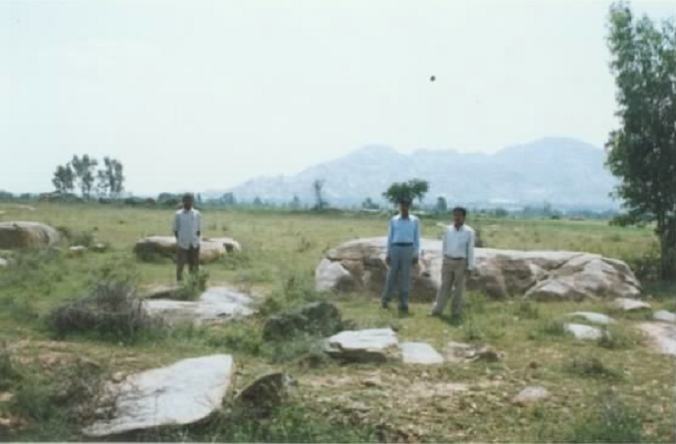
Picture 1 Condition of land that was acquired
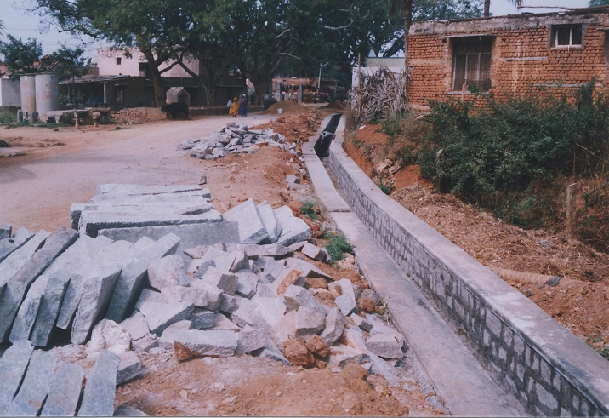
Picture 2 Construction of storm water drain as part of community development works
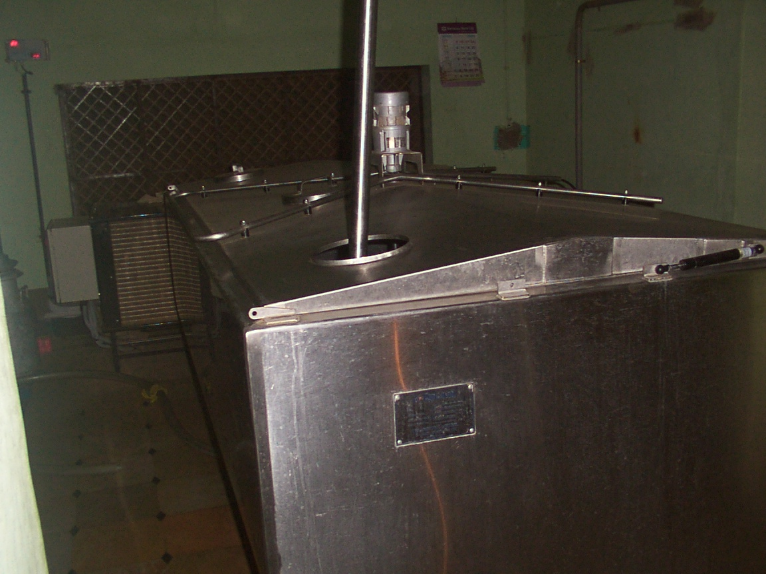
Picture 3 Chilling unit provided under the community development works
Picture 4 Dairying under taken by project-affected households
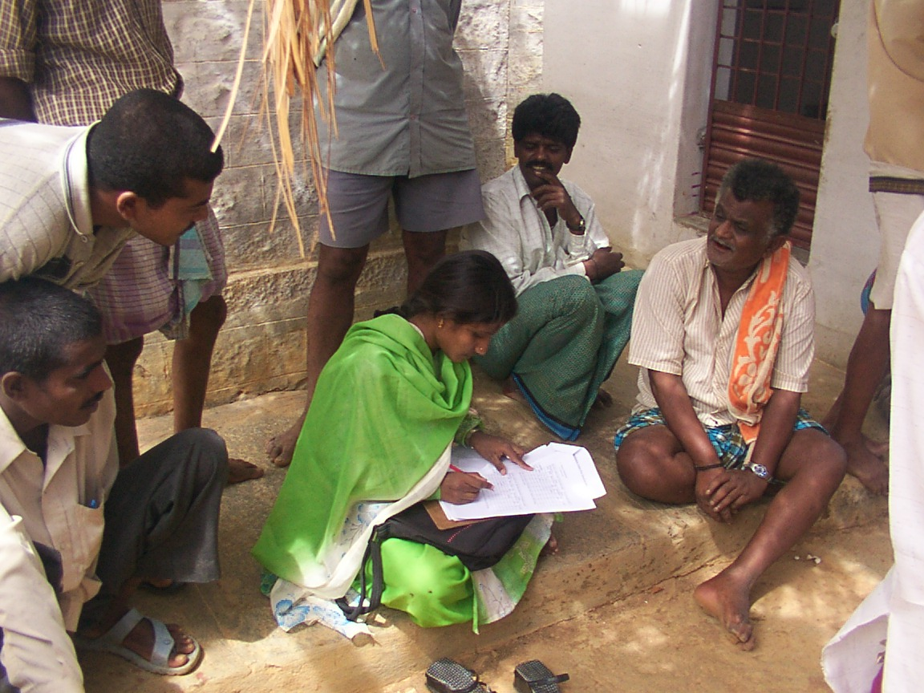
Picture 5 Assessment surveys in progress
Picture 6 Members of women Self Help Groups being interviewed
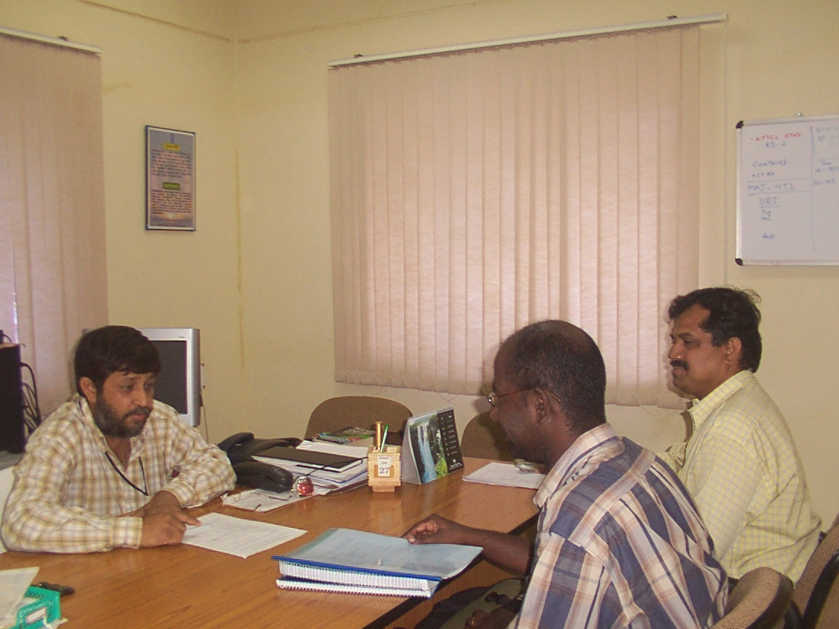
Picture 7 Discussions with POWERGRID officials
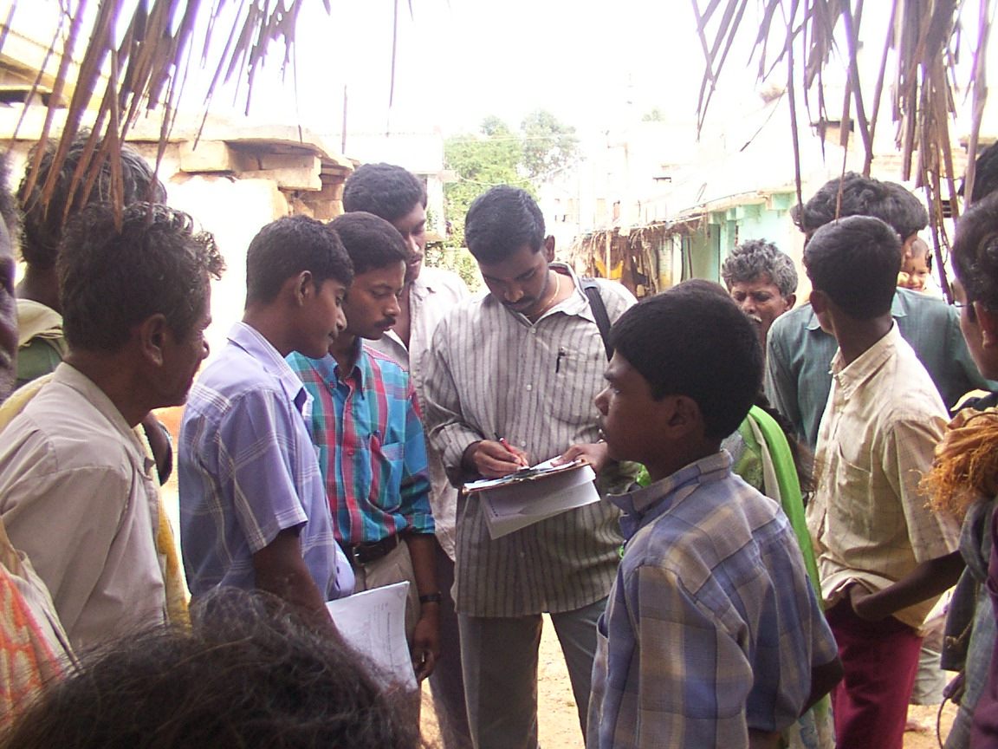
Picture 8 Village youth being interviewed

Environmental and Social Policy & Procedures (ESPP)
The market value of the land is determined usually on the basis of the sale transactions made in the Local Sub-Registrar Office during the period of one year proceeding the date of publication of notification U/s 4(1). If sale transactions are not available in respect of the village in which land is acquired, the sale transactions in respect of the neighbouring villages are taken into account. While fixing the land value, the speculative transactions are ignored. If buildings are acquired, the valuation is usually done by the Public Works Department in the areas. – Land Acquisition Act 1894
Subsequently, dairy has been identified as an IGS by Arahalli members.

