Impact Assessment of Rehabilitation Action Plan:

Measures for Project Affected Families (PAFs)

of Sasaram HVDC Sub-Station Project.

Prof. Rita Ray
Utkal University
Vani Vihar,
Bhubaneswar.

For and on behalf of
POWERGRID CORPORATION OF INDIA LTD.
EASTERN REGION, PATNA

Feb’ 2006

CONTENTS

Page
Abbreviations |  | 3
Executive Summary |  | 04-10
Chapter 1 | Aims and methodology | 11-17
 | Background
 | Goals and objectives
 | Methodology
Chapter 2 | Implementation of the Rehabilitation Action Plan (RAP) | 18-30
 | The Rehabilitation and Resettlement Policy of POWERGRID
 | The Rehabilitation Plan of Sasaram
 | Rehabilitation Action Plan Implementation
Utilisation of Land Compensation and
Rehabilitation Assistance
 | Additional Development Works
Chapter 3 | Overall changes in the living standard of the PAFs | 31-38
 | Assessing the impact of land compensation and rehabilitation assistance
 | Changes in landholding size
 | Changes in occupational pattern
 | Changes in average income and its sources
 | Changes in poverty level
 | Changes in indebtedness
 | Changes in household expenditure
 | Housing facilities
 | Irrigation facilities
 | Sources of drinking water
 | Asset possession
 | Access to civic amenities
 | Access to employment opportunities
 | Overall standard of living
Chapter-4 | Conclusions, lessons learnt and recommend-dations | 39-41
Annexure 1-9 |  | 42-60

Abbreviations

A/C | Account Cheque
Avg | Average
B/B | Back to Back
BDO | Block Development Officer
BPL | Below the Poverty Line
BSEB | Bihar State Electricity Board
CDP | Community Development Programme
DAV school | Dayanidhi Anglo Vedic (school network)
DM | District Magistrate
DWL | Daily Wage Labour
ESPP | Environmental & Social Policy & Procedure
G. T. Road | Grand Trunk Road
GC | General Caste
Govt. | Government
GRC | Grievances Redressal Committee
HVDC | High Voltage Direct Current
IGP | Income Generating Programme
IGS | Income Generating Scheme
KV | Kilo Volt
LAA | Land Acquisition Act
LPC | Land Purchase Committee
Ltd. | Limited
MW | Mega Watt(s)
NGO | Non-Governmental Organisation
OBC | Other Backward Class
PAFs | Project Affected Families
PAFs | Project Affected Persons
PCO | Public Call Office
PDS | Public Distribution System
POWER GRID | POWER GRID Corporation of India Ltd.
PRA | Participatory Rural Appraisal
Pvt. | Private
R & R | Resettlement and Rehabilitation
RA | Rehabilitation Assistance
RAP | Rehabilitation Action Plan
SC | Schedule Caste
STD | Subscriber Trunk Dialling

EXECUTIVE SUMMARY

Background
The Powergrid Corporation of India Ltd. has installed a 1 x 500 MW High Voltage Direct Current (HVDC) B/B substation at Pusauli (near Sasaram) in Bihar to transfer surplus energy from the Eastern to the Northern regions of India. In order to implement the project, the State Government of Bihar has acquired 97.8 acres of land for the construction of Sasaram Sub-Station which has 136 Project Affected Families (PAFs), settled on land belonging to 52 landholders. POWERGRID has paid the land compensation amount as per the LA Act, 1984, and provided rehabilitation assistance (RA) for income generation as per the “Social Entitlement Frame work” of ESPP and as per the Rehabilitation Action Plan (RAP) drawn by POWERGRID on the basis of socio-economic studies.

The main objective of the present study is to assess the standard of living of the PAFs in terms of improvement on, or restoration of their previous livelihoods, earning capacities and production levels.

The impact assessment study includes a sample survey of 75 PAFs (constituting 55% of the total PAFs) and a control sample of 25 families. Their socio-economic status pertaining to occupation, annual income, land ownership, family size, productivity, asset possession and type of house, was obtained from the baseline socio-economic study of 1998 and compared with the primary data collected representing the situation in 2005. As comparative data on electricity, sanitation, separate kitchen, expenditure on food and non-food were not available in the base-line data of 1998, this information was elicited from the respondents on a recall basis. To record this data even on recall basis is important because they constitute measurable indicators of livelihood status.

The study used a variety of means to collect the information, including household surveys, focused group discussions, oral narratives and review of documents available with POWERGRID. Tools of the Participatory Rural Appraisal (PRA) methodology such as trend change (before and after), transact walk, sub-group meetings were used to generate information regarding the benefits received from public utilities and community assets created under the project by POWERGRID.

The demographic and socio-economic status of 1998 and 2005 of the PAFs are then compared with the control group.

Impact of RAP Implementation
- Standard of living
The present study shows that the overall standard of living among the PAFs has been sustained and even somewhat improved.
- Payment of land compensation and rehabilitation assistance
The entire land compensation against the land acquired has been paid by POWERGRID to the District Administration and the District Magistrate (DM) through the Land Acquisition Officer (LAO). The LAO has distributed 80% of the land compensation cash and 100% of the rehabilitation assistance to all the land losers. The distribution of land compensation and the rehabilitation assistance was done very efficiently and without any pilferage as has occasionally happened in other cases. All the PAFs who lost their land in the project have received 80% of their land compensation. The rest (20%) remains undistributed since the PAFs filed a case, which is sub-judice, for enhanced land compensation. Land for a link approach road was also acquired, for which all PAFs have received compensation.
- Utilisation of land compensation and rehabilitation assistance
73% of the PAFs have spent their land compensation on productive purposes such as purchase of land, house construction and business. The rest (27%) have spent their compensation on social needs such as daughter’s marriage and health related issues.
Of the PAFs surveyed, 93% have spent their rehabilitation assistance for productive purposes, mostly either in initiating new income generating activities or strengthening the existing ones. The assessment shows that 63% of the PAFs invested in livestock development, which is their traditional economic activity, while 30% spent their rehabilitation assistance on other activities, including agriculture, hotel business, establishing Public Call Office (P.C.O) booths, medicine stores, blanket weaving business, purchase of land, house construction etc. The people themselves consider these expenditures as ‘productive’ uses. The rest, 7% of the PAFs, spent their rehabilitation assistance to meet their immediate household requirements such as food, medicines etc.
- Mobilisation of additional funds
It was found that 76% of the PAFs have mobilised their additional funds to start income-generating activities and to acquire assets. This, in itself, is an enterprising effort.
- Average amount of additional income
The average additional income accrued from the Income Generating Schemes (IGSs) of POWERGRID comes to Rs. 2,905/- per annum for each PAF. On the other hand, every PAF lost on an average Rs. 2,351/- (taking into account the 2005 prices) through the process of land acquisition by POWERGRID.
- Changes in landholding size
There is a positive change in the land holding size of the PAFs, in that it has increased from an average of 2.2 acres to 2.4 acres. It is due to the fact that 12 PAFs have been allotted 5.2 acres of land, out of which 4 PAFs were landless and the rest 8 PAFs were under the category of uneconomic land holders. It is also found that 0.6% of small farmers were added to the marginal category and 0.6% of large farmers slid down to the medium farmer category. Both indicate a small reduction in the status of the farmers. The average land holding status of the control group is 2 acres.
- Changes in occupational pattern
Cultivation as an occupation has increased from 48% to 51% after RA. Simultaneously, the percentage of non-agricultural wage labour has dropped from about 18% to 13%. It was also found that 40% of the control group are engaged in cultivation. Non-agricultural wage labourers are 28% among the control group. An increase of business activities was noted, from 5% to 9% while the service-holders group has increased from 10% to 15%. Smaller percentages are found in the control group.
- Changes in income level
The study revealed that the average yearly income of the PAFs has increased by about Rs. 9,166/- as compared to the 1998 status (the calculation was made taking into account the rate of inflation). The average income of the PAFs is Rs.46, 509/- whereas the average income of non-PAFs (control group) is Rs.43, 732/-.
- Changes in poverty level
The percentage of Below Poverty Line (BPL) PAFs has marginally decreased from 10% to 9%, whereas about 16% of the control group are in the BPL category. PAFs whose income was less than Rs.11, 000/- in 1998 were taken as BPL whereas in 2005, Rs. 22,400/- was the upper limit to be categorised as a BPL. In spite of the fact that there was an increase in the average income of the PAFs, there is minimal decrease in the number of BPLs because of the major change in the BPL criterion.
Changes in indebtedness
The percentage of indebtedness among the PAFs covered under the survey has decreased from 17% to 13%. This is a positive change reflecting improvement in the economic conditions of the PAFs. In comparison 20% of the control group are indebted mainly due to investment in entrepreneurial activities.
- Changes in household expenditure (food and non-food)
The consumption pattern among the PAFs, i.e. expenditure on food and non-food items, is about the same as before the project and is very similar to the control group.
- Changes in housing facilities
Positive trends are observed in the housing conditions of the PAFs. 61% of the PAFs now live in pucca houses as compared to 49% before the project, whereas 48% from the control group live in pucca houses.
❍ Electricity
More PAF families now have electricity (77% in 2005 as compared to 68% in 1998). 64% from the control group have an electricity connection to their household.
❍ Sanitation
A change has been noticed in sanitation conditions, in that 41% now have sanitation facilities as against 29% earlier. Among the control group, 28% have sanitation facilities. This is a marked improvement.
❍ Separate kitchen
It is found that there is an increasing trend (36% in 2005 as against 23% in 1998) of having a separate kitchen in the houses of the PAFs. 44% from control group have a separate kitchen in their household.

- Changes in irrigation facilities
There is an increase in PAFs with access to irrigation facilities (from 15% to 19%). Among the control group 14% have irrigation facilities.
- Changes in sources of drinking water
At present 37% PAFs have access to tube wells for drinking water while previously they were dependant on natural wells, dug wells, hand pumps and ponds. In the control group, 49% have access to tube wells for drinking water.
- Changes in asset possession
The possession of agricultural assets, (pump sets + 5%, ploughs – 2% and tractors + 1%), has increased among the PAFs. It was also found that non-agricultural assets (TVs, almirahs and two-wheelers) were owned by more PAFs than in the control group.
- Access to civic amenities
The development of civic amenities of roads has provided easy and fast accessibility to health care centres and market places. Access to electricity makes life brighter and easier, and facilitates homework for the children
- Access to employment opportunities
The employment opportunities of PAFs have been enhanced due to increased economic opportunities through housekeeping, maintenance of colonies, orchards etc.

Conclusions and recommendations
The impact assessment study indicates that there has been an enhancement in the living standard of the PAFs. It may be concluded that the initial objective of economic rehabilitation, at least to previous standard and preferably to an improved standard, has been achieved in both respects.

The socio-economic study fails to identify the health needs of the PAFs as there is no health centre within 10 kms of the project site. Thus there is need to set up a health centre in the area.

Allotting land through linkages with the District Magistrate, besides land compensation, is a good move by POWERGRID. There is a need to provide support for land development to the families who have been provided with land.
Chapter 1
AIMS AND METHODOLOGY

1 Background
1.1 Implementation of Sasaram HVDC Back to Back Sub-station at
Pusauli
The POWERGRID Corporation of India Ltd. has installed a 1x500 MW High Voltage Direct Current (HVDC) “B/B” substation at Pusauli (near Sasaram) in Bihar, with an objective to make better use of existing generating capacity by using the link to transfer surplus energy from the Eastern region to meet the demands of the Northern region of India. The State Government has acquired 97.8 acres of land for POWERGRID, out of which 74.8% (73.6 acres) is privately owned and 24.8% (24.2 acres) is Government owned land. As a result of acquisition of private land for the project, 136 families (52 land holders) were affected by way of loss of farm income. Out of the families affected, 4 who earlier were in the uneconomic land holding category (< 1.0 acres of land) became landless due to land acquisition. For the project, no homestead was acquired. The people affected (13 PAFs) as a result of land acquisition for the widening of approach roads had demanded drinking water supply to their villages. Accordingly, provisions were made by POWERGRID.
1.2 The POWERGRID’s R&R Policy
The POWERGRID’s policy on Resettlement and Rehabilitation (R&R) is to provide “people, who are displaced or otherwise affected by the projects, means to improve or at least restore their former living standards, earning capacity and production levels”, through a process in which they participate through their own social and cultural institutions. Therefore, the process of rehabilitation of the project affected persons is participatory with an emphasis on the need to “ensure that development fosters full respect for their dignity, human rights and cultural uniqueness.”
1.3 Impact Assessment
In order to assess the magnitude of the losses, A. N. Sinha Institute had carried out a socio-economic survey in 1998 based on which, POWERGRID has developed a Rehabilitation Action Plan (RAP) for affected persons listing losses and measures to be taken for the restoration of livelihoods. These have been implemented during the project execution. In order to assess the effectiveness of the rehabilitation measures extended to PAFs, POWERGIRD approached the Consultant to undertake an impact assessment study of the RAP implementation. It is pertinent to mention here that the Rehabilitation Action Plan prepared for Sasaram substation consisted of payment of compensation for the loss of land and other properties, provisions for support of Income Generation Schemes (IGS) to restore / support livelihoods and improvement of the quality of life through community development programmes.

2 Goals and Objectives
2.1 The overall goal
The overall goal of the present study is to conduct an impact assessment of Project Affected Families (PAFs) in order to evaluate the extent of restoration of livelihoods.
2.2 Objectives in detail
The objective of this study is to independently assess the impact of the mitigation measures in restoring/improving the living standards of the affected persons in terms of increase in incomes, acquiring assets etc. The study also assesses the extent to which the project has been successful in compensating for the assets lost and in the economic rehabilitation of the project affected families.
(TOR for the study is enclosed in Annexure 1)
2.3 Scope of the study
The impact assessment study required the following as per the Terms of Reference (TOR).

- prepare a detailed methodology including survey instruments for the evaluation study;
- review the overall implementation of the income generation programme and see whether the desired objectives of income restoration have been realised;
- assess the process followed for the implementation of the income generation programme;
- find out the impact of the income generation schemes with respect to improving the living standard and creating productive assets;
- assess the changes in the living standards of affected people in terms of income, land ownership, material assets, debt, housing, demographic characteristics etc. and compare those with a control population;
- assess whether the compensation amounts were sufficient to replace lost assets and identify how the receipts have been used to conclude whether such compensation has been used for productive purposes or not;
- identify lessons learnt and follow-up remedial measures required for realization of the objectives; and
- prepare an impact assessment report describing the results of the above mentioned aspects.

3 Methodology
3.1 Sampling of PAFs for detailed study
In order to obtain qualitative and quantitative information, stratified random sampling was done. Out of 136 PAFs, 124 PAFs were considered for sampling since they had received rehabilitation assistance and the rest 12 PAFs were not eligible for this assistance. First, the PAFs were classified on the basis of different income generation packages received. Out of the stratified PAFs 50% were selected for interview. Thus, the sample size for interview should have been 62 PAFs. However the survey covered 75 PAFs for the Impact Assessment Study. 13 PAFs were added to highlight the condition of vulnerable groups such as widows with un-economic land holdings. The findings of the study were compared with a control group, consisting of about 33% of the size of the main sample, i.e. about 25 persons who are not affected by the project. They were selected on a strictly random basis.

Data on the amount of rehabilitation assistance received by PAFs were obtained from the Socio-economic Survey report and the RAP of Sasaram Sub-station. Detailed information regarding types of income generating activities under RAP as well as activities actually preferred by the PAF’s during implementation, were ascertained directly from them during the primary data collection phase through personal interviews. For detailed information, the types of income generating activities taken up under rehabilitation assistance and opted during RAP implementation (the two may not coincide) as well as changes having occurred, were ascertained directly from the PAFs during the primary data collection phase through personal interviews with them.
3.2 Data collection instruments
The study has used various means to collect the information, including household surveys, focused group discussions, oral narratives and interviews with the officials.
Table No 1.1
Tools of primary data collection and number of participants
Tools of data collection | No. of participants
Household Survey | 75 PAFs and  25 Non-PAFs
Focused Group Discussion | 6 groups  ( Each group 10-12 persons)
Discussion | 4 Sessions with DGM, CM.
Oral Narrative | 13 PAFs

3.3 Parameters used
The following indicators were taken up as basic reference points to locate changes as a result of land acquisition and implementation of RAP.
- land ownership
- occupation
- average annual income and sources
- poverty line
- indebtedness
- expenditure on food and non-food items
- housing facilities
- access to irrigation facilities
- access to basic amenities i.e. drinking water and electricity
- asset possession (agricultural and non-agricultural equipment)

3.4 Types of methodology to obtain data
The household survey was conducted through a pre-tested interview schedule to elicit information on the above parameters to understand the standard of living of PAFs and non-PAFs. The interviews were held in the household of the respondents. Survey schedule is enclosed in Annexure 2 (A&B).

Focused group discussions of 10-12 persons were held to capture the opinion of PAFs and non-PAFs regarding access to basic amenities of drinking water and health care. Focused group discussions were held in different locations of the affected villages. Photographs of focused group discussions are enclosed in Annexure-3.

Discussions were held in public places with leaders and non-PAFs to obtain views of the local people with regard to the benefits of the community development programmes.

During group discussions, the PAFs discussed issues of education, health and basic amenities and demanded a health care centre, reduced fees for the PAFs children in the DAV school, drinking water facilities and free electricity to the villagers. They also discussed the positive impact of street lights for safety at night and for decreasing thefts in the area.

Discussions also took place with the officials of POWERGRID (DGM, Chief Manager/Manager and Supervisor of Sasaram Sub-Station) to know the process and progress of RAP implementation.

Wherever appropriate, secondary data from POWERGRID’s project documents and reports, such as the Socio-Economic Survey and the Rehabilitation Action Plan, 1998, and the progress report on the Rehabilitation Action Plan, 2002 was used. The present household survey concentrated on the changes in economic activities, income and other social conditions of individual households.

The socio-economic study and Rehabilitation Action Plan of Sasaram HVDC B/B Sub-station, 1998, contained baseline information on the above-mentioned indicators, which have been compared with the current situation. Information on some of the parameters, such as access to electricity, sanitation, health care, availability of separate kitchen, and expenditure on food and non-food commodities, before and after land acquisition, was collected on a recall basis due to the absence of any baseline data.

Information regarding the benefits received from public utilities and community assets that were created under the project’s community development program was gathered through Participatory Rural Appraisal (PRA) exercises in the affected villages. The purpose was to assess the accessibility of common resources by affected population and to assess the wider socio-economic changes in the area as a whole. The PRA exercises were also done through focused group discussions and key informant interviews. Perceptions regarding over-all changes due to this POWERGRID project were obtained from the PAF groups and compared with the perceptions of other groups who were not affected by the project.

Chapter 2
IMPLEMENTATION OF THE
REHABILITATION ACTION PLAN

2 Introduction
2.1 The Rehabilitation and Resettlement Policy of POWERGRID
POWERGRID has formulated a social entitlement framework in its corporate policy i.e. Environmental and Social Policy & Procedure (ESPP) 1995, which is applicable to help families affected due to the acquisition of land/assets for the substation. Its prime objective is to help in rehabilitation and resettlement of people affected by land acquisition. In order to avoid hardships to PAFs and their families, ESPP, 1995, provides land for land as far as possible and where not possible, offers assistance for income generating schemes and training instead of providing cash assistance. The social entitlement frame work of ESPP, 95 is given below.

Table 2.1
POWERGRID’S SOCIAL ENTITLEMENT FRAMEWORK*

TYPE OF ISSUE/IMPACT | BENEFICIARY | ENTITLEMENT OPTIONS
1. Loss of land  a. Homestead  (i) with valid title, or customary or usufruct rights | (i) Family | (i) equivalent area of land subject to availability (State Govt./ Voluntary sellers at existing rate) within a radius of 25 km.  or cash compensation + rehabilitation assistance**
b. Agricultural land  (i) with valid title, or customary or usufruct rights  (ii) tenants, sharecroppers, leaseholder, squatters | (i) Titleholders  (ii) Individual | (i) alternative land of equivalent production potential subject to  - agriculture based PAPs (rendered landless by project or left with landholdings that are not economically viable)  - availability (State Govt./Voluntary sellers at existing rate) within a radius of 25 km  - maximum limit is land ceiling limit  or cash payment + rehabilitation assistance**  (ii) local standard for min. economic land holding (if not claimed by owner) or cash paymentand reimbursement for unexpired lease+ rehabilitation assistance
c. Shop/ Institutions  (i) with valid title, or customary or usufruct rights  (ii) tenants, leaseholder | (i) Titleholders  (ii) Unit | (i) cash compensation + rehabilitation assistance**  (ii) reimbursement for unexpired lease, transition allowance equivalent to 1 year average income as finalised by land purchase committee
2. Loss of structure  a. House  (i) with valid title, or customary or usufruct rights  (ii) tenant, leaseholder  (iii) squatters | (I) Family  (ii) Family  (iii) Family | (i) cash compensation + rehabilitation assistance**  (ii) lumpsum payment equivalent to 6 month rent to re-establish residence as finalised by land purchase committee  (iii) Cash compensation for structure+ lumpsum payment equivalent to 6 month income finalised by land purchase committee to re-establish residence + rehabilitation assistance and transition allowance as per category-6.
b. Shop/ Institutions  (i) with valid title, or customary or usufruct rights  (ii) tenants, leaseholder  (iii) squatters | (i) Unit  (ii) Unit  (iii) Unit | (i) cash compensation + rehabilitation assistance**  (ii) transition allowance equivalent to 1 year income as finalised by  land purchase committee  (iii) Cash compensation for structure+ lumpsum payment equivalent to 1 year income as finalised by land purchase committee to re-establish structure + rehabilitation assistance and transition allowance as per category-6.
3. Loss of livelihood/trade / occupation  a. Wage/ Self employment  (i) agriculture/ commercial | (i) Individual | (i) package for starting a income generating enterprise and transition  allowance equivalent to 1 year income as finalised by LPC
4. Loss of access to common resources and facilities  a. Rural common property resources  b. Urban Civic amenities | (i) Household/ Community  (ii) Household/ Community | (i) replacement CPRs/amenities or provisions of functional equivalence  (ii) access to equivalent amenities/services
5. Loss of standing crops/trees  a. With valid title  b. Tenant/lessee | (i) Family  (ii) Family | for either category, only the cultivator will get compensation at market rate for crops and 8 years income for fruit bearing trees
6. Losses during transition of displaced persons/ establishments  a. Shifting/Transport  b. Maintenance  c. Construction | (i) Family/unit  (ii) Family/unit  (iii) Family/unit | (i) provision of transport or equivalent cash  (ii) cash payment to be finalised by the LPC  (iii) cash for transport of materials
7. Losses to Host Communities  a. Amenities/Services | (i) Community | (i) augmentation of resources of host community to sustain pressure of PAPs

* The proposed entitlement framework will be applicable only in the case of land acquisition for substation

** POWERGRID will provide adequate compensation as required under Indian law and will compensate at replacement cost. POWERGRID if required, will complement (i.e. top up) this with rehabilitation assistance and other measures to ensure that PAPs are not made worse off by their operations.
As per the ESPP, a socio-economic study was conducted by A. N. Sinha Institute of Social Studies, Patna, in 1998. Based on its outcome, a Rehabilitation Action Plan for the PAFs of Sasaram substation was prepared and implemented by the POWERGRID. POWERGRID also prepared a progress assessment report of the RAP implementation in 2002 to assess the physical and social achievements of the project.

ESPP, 1995 provides an amount of Rs.15,000/- per PAF (but the amount varies depending upon the type of scheme, land lost, income level etc.) as a grant towards rehabilitation assistance for taking up income generating activities. The amount for each PAF is given as RA depending on the magnitude of land loss, left-over land, family size, caste composition and loss of income determined by the Socio-economic Study.
2.2 RAP of Sasaram for livelihood restoration
Mitigating or reducing development induced adverse impacts on the local population and livelihood /income restoration is a challenging task. Therefore, good strategies are imperative for successful income restoration programmes.
2.2.1 The RAP of Sasaram consists of the following components
1. Land for land - 6 PAFs
2. Rehabilitation assistance through IGS- 124 PAFs

Table 2.2
Details of IGS

Name of IGS | No. of PAFs | Percentage
Agriculture implement shop | 1 | 1.15
Auto type repairing | 1 | 1.15
Blanket weaving | 1 | 1.15
Buffalow | 19 | 28.4
Buffalow-b | 1 | 1.15
Cow Unit | 25 | 28.74
Cow unit-b | 13 | 14.94
Grocery | 3 | 3.45
Poultry | 4 | 4.60
Sheep | 2 | 2.30
STD Booth | 1 | 1.15
Tailoring | 1 | 1.15
Tyre reparing | 1 | 1.15
Dhaba | 1 | 1.15
Goat rearing | 13 | 14.94
Total | 87 | 100.00
3. Rehabilitation assistance through cash-37 PAFs
4. Vocational training- 7PAFs
5. Restoration of common property resources: Development of
3 ponds
6. Drainage and construction of culverts
7. Installation of 2 hand pumps
8. Community development (Other developmental work)
A. Development work by POWERGRID
- Construction of approach road
B. Development work under various State Governmental scheme
- Construction of link road
- Development of middle school
- Construction of community hall

2.2.2 Involvement of PAFs in RAP
The PAFs were involved in the preparation, finalisation and implementation of RAP, for individual and community development work, through village meetings and discussions with key informants. PAFs were consulted for selecting location of drinking water points. During the meeting of the Land Purchase Committee (LPC), PAFs were involved in taking decisions regarding land for land option.

2.3 RAP Implementation
The implementation of RAP was undertaken by POWERGRID with the help of the LPC, which included the representative of PAFs, Grampanchayat, Local Administration as well as POWERGRID officials.

2.3.1 Land for land option
Empirical studies (Monitoring and Evaluation of Orissa Water Resource Consolidated Projects, M.E. Consultancy, Utkal University, 2002) found that cash compensation for land and other assets lost alone did not help ensure income streams and restore living standards of PAFs. Land for land is a better option than cash compensation for restoring income streams. But land was not easily available in the nearby village. As per the provisions of ESPP when the Land Purchase Committee informed the PAFs about the availability of land in the village Auriya (3kms away from Pusauli), the PAFs expressed their unwillingness to purchase the land and opted for cash compensation. 5.23 acres of land were provided to 12 PAFs under the provisions of land for land option.
2.3.2 Rehabilitation Assistance
2.3.2.1 Rehabilitation assistance for IGS
Cash-based income generation schemes in the form of rehabilitation assistance has been implemented for the PAFs of Sasaram substation to take up their opted IGS of buffalo unit, cow unit, poultry unit, grocery shop, goat rearing, sheep rearing, tailoring shop, STD booth and blanket weaving. Out of 124 eligible PAFs, 87 PAFs have received Rehabilitation Assistance (RA) under Income Generation Schemes (IGS). The rehabilitation assistance was distributed by POWERGRID efficiently in the presence of the District Collector of Kaimur. Photographs of IGS of buffalo unit, cow unit, blanket weaving etc. are enclosed in Annexure 4.

2.3.2.2 Rehabilitation assistance through cash
37 PAFs who were eligible for cash compensation were given account
payee cheques as rehabilitation assistance.

2.3.3 Training
Out of 7 PAFs identified for training, 2 PAFs have already undergone training in plumbing and masonry work at the POWERGRID campus. The skills of these PAFs have been developed and they are employed in POWERGRID and other places. The rest 5 PAFs have taken up jobs in cities.

2.3.4 Restoration of common resources
To restore the common resources, three ponds (Mosmat pokhar, Sadhu pokhar, Benia pokhar) were developed by POWERGRID in lieu of the Banabigh Pokhar lost in land acquisition. Out of these, one pond is situated on the premises of the project and the other two ponds were developed in the affected villages for public use. People are of the opinion that POWERGRID has solved the scarcity of water problem for humans as well as the livestock. However the problem of water scarcity for irrigation project has hardly been met. Photographs of renovated ponds are enclosed in Annexure 5.

2.3.5 Drainage and construction of culverts
With regard to drainage of water, a peripheral drain around the project area has been constructed and connected to the main drainage system for safe discharge of water and so does not affect any person or land in the vicinity. A culvert has been constructed on the approach road for natural flow of water. Thus, the project has not affected the area adversely.

2.3.6 Installation of hand pump
Two (2) hand pumps were installed in the middle school and the Panchayat office for providing drinking water. The hand pump in the school is a major help to school children who use it mostly while taking their snacks during recess hours. The school management has taken the responsibility for maintenance of the hand pump. The hand pump installed in the Panchayat office is very useful for families residing close to the office and the panchayat is responsible for maintaining it. The PAFs think that water problem in the area, including in the school and panchayat premises, has been solved.

2.3.7 Community Development Programmes
Under the Community Development Programme, POWERGRID has taken the following community welfare measures.
A. Development work by POWERGRID
Construction of approach roads
i. The construction of approach roads connecting NH with
the project area has been done by District authorities. POWERGRID paid Rs. 91.0 lakhs for construction of this approach road.
B. Development work under various State governmental schemes
The following developmental works in the villages are being implemented by POWERGRID in collaboration with the state government and district authorities.
Construction of link road
i. A link lane from the approach road between Chotki and Barki Pusaulit (500 mtrs) ,
ii. An inter-connecting road from project area to Barki Pusauli (approx. 500 Mtrs) through local administration for the convenience of the villagers.
Development of middle school
i Development of middle school at village Pusauli has been completed.
Construction of community hall
i. A two roomed community building was constructed near the middle school.
ii. A two roomed community building was completed on the south side of the project boundary.

2.4 Process of RAP implementation
The list of PAFs was prepared through a socio-economic survey of titleholders who have received cash compensation against their land and their dependants. On 25th October, 2002, the District Magistrate of Kaimur district distributed the rehabilitation assistance amount through A/C payee cheques on the condition that the PAFs would utilise the assistance for the opted IGS within three months. All the PAFs have submitted their utilisation certificate and verifications have been conducted by the District Magistrate through the Block Development Officer (BDO). The report shows a satisfactory utilization of RA and has been submitted to the district authorities.

2.5 Payment of land compensation
The land compensation has been paid by POWERGRID to the District administration. With regard to the payment of land compensation, all the PAFs (136) who lost their land have received 80% of their compensation in 1998. The rest 20% remains undistributed due to a court case filed by the PAFs to enhance the land compensation. As the litigation is under sub-judice, court order is awaited for action.

Section-IV and VI notification for land acquisition (Land Acquisition Act, 1984) was issued in November, 1997and the State Government of Bihar handed over the land to POWERGRID in October 1998. The whole process of land acquisition took about one year. (Time line for land acquisition and rehabilitation is found in Annexure 6)

Utilisation of land compensation
The utilisation of land compensation by the PAFs is reflected in Table 2.3. It shows that 73% of the PAFs spent their compensation in a productive way and the remaining 27% spent it on basic needs. 43% of the PAFs, spent the compensation amount on construction of houses.
Table 2.3 Utilisation of Land Compensation
Use patterns
1. Productive purposes | Frequency | Percentage
Livestock development | 3 | 4
Cultivation | 2 | 3
Bank deposit | 5 | 7
Hotel | 2 | 3
House construction | 32 | 43
Purchase of land | 7 | 9
Poultry firm | 2 | 2
Tractor | 1 | 1
Blanket weaving | 1 | 1
Sub-total | 55 | 73
2. Un-productive | Frequency | Percentage
Daughter’s marriage | 11 | 15
Health | 8 | 11
Loan repayment | 1 | 1
Sub-total | 20 | 27
Total | 75 | 100

2.6 Support in economic rehabilitation
For economic rehabilitation, an amount of Rs.10, 53,140/- was disbursed to 124 PAFs in the form of A/C payee cheque to take up various income generating activities identified in the socio-economic study. The amount was paid by POWERGRID in the presence of the District Magistrate and other State Government Officials. As the PAFs wanted cash payment, they were annoyed with payment through cheques. Moreover, the officials also faced the problem of changing options as regarding IGP preference during the distribution of RA. Petty contracts were also awarded to eligible PAFs in civil works of road construction/development, construction of foot paths, ground levelling, grass cutting, lawn development, horticulture plantation, house keeping etc. within the project premises.
2.7 Utilisation of rehabilitation assistance
This section discusses the utilisation of rehabilitation assistance, i.e. assistance given in cash or kind over and above land compensation. The following Table (2.4) shows that 93% of the PAFs have spent their rehabilitation assistance productively, mostly on income generating activities. 63% of the PAFs invested in livestock development which has been their traditional practice. The remaining, 30% out of 93% spent their rehabilitation assistance on agriculture, establishing a hotel, P.C.O booth, medicine store, weaving blankets, purchase of land and house construction. The rest (7%) spent the money on basic needs, such as health care and household expenses.

Table 2.4 Rehabilitation assistance utilisation
Use Patterns | Frequency | Percentage
Productive
Agriculture | 3 | 4
Buffalo | 30 | 40
Cow | 14 | 19
Sheep | 3 | 4
Business of cloth | 1 | 1
Sewing cloth | 2 | 3
Hotel | 3 | 4
P.C.O booth | 2 | 3
Medicine store | 1 | 1
Poultry firm | 1 | 1
Weaving blanket | 1 | 1
Pump set | 2 | 3
Music system | 01 | 1
Purchase of land | 01 | 1
House construction | 05 | 7
Sub-total | 70 | 93
Basic needs | Frequency | Percentage
Medicine | 02 | 3
Household expenses | 03 | 4
Sub-total | 05 | 7
Total | 75 | 100

2.8 Owning of assets
As shown in the following Table (2.5) 63% of the PAFs have acquired livestock assets of buffaloes, cows and sheep through which they accrue income and supplement their daily nutrition.

Table 2.5
Owning of assets
Type | Frequency | Percentage
Buffalo | 30 | 40
Cow | 14 | 19
Sheep | 3 | 4
Hotel | 3 | 4
P.C.O booth | 2 | 3
Medicine store | 1 | 1
Poultry firm | 1 | 1
Pump Set | 2 | 3
Music system | 01 | 1
No assets | 18 | 24
Sub-total | 75 | 100

Table 2.6
Mobilisation of additional amount

Amount (In Rs.) | Frequency | Percentage
500 – 2500 | 1 | 1
2501- 5000 | 21 | 28
5001 – 7500 | 19 | 25
7501 – 10000 | 13 | 18
> 10000 | 3 | 4
Not Applicable | 18 | 24
Sub-total | 75 | 100

Average amount of mobilisation of additional amount for IGP= Rs. 2,775/-
Average amount of additional income = Rs. 2,905/- per annum.

It was found that 76% PAFs (Table 2.4) have mobilised additional amounts apart from the RA amount to start income generating activities and for creating assets. The average additional income from the IGS activities comes to Rs. 2,905/- per annum for each PAF.

2.9 Additional development works
The following additional development works were implemented by POWERGRID for the welfare of villagers of the locality.
2.9.1 Education: Provided land and cost of construction for a DAV school, which is 1 km from the project site. Approximately, 200 children of directly or indirectly affected persons are studying in the DAV school.
2.9.2 Street lights: Erected lamp posts on the approach road from G.T. road through the village Pusauli to the project site and on the link road from the project site through village Pusauli to the railway station. As a result, theft in the area has been reduced and people are much safer.
2.9.3 Electricity: Villages Pusauli, Karigaon, Bhopatpur and Ghatayan were provided with uninterrupted electricity supply by BSEB through POWERGRID 132/11 KV sub-station, 1 MVA, 33/11 KV transformer through the district administration. To supply electricity, another 3MVA transformer (33/11 KV) has been commissioned in July 2003 in HVDC POWERGRID premises in co-ordination with BSEB. This has helped 5 PAFs to run their rice mills.
2.9.4 Water supply: The water supply for agriculture and drinking water is under construction. The boring of tube wells has been completed and the laying of pipelines is in progress, which should meet the water needs of approximately 5,000 people of the surrounding villages of Pusauli, Karigaon, Ghatain, Bhelma and Ghataon. People of the area feel that their demand has been considered by POWERGRID and the availability of safe drinking water has led to better health care.
2.9.5 Ecological development: For ecological development, more than 6000 plants of various types, including fruit bearing types and other species have been planted along the approach road and in the project premises.

Chapter 3

OVERALL CHANGES IN LIVING STANDARD OF THE PAFs

3.1 Introduction
3.1.1 Assessing the impact of land compensation and rehabilitation
assistance
The main objective of the study was to assess the impact of implementation of land compensation package and rehabilitation assistance, on the socio-economic status of the PAFs. The study was designed to capture the changes in the key indicators of livelihoods -- occupation, landholding, income, poverty, consumption pattern, residential facilities and livestock possession -- of the PAFs. The indices of 2005 are compared with the base line data of the 1998 situation. The income and expenditure amount of PAFs in 1998 have been computed at the rate of 4% inflation to compare with the PAFs situation in 2005. The status of the control group was assessed from their present position in 2005.

The study covered 75 PAFs who have received rehabilitation assistance. In the control group, 25 persons who were not affected by the project were interviewed.

It should be noted that all figures and data come from the informants themselves. Thus, they are subjective judgements and not objective measurements, and may be flawed, perhaps for reasons of self-interest.

3.2 Changes in landholding size
The size of the average land holding has increased from 2.2 acres to 2.4 acres when to compared to the 1998 data, whereas the control group remains at 2 acres. This means there has been a positive change in the land holding status of the PAFs. The use of land compensation and rehabilitation assistance cash for IGS has been spent in a productive way and 12 PAFs who were rendered landless due to acquisition of their land and those who possessed uneconomic land holdings were given 5.23 acres of land.

3.3 Changes in occupational pattern
The occupational pattern reveals that about 48 percent were engaged in cultivation in 1998, while this proportion has increased to 51% in 2005 as against 40% in the control group. Earlier, 18% were engaged in wage labour, whereas at present the percentage has fallen to 13%. There is an increase from 5% to 9% in the number of affected people in business. This is higher than in the control group (4% in business). A change has been found in the service category from 10% to 15% more as service-holders, and this percentage of PAFs is higher than that of the control group. It may be concluded that people are increasingly engaged in productive activities. This is one of the intended outcomes of the project.

3.4 Changes in average income and its sources
The average income of PAFs has increased from Rs. 37, 343/- in 2005 price (Rs. 28,378/- in 1998) to Rs. 46,509/-, which is higher than the control group. The average income of the control group is Rs.43,732/-. The increase in household income is mainly due to the efforts of the PAFs to avail of a variety of employment opportunities and the use of electric pump sets for irrigation.

The informants knew that the POWERGRID’S project was coming up. Hence, the earnings in 1998 among the PAF group might be somewhat depreciated in order to attain better provisions from the project. The average income of non-PAFs (control group) is Rs. 43,732/-.
3.5 Changes in poverty level
The socio-economic data of 1998 shows that 10% of the PAFs were below the poverty line (BPL). The impact assessment study 2005 shows that 9% of the PAFs were below the poverty line, as compared to 16% in the control group. This analysis is based on BPL income level of Rs. 11,000/- for assessing the 1998 status, and BPL income level of Rs. 22,400/- (revised BPL criterion) for assessing the situation in 2005. The control group has 16% population in the BPL category.

3.6 Changes in indebtedness
The percentage of indebtedness among the PAFs has decreased from 17% to 13% over the years (from 1998 to 2005). This shows a change in the economic condition of the PAFs. There is 20% indebtedness among the control group.

3.7 Changes in household expenditure (food and non-food)
The household expenditure on food items of the PAFs in 1998 was Rs.21,322/- (67.5% of the total expenditure) whereas it is Rs. 25,838/- in 2005 (66.7% of the total expenditure). Rs.10,220/- (32.5% of the total expenses) were spent on non-food items in 1998 where as it is Rs.12,886/- in 2005 (33.5% of the total expenses).

Thus, a minor change is found in the consumption patterns of the PAFs as there is a 1% increase in non-food expenses as compared to food expenses. The situation is almost the same within the control group.

3.8 Housing facilities
Changes in housing facilities of the PAFs show that they are far better off now as compared to their situation in 1998. In 2005, 61% of the PAFs lived in permanent pucca houses, as compared to only 30% in 1998. The data also show that in the control group 48% non-PAFs possessed pucca houses. Provisions of sanitation are more for PAFs than for control group due to the enhancement in their income.
- Electricity
There are better electric connections and use of electricity increased from 68% to 77% for PAFs. POWERGRID has taken steps to provide a transmission machine for 24 hours electric supply by the Bihar State Electricity Board. Previously, the area faced the problem of low voltage and irregular power supply. 64% of the control group have electricity connection to their houses.
- Sanitation
29% PAFs had sanitary facilities in 1998 where as the percentage has increased to 41% in 2005. The control group has 28% sanitation facilities.
- Separate kitchen
The provisions of separate kitchen in PAF households have increased from 23% to 36% between the years of 1998 and 2005. 44% from control group have separate kitchen in their households.
3.9 Irrigation facilities
There is an increase of irrigation facilities (from 15% to 19%) among the PAFs. In the control group 14% have irrigation facilities.

3.10 Sources of drinking water
At present, 37% PAFs have access to tube wells for drinking water. Previously they were dependant on natural and dug wells, hand pumps and ponds. In the control group 49% have access to tube wells for drinking water.
3.11 Asset possession
With regard to agricultural asset possession (pump sets, ploughs and tractors), 16% PAFs possessed pump sets in 2005 whereas 11% in 2005. The number is almost same with the control group. There is a marginal increase (0.7%) in the possession of tractors among PAFs compared to the 1998 situation. A downward trend is seen as regards possessing ploughs (from 87% to 85.3%) among PAFs between 1998 and 2005 where as the control group has 16% of the population using ploughs. It is also found that the non-agricultural assets (TVs, almirahs and two wheelers) of the PAFs are more than in the control group.

3.12 Access to civic amenities created under the project

All the project affected villages in the local area now have motor-roads and street-lights, which has improved transport and communication facilities considerably. The development of these facilities not only makes travel easy, but also increases the frequency of travel and provides easy and fast accessibility to the market and health centres. Photographs of roads (in 1998 and 2005) are enclosed in Annexure 7.
PAFs have access to modern educational facilities of a DAV school (Dayanidhi Anglo Vedic school), which was established by the initiative of POWERGRID on the project site. However, the school is mostly used by the children of the higher income groups of the village. Photographs of the DAV school are enclosed in Annexure 8.
The villagers expressed their interest for the establishment of a health centre.

3.13 Access to employment opportunities
The employment opportunities of PAFs has increased after engaging in different activities of the project like foot path construction, road construction, playground development through contractors/project etc. Also house keeping works, maintenance of orchards and colonies etc. are being done by the PAFs and the local villagers.

3.14 Overall standard of living
The data collected from the sample PAFs indicate that the overall living standard of the families has improved. The following changes are noteworthy, indicating a positive development (See Table 3.1).
a) There is an increase in land holding size and 12 PAFs have been provided with 50-60 decimals of land each who previously were landless
b) There has been an increase in annual income
c) There is small, statistically probably insignificant, decrease in poverty levels. Taken along with other positive changes, this may indicate a positive trend that needs to be followed up
d) There is an improvement in the quality of houses, electricity facilities and provision of sanitation and separate kitchen in the houses
e) There is easy and fast accessibility to health care centres and market places
Over all, the data indicates an improvement in the living standards and quality of life of the PAFs. Further research, for instance, of migratory patterns, the PAFs’ perceptions of their situation etc., is needed. However an improvement in the quality of life is undeniable.

Table 3.1
Changes in standard of living
Sl. No. | Indicator | Base Line Survey (1998) | Impact Assessment Study (2005) of PAFs | Non-PAFs  (2005)
 | Land Holding Size (In acre)
1. | Avg. land holding size | 2.2 | 2.4 | 2.0
2. | Avg. irrigated land |  | 2.6 | 2.37
3. | Avg. un-irrigated land |  | 2.4 | 1.75
 | Occupational Pattern
4. | % engaged in cultivation | 47.7 | 51 | 40
5. | % wage labour | 18.4 | 13 | 28
6. | % of agriculture wage labour | 12.5 | 7 | 08
7. | % engaged in business | 5.2 | 9 | 04
8. | % engaged in service | 9.6 | 15 | 12
9. | % artisans | 6.6 | 5 | 08
 | Income Level
10. | Average annual family income | 37,343 | 46,509 | 43,732
 | Poverty Level
11. | % of families living below poverty line | 10.3 | 9.3% | 16%
 | Indebtedness
12. | % of indebtedness | 16.9 % | 13.3 % | 20 %
 | Household Expenditure
13. | Average expenses on food | 21,322 | 25,838.60 | 31,824
14. | % of food expenses | 67.5 | 66.7 | 68.3
15. | Average expenses on non-food | 10,220 | 12,867 | 14,716
16. | % of non-food expenses | 32.5 | 33.3 | 31.7
 | Housing Facilities
17. | % PAFs with kucha houses | 33.1 | 38.7 | 52
18. | % PAFs with pucca houses | 49 | 61.4 | 48
 | Basic Amenities
19. | % of PAFs with electricity | 68 | 77.3 | 64
20. | % of PAFs with sanitation | 29.3 | 41.3 | 28
20 | % of PAFs with separate kitchen | 22.7 | 36 | 44
 | Livestock Position (Average per PAF)
21 | Buffalo | .4 | .5 | .6
22 | Cow | .35 | .32 | .52
23 | Goat | .37 | .4 | .04
24 | Sheep | 1.9 | 1.0 | 0
25 | Major Crops | Rice & Wheat | Rice & wheat | Rice & Wheat
26 | Avg. yield per acre (Rice)  Irrigated/Un-irrigated |  | 12 qntl. per acre  9 qntl per acre
27. | Avg. amount mobilized by PAFs |  | Rs. 2,775.00
28. | Avg. amount of additional income from IGP |  | Rs.2,905.00
29. | Avg. amount of loss | Rs.1,787.00

Note: The details of changes in the standard of living of the PAFs are enclosed in Annexure 9.
Chapter 4

CONCLUSIONS, LESSONS LEARNT AND RECOMMENDATIONS

Conclusions
On the basis of the impact assessment study we arrived at the following conclusions as regards the implementation of rehabilitation assistance of IGP and community development programmes.

4.1 The average landholding size per PAF has increased from 2.2 acres to 2.4 acres of land. The uneconomic landholders among the PAFs who were rendered landless, were allotted 50-60 decimals of land by the district administration.

4.2 There has been a change in the occupational pattern for the PAFs. Earlier, 48% were engaged in cultivation in 1998 whereas the percentage now is 51%. 9% are in business in 2005 while in 1998, it was 5%.

4.3 The average annual income of PAFs has increased (compared to the 1998 status)

4.4 The percentage of the BPL category of PAFs has decreased from 10% to 9%.

4.5 The expenditure on food and non-food items indicate that there has been a very slight decrease in expenditure on food items and an increase in non-food items when compared to the 1998 situation.

4.6 There is a major change in the quality of housing of the PAFs as compared to their situation in 1998. Now, 61% of the PAFs possess pucca houses whereas 30% possessed pucca houses before.

4.7 The housing facilities (sanitation, electricity, separate kitchen etc.) among the PAFs have improved considerably, and they now have much better infrastructure than the control group.

4.8 There is an increase in irrigation facilities (from 15% to 19%) among the PAFs. Among the control group, 14% have irrigation facilities.
4.9 At present 37% PAFs avail of tube wells for drinking water while previously they were dependant on wells, hand pumps and ponds. In the control group 49% have access to tube wells.
4.10 Agricultural assets possession (pump sets, ploughs and tractors) have increased among the PAFs. It was also found that the non-agricultural assets possession (TVs, almirah and two wheelers) is more among the PAFs than the control group.

4.11 No significant change was found in the possession of livestock because of the low survival rate due to lack of veterinary services and livestock food although 63% PAFs purchased livestock under income generation programmes.

4.12 The impact assessment study indicates that there is an enhancement in the living standards of the PAFs. It may be concluded that the initial objective of economic rehabilitation has been achieved.

Lessons learnt
4.13 Intensive institutional monitoring and supervision enables successful income generation programme.
4.14 The procedure adopted for handing over the rehabilitation assistance amount through A/C payee cheque is a transparent system.
4.15 Accepting the choices of the people for income generation programmes, helps in enhancing the efficacy of IGS programs.
4.16 A detailed benchmark survey with a computerised database of various indicators would be essential for post-project evaluation.
4.17 When cash compensation is monitored, like in case of the RA package, spending on productive assets has been more than on the unproductive assets.
4.18 A good linkage between the district administration and the corporate sector is vital for availing land for landless families and to implement other development schemes.

Recommendations
4.19 The socio-economic study fails to identify the health needs of the PAFs as there is no health centre within 10 kms of the project site. Thus, there is need to set up a health centre in the area.

4.20 Allotting land besides land compensation for the landless is a good move by POWERGRID. There is a need to provide support for land development to the families who have been allotted land.

Annexure-1

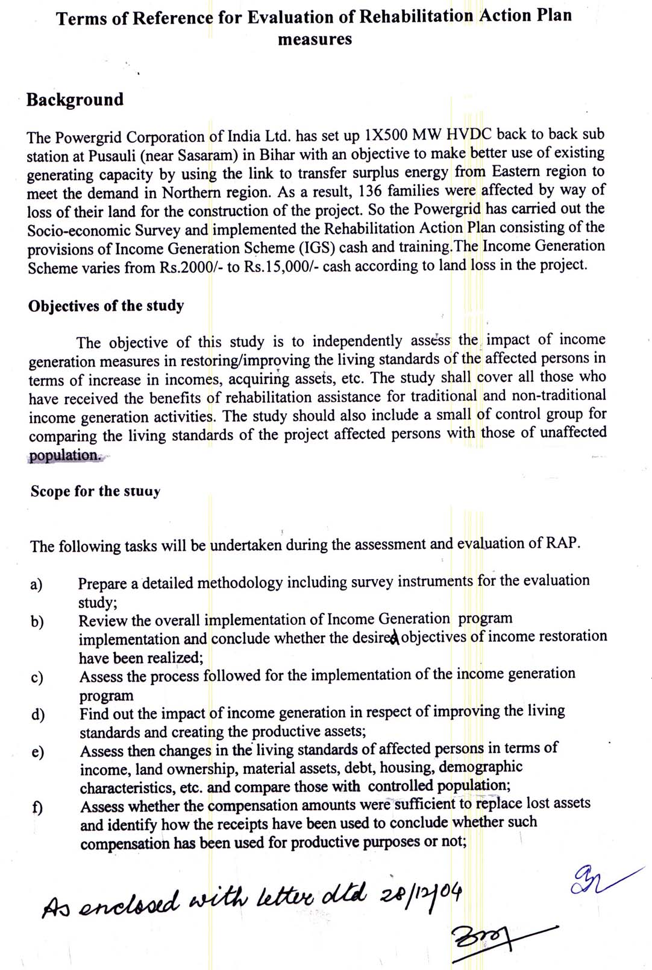

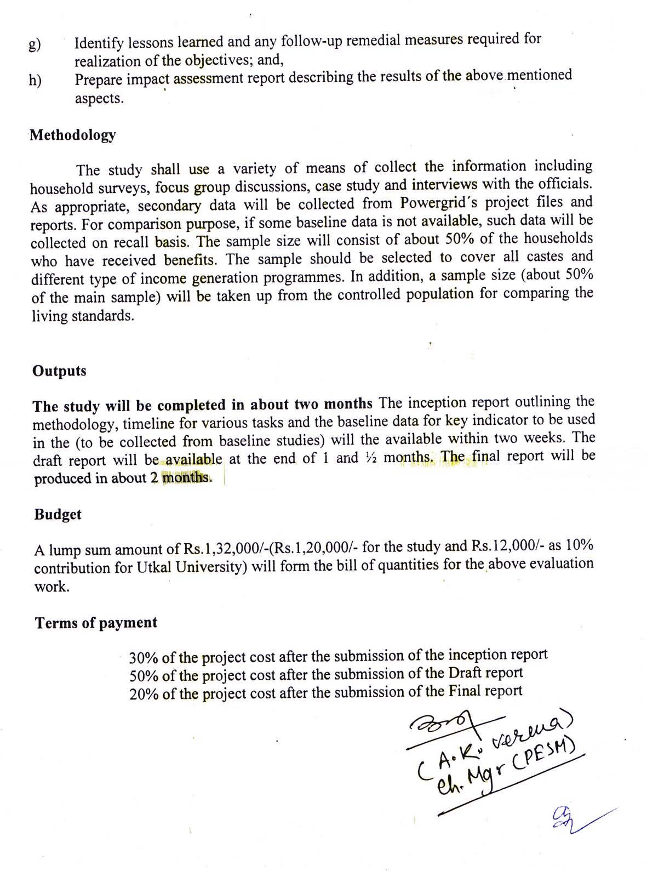

Annexure 2(A)

Interview Schedule for Project Affected Persons (PAFs)
Sasaram HVDC Sub-Station, Bihar.

Identification |  |  | Distance from Sub-station
1.1. Name of the village
1.2. Name of the Block
1.3. Name of the Tehsil
1.4. Name of the District
2.1 Name of the Head of the HH
2.1.1 Age: 2.1.2 Sex: 2.1.3 Marital Status:

2.2 No. of family members | 2.2.1 No. of males 2.2.2 No. of females
2.3 No. of earners | 2.3.1 No. of males- 2.3.2 No. of females:
2.4 No. of widows/separated
3.1 Ethnic Composition | 01.S.C. | 02. S.T |  | 03. OBC | 04.G.C.
3.1.1Caste/Tribe Name:
3.2. Occupation
3.3 Family type | 01. Joint 02. Nuclear
4. Compensation received

4.1 Have you received the entire legal compensation amount for the land loss?
Yes/No. If no, give reasons-

4.2. What was the single most item on which you spent the compensation ?

4.3. Was the compensation sufficient for replacing the lost assets? Yes /No.
If no, give reasons-

5. Rehabilitation Assistance (RA)

5.1 How much money have you received as RA?

5.2 The type of IGS you have you opted for?

6. How was the decision taken for the IGS option? Explain the process.

7. Who all are involved in this enterprise?

Family members: Males Females

Non Family members: Males Females

8. Additional Income from IGP Rehabilitation Package of POWERGRID

Name of IGS * | No./  Area | Total  Investment | From  POWERGRID | Other  Source | Additional  Income | Remark

* a. Traditional: i) Handloom weaving ii) Buffalo unit iii) Cow Unit
iv) Sheep rearing v) Goat rearing unit
b. Small Scale Industry: i) Motor winding shop, ii) Auto tyre repair shop,

c. Commercial: i) Agriculture implement shop ii) Tailoring iii) Fish selling/ Vegetable/ Fruit shop iv) Grocery shop.

d. Non-traditional: Poultry

Household Asset Possession under Income Generation Scheme
Particulars | No./ area | Total  Investment | Income from  IGS | Other  Source
a. T.V.
b. Almirah
c. Utensils
d. Two wheeler
d. Any other

10. What are you doing with the assets created under rehabilitation
assistance?
Sold it Using it Any other

11. Land ownership, Irrigation, Major Crops and Yield

Particulars | Current position
1. Land owned( in acres) | Total : Irrigated: Unirrigated:
2. Major Crops grown
5. Total yield
( Yield per acre- )

12. Total Income:

13. Asset Possession

Asset Possession | Current
1. Agriculture
1.1 Pumpset
1.2 Tractor
1.3 Bullock Cart
1.4 Any other
2.Non-agriculture
2.1 T.V.
2.2 Two wheeler
2.3 Almirah
2.4 Any other
3. Major Livestock (Bullock, Cows, goats etc.)

14. House Type and Sources of Water
Particulars | Current
i. Type of house
ii. Source of drinking water
iii. Source of irrigation

Indebtedness:

Indebtedness | Current
i. Amount
ii. Purpose

16. Other basic amenities

Basic amenities | Before | After
i. Electricity ( Yes/ No)
ii. Sanitation (Yes/No)
iii. Separate kitchen (Yes/No)
iv. Health care

17. Annual expenditure pattern of household

Items | Amount ( In rupees)
 | Before | After
1. Food
ii. Clothing, education etc.

What are the other benefits provided by POWERGRID for receiving the rehabilitation assistance for IGP?

What difficulties did you face for availing the IGP?

What benefits do you desire from community development works such as, road construction, pond renovation, electricity and school etc?
Annexure 2(B)

Interview Schedule for Non-PAFs
Identification |  |  | Distance from Sub-station
1.1. Name of the village
1.2. Name of the Block
1.3. Name of the Tahasil
1.4. Name of the district
2.1 Name of the Head of the HH
2.1.2 Age: 2.1.3 Gender: 2.1.4 Marital Status:

2.2 No. of family members | 2.2.1 No. of males 2.2.2 No. of females
2.3 No. of wage earners
2.4 No. of widows/separated
3.1 Ethnic Composition | 01.S.C. | 02. S.T |  | 03. OBC | 04.G.C.
3.1.1Caste/Tribe Name:
3.2. Occupation
3.3 Family type | 01. Joint 02. Nuclear

Land ownership, Irrigation, Major Crops and Yield.

Particulars | Current position
1. Land owned( In acres) | Total: Irrigated: Non-irrigated:
2. Major crops grown
5. Total yield
( Yield per acre- )

5. Total Income:
6. Asset Possession

Asset Possession | Current
1. Agriculture
1.1 Pumpset
1.2 Tractor
1.3 Bullock cart
1.4 Any other
2.Non-agriculture
2.1 T.V.
2.2 Two wheeler
2.3 Almirah
2.4 Any other
3. Major Livestock
( Bullock, Cows, goats etc.)

7. House Type and Sources of Water

Particulars | Current
i. Type of house
ii. Source of drinking water
iii. Source of Irrigation

8.Indebtedness

Indebtedness | Current
i. Amount
ii. Purpose

9. Other Basic Amenities

Basic amenities | Current
i. Electricity ( Yes/ No)
ii. Sanitation (Yes/No)
iii. Separate kitchen (Yes/No)
iv. Health care

10. Annual Expenditure Pattern of Household

Items | Current (Amt. in Rs.)
1. Food
ii. Clothing, Education etc.

11. What other benefits do you desire from community development works such as road construction, pond renovation, electricity and school etc.?

Annexure 3

Photographs of focused group discussions

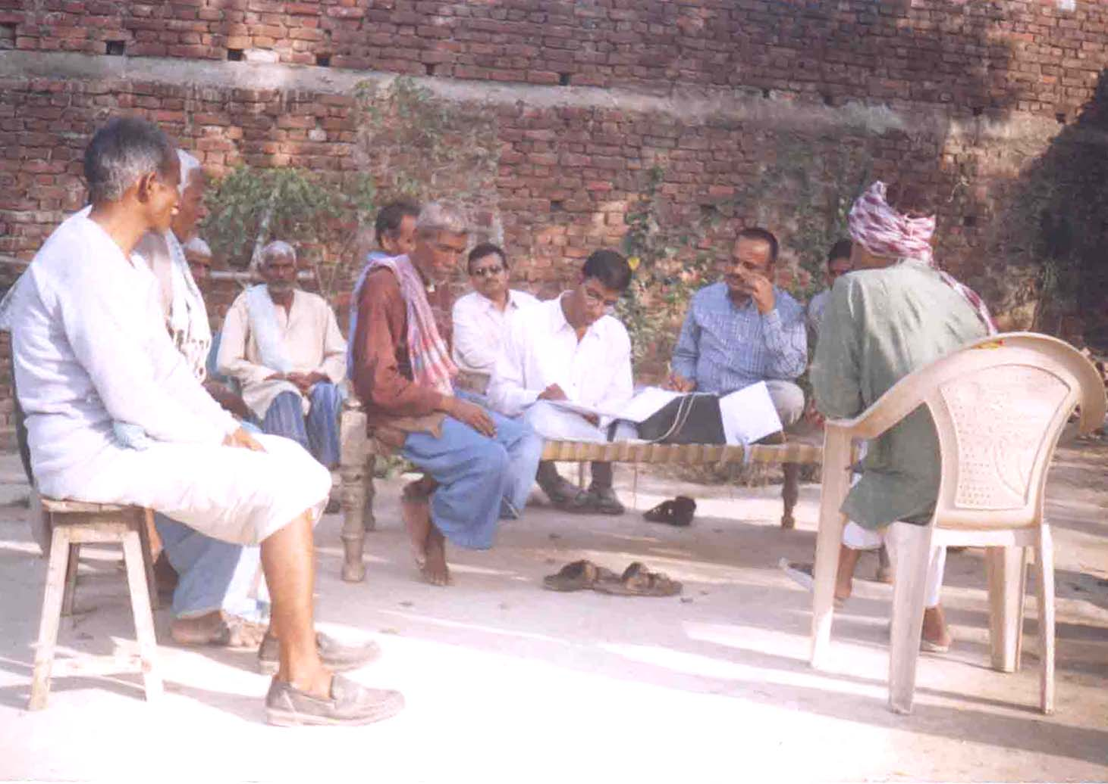

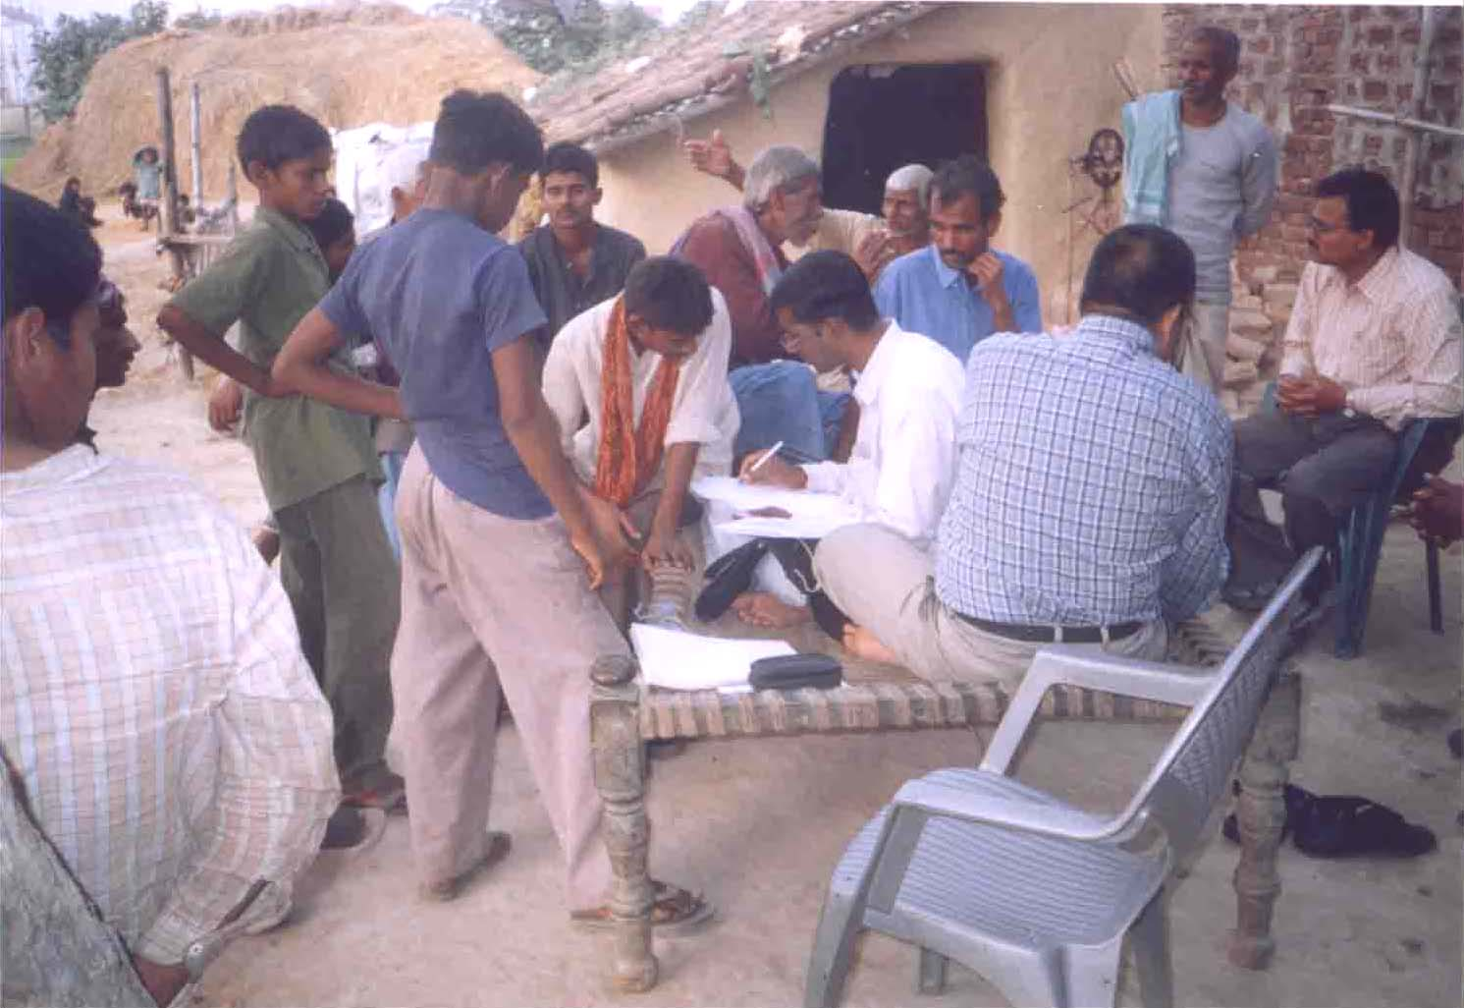
Annexure 4
Photographs of IGS
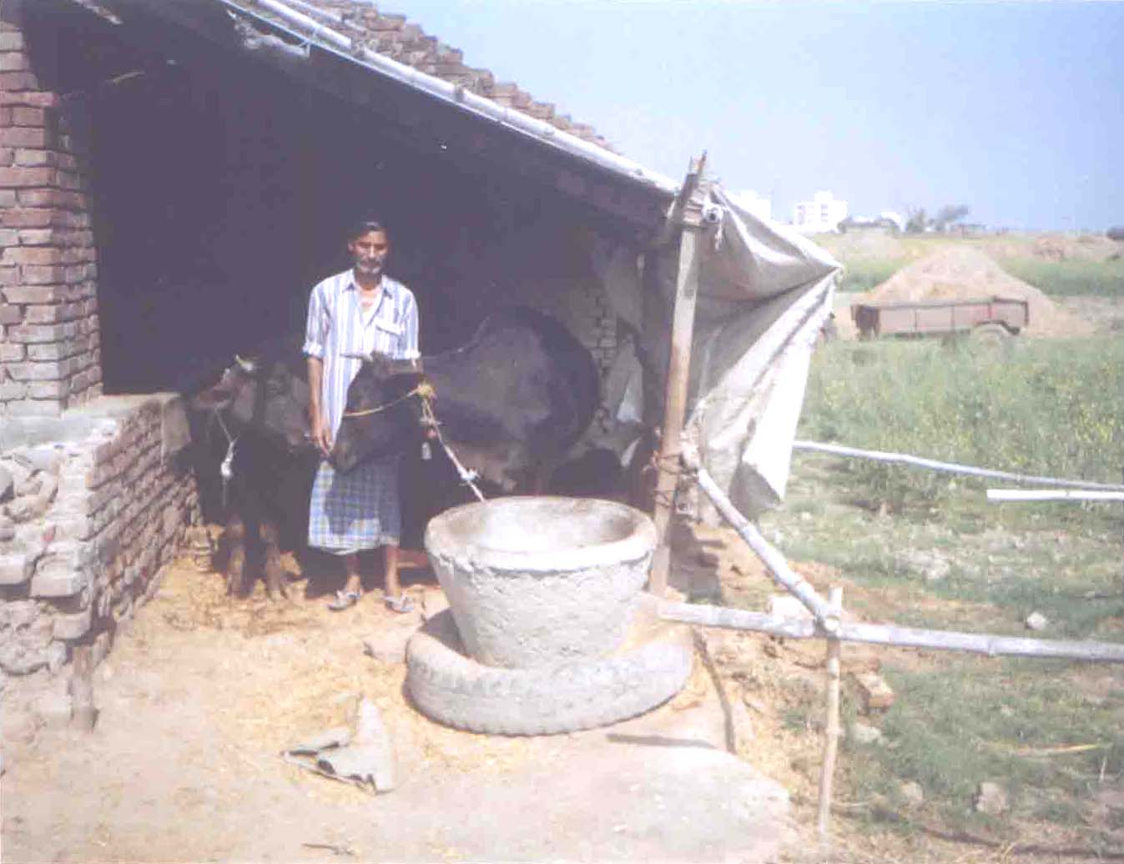
Buffalo Unit

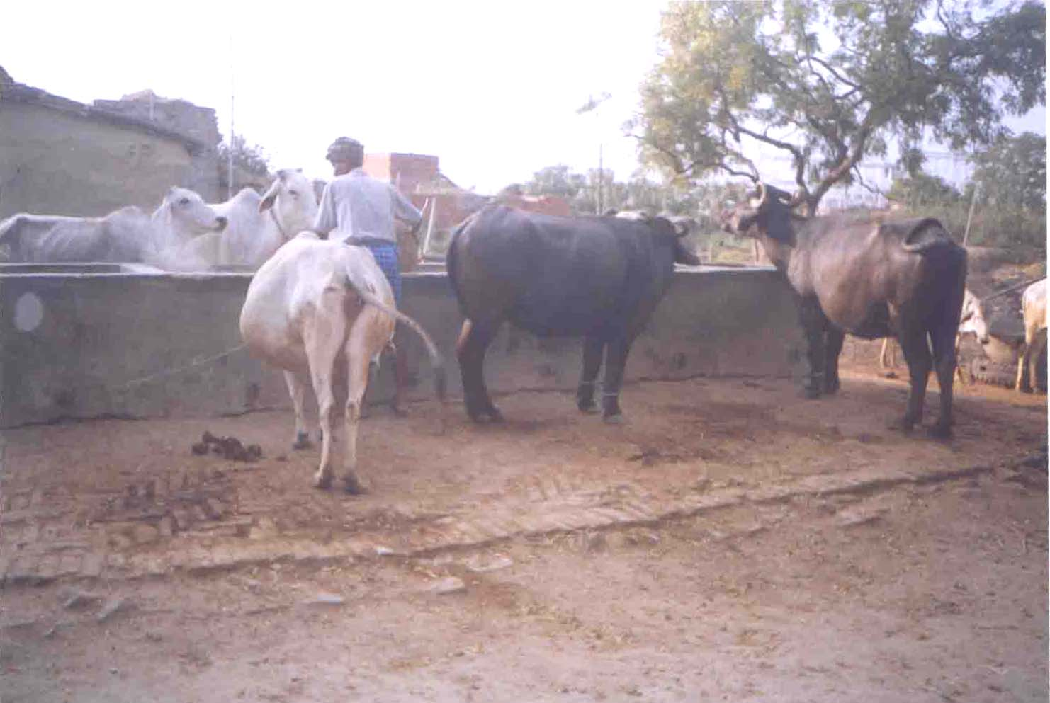
Cow Unit

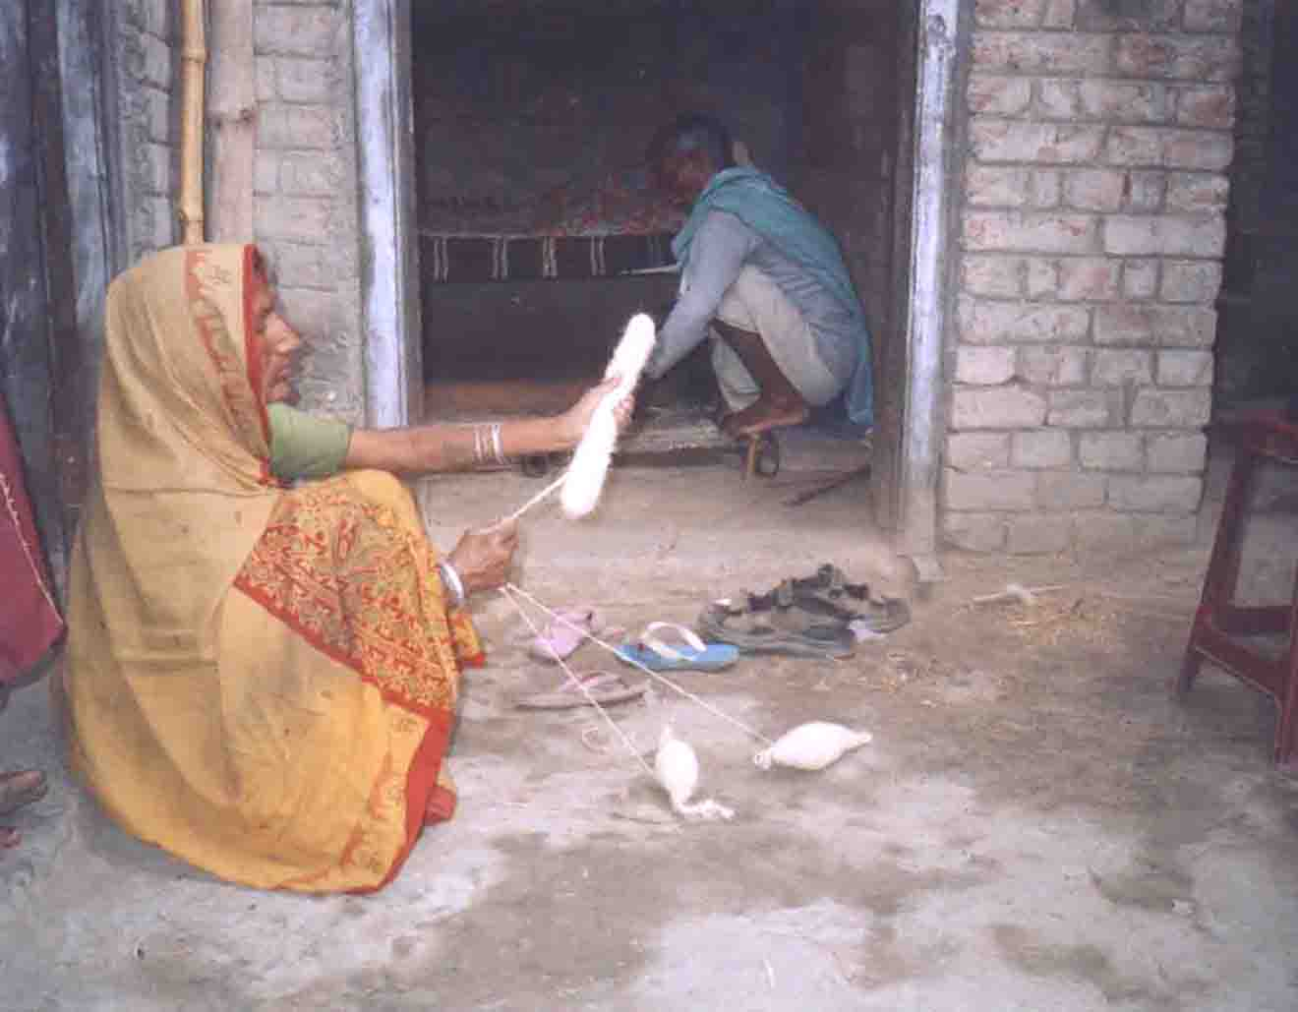
Blanket Weaving
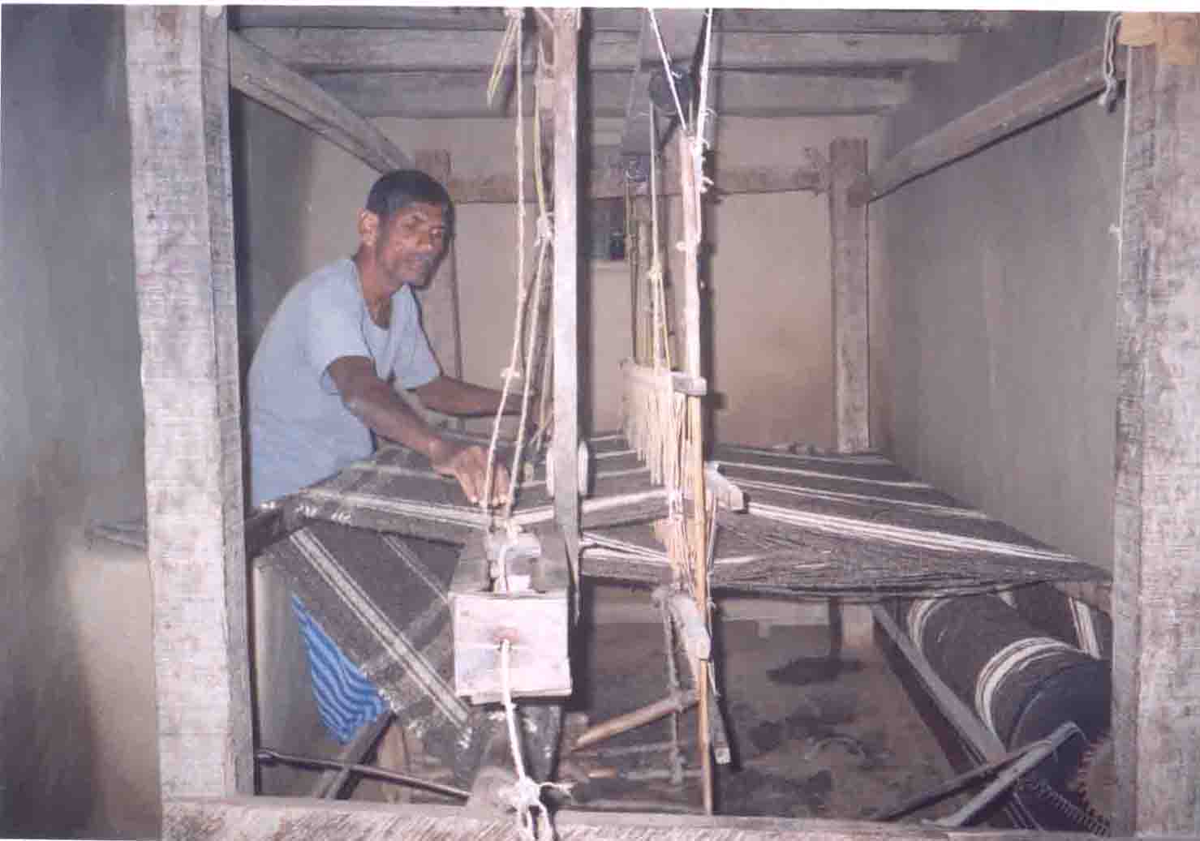

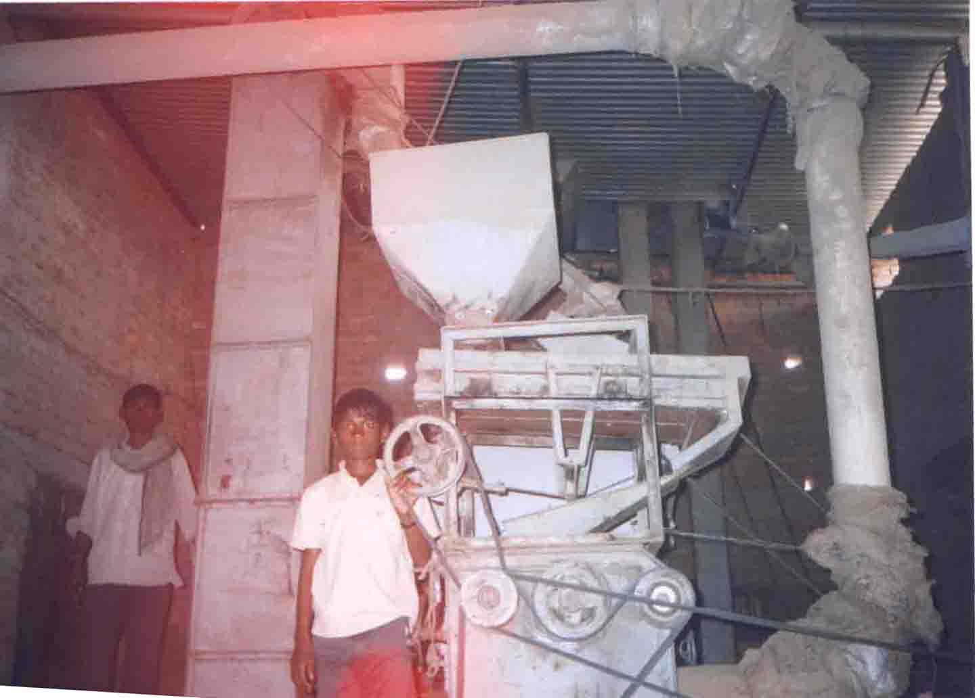
Rice Mill
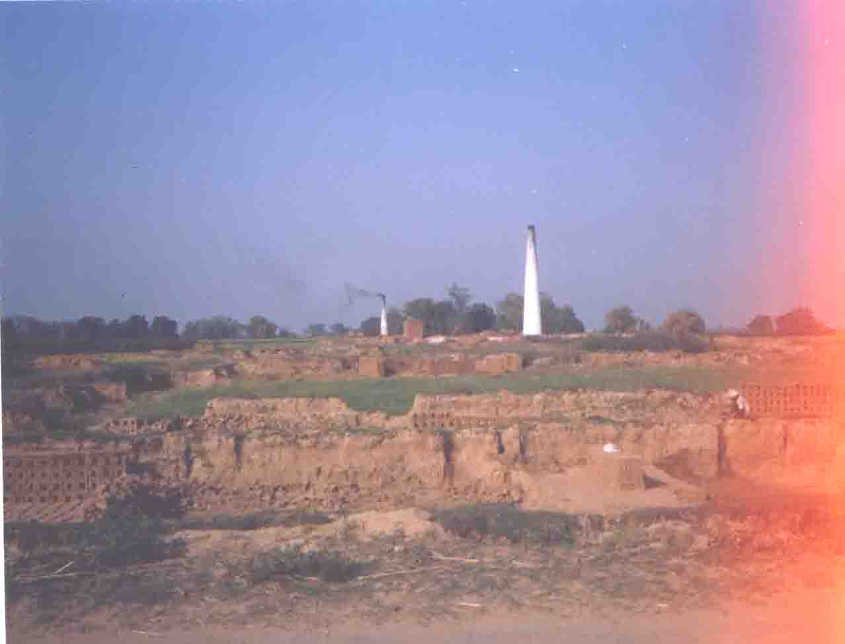
Brick Kiln

Annexure 5

Photograph of renovated pond

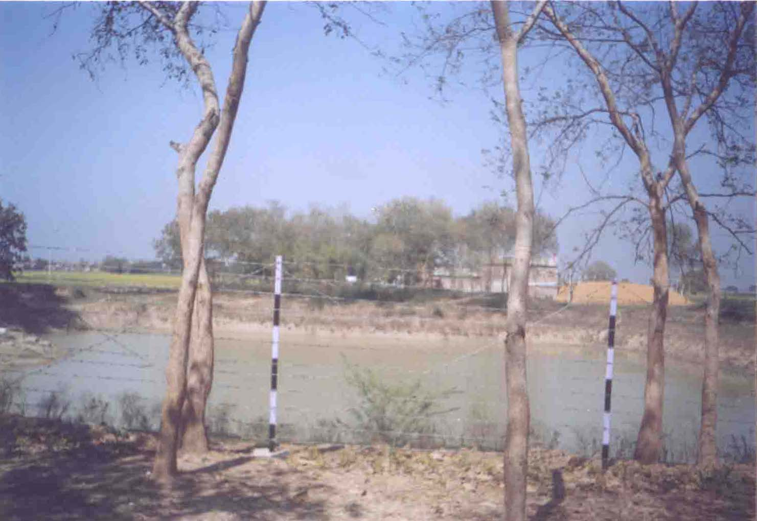

Annexure 6
Time line for land acquisition and rehabilitation

26th Nov., 1997: Gazette Notification under sections IV and VI of
Land Acquisition Act 1894 has been published
Dec.1997 & Jan. 1998: Socio-Economic survey work was awarded to Ms. A.N.Sinha Institute of Social Sciences, Patna.

23rd March, 1998: Issue of Notice under section IX of the Land
Acquisition Act (1984).

25th May, 1998: Issues related with development of PAFs.

18th July, 1998: 2nd Land Purchase Committee Meeting.

Oct.1998: Handing over possession of land.

21st Jan., 1999: Meeting with State Govt. for allotment of land to eligible PAFs.

11th March, 2000: 4th meeting of Land Purchase Committee.

14th July, 2000: Repair of middle school.
Development of link lane between Harriman tolas
and approach road. Construction of Community
hall.

30th Nov., 2000: Review meeting.

16th Aug., 2000: Repair of Middle school, Development of link lane
between Harijan-tola and approach road.
Construction of community hall.

February, 2002 Distribution of land for landless families.

25th Oct., 2002: RA Distribution

28th Nov., 2002: Implementation of IGS scheme.
Development of Harijan-tola road.
Construction of Community hall.
Dec., 2002 : Progress report on RAP by POWERGRID

Annexure 7
Photographs of Roads

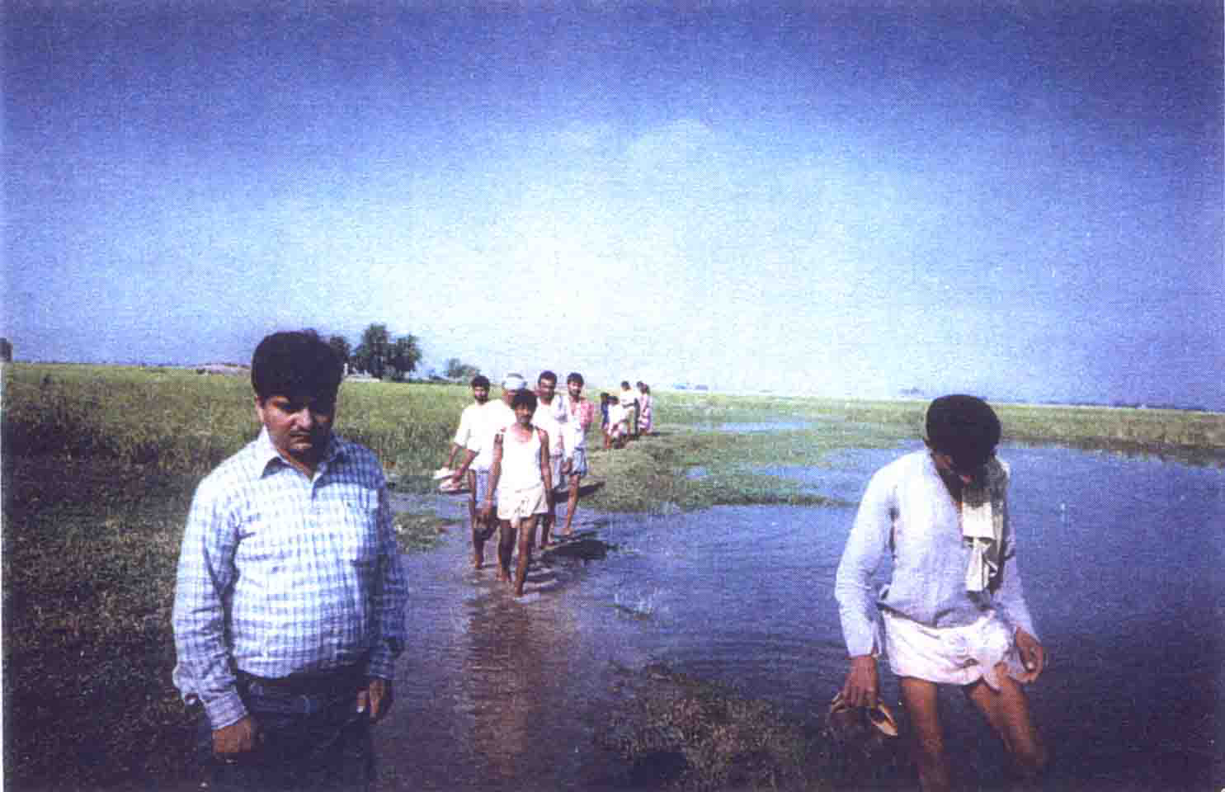

Road in 1998

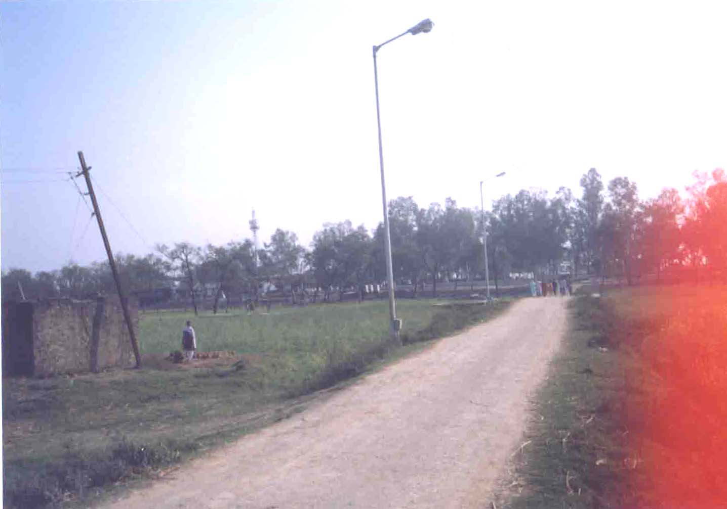
Road in 2005
Annexure 8
Photographs of DAV school

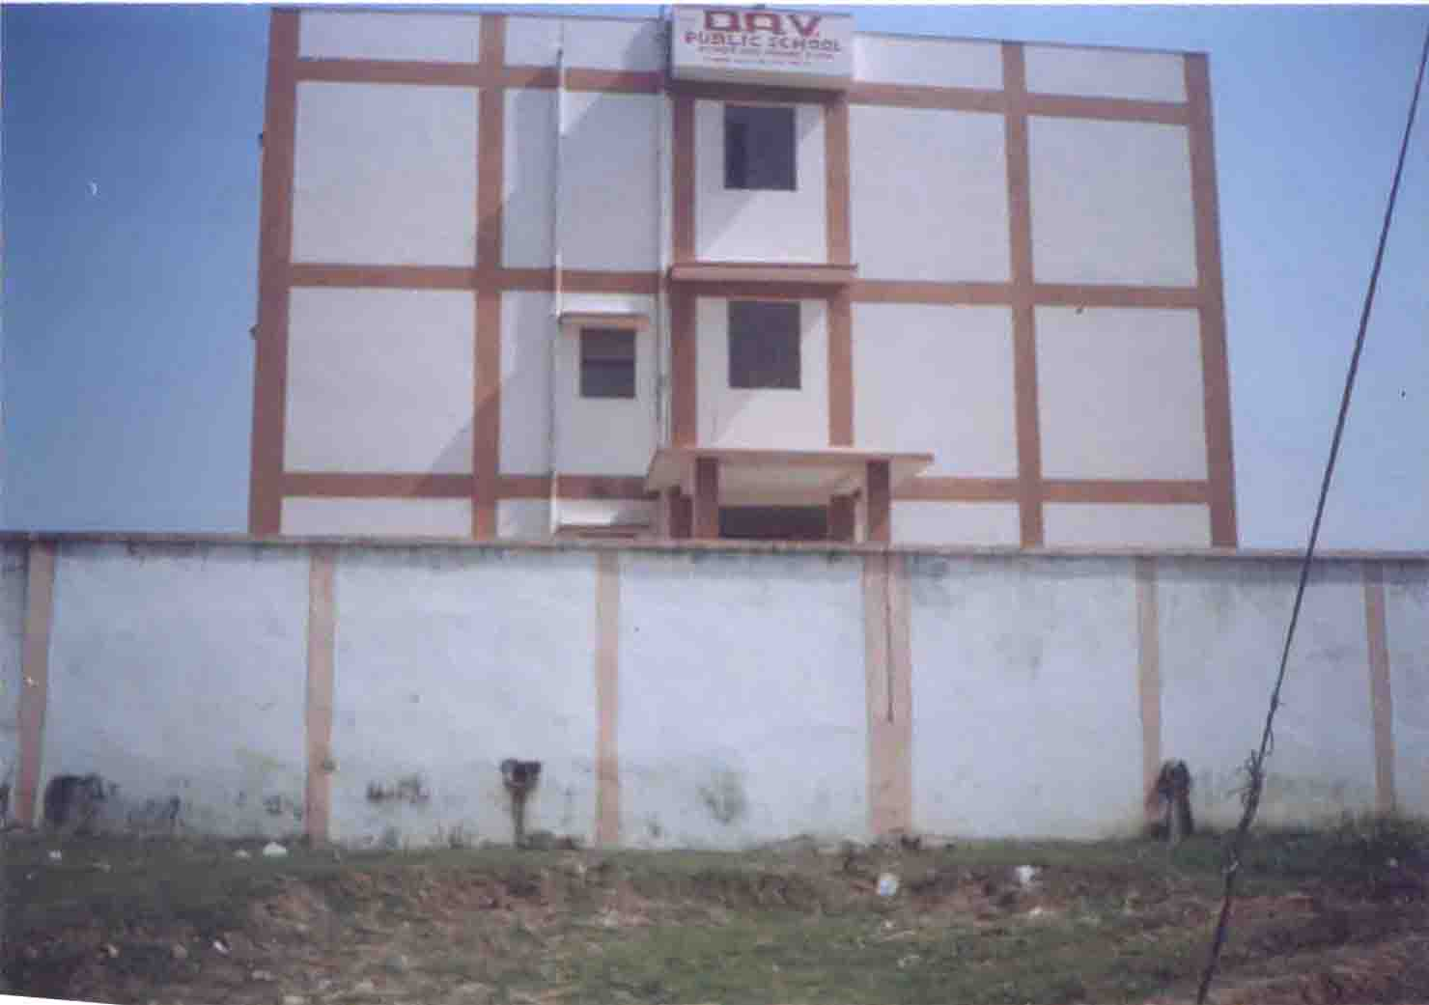

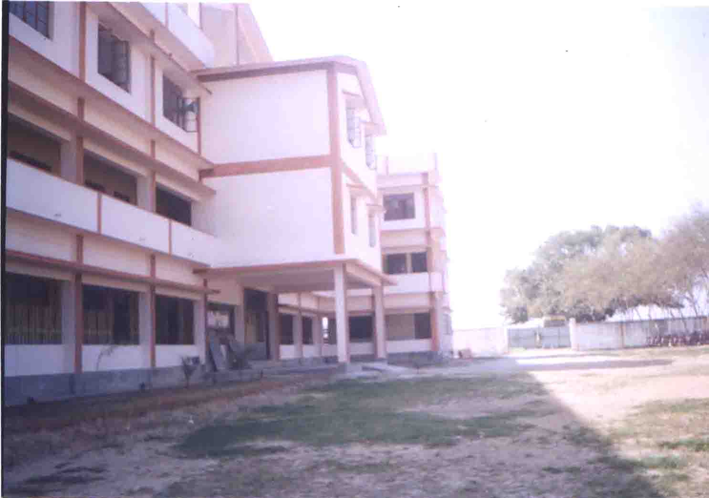

 |  |  |  |  | Annexure 9
Standard of Living of PAFs and Control Group
Landholding Status (Past and Present)
Sl No | Farmer Category (Land in acres) | Past 1998 (% of PAFs) | Present 2005 (% of PAFs) | % of change | Control Group
1 | Landless Farmer (0) | 4(2.9%) | 0(0%) | -2.9 | 0(0%)
2 | Marginal Farmer (Upto 2.5 ) | 89(65.4%) | 52(69%) | 3.6 | 21(84%)
3 | Small Farmer (>2.5-5.0) | 28(20.6) | 15(20%) | -0.6 | 3 (12%)
4 | Medium Farmer(5.0-9.99) | 10(7.4%) | 6(8%) | 0.6 | 1(4%)
5 | Large Farmer(10.0 and above) | 05(3.6%) | 2(3%) | -0.6 | 0(0%)
 | Total | 136(100%) | 75(100%) |  | 25(100%)
 | Average Landholding Size |  | 2.2 | 2.4 | 2.0
Occupational Pattern
S.No | Category | PAFs (Past 1998) | PAFs (Present 2005) | % of change | Control Group
1 | Cultivation | 65(48%) | 38(51%) | 3 | 10(40%)
2 | Wage Labour | 25(18%) | 10(13%) | -8 | 7(28%)
3 | Business | 7 (5%) | 7(9%) | 4 | 1(4%)
4 | Agriculture Wage Labour | 17(12%) | 5(7%) | -7 | 2(8%)
5 | Service | 13(10%) | 11(15%) | 1 | 3(12%)
6 | Artisan and others | 9(7%) | 4(5%) | -3 | 2(8%)
 | Total | 136(100%) | 75 (100%) |  | 25(100%)
Sl No | Income | Past 1998 in 2005 price(In Rs.) | Present 2005 (In Rs.) | % of change | Control Group (In Rs.)
1 | Average Income | 37343 | 46509 | 9166 | 43732
Sl No | Category | PAFs (Past 1998) | PAFs (Present 2005) | % of change | Control Group
1 | Below Poverty Line | 10% | 9% | -1% | 16%
Indebtedness
Sl No | Category | PAFs  (Past 1998) | PAFs (Present 2005) | % of change | Control Group
1 | Indebtedness | 16.9% | 13.3% | 3.6% | 20%

Household Expenditure (Food and Non-food)
Sl No | Category | PAFs  (Past 1998) | PAFs (Present 2005) | % of change | Control Group
1 | Food | Rs. 21322.6  (67.5%) | 25,838.60  (66.7%) | 0.8% | 31,824.00  (68.3%)
2 | Non-food | 10,220.0  (32.5%) | 12,866.6  (33.3%) | - 0.8% | 14,716.00  (31.7%)

Housing and basic amenities
Sl No | Particulars | Past 1998 | Present 2005 | % of change | Control Group
1 | % PAFs with Kucha house | 51% | 39% | -0.12 | 52%
2 | % PAFs with Pucca house | 49% | 61% | 0.12 | 48%
3 | % PAFs with Electricity | 68% | 77% | 0.09 | 64%
4 | % PAFs with Sanitation | 29% | 41% | 0.12 | 28%
5 | % PAFs with Separate Kitchen | 22% | 36% | 0.14 | 44%
Irrigation Facility
Sl No | Irrigation | PAFs (1998) | PAFs (2005) | % of change | Control Group
1 | Irrigation | 20 (15%) | 14 (19%) | 4 | 3 (14%)
2 | Non-Irrigation | 116 (85%) | 61 (81%) | -4 | 22 (86%)
 | Total | 136 (100%) | 75 (100%) |  | 25 (100%)
Sources of Drinking Water
Sl No | Sources | PAFs (1998) | PAFs (2005) | % of change | Control Group
1 | Well | 7 (5.1) | 21 (28%) | 22.9 | 5 (20%)
2 | Handpump | 22 (16.1) | 12 (16%) | -0.1 | 19 (76%)
3 | Pond etc. | 107 (78.8%) | 0 (0%) | -78.8 | 0 (0%)
4 | Tube well | 0 (0%) | 37 (49%) | 49 | 1 (4%)
5 | Govt. supply water | 0 (0%) | 5 (7%) | 7 | 0 (0%)
 | Total | 136 (100%) | 75 (100%) |  | 25 (100%)
Asset Possession
Sl No | Agricultural Assets | PAFs (1998) | PAFs (2005) | % of change | Control Group
1 | Pumpsets | 15 (11%) | 12 (16%) | 1 | 4 (16%)
2 | Tractor | 8(6%) | 5 (6.7%) | 0.7 | 0 (0%)
3 | Plough | 118 (87%) | 64 (85.3%) | -23 | 4 (16%)
Sl No | Non-agricultural Assets | PAFs (1998) | PAFs (2005) | % of change | Control Group
1 | TV | 20(26.6%) | 24 (32%) | 5.4 | 7 (28%)
2 | Two-wheeler | 4 (5.3%) | 7 (9.3%) | 4 | 1 (4%)
3 | Almirah | 23 (30.6%) | 28 (37.3%) | 6.7 | 8 (32%)
Note : The figures in parentheses denote percentages to the total.

Socio-Economic Study and Rehabilitation Action Plan by A.N.Sinha Institute, PATNA, 1998.
Socio-Economic Study and Rehabilitation Action Plan by A. N. Sinha Institute, PATNA, 1998
Socio-Economic Study and Rehabilitation Action Plan by A. N. Sinha Institute, PATNA, 1998
Socio-Economic Study and Rehabilitation Action Plan by A. N. Sinha Institute, PATNA, 1998
Socio-Economic Study and Rehabilitation Action Plan by A. N. Sinha Institute, PATNA, 1998

