**IMPACT ASSESSMENT OF REHABILITATION ACTION PLAN MEASURES FOR PROJECT AFFECTED FAMILIES (PAFs) of 400/220 KV MUZAFFARPUR S/s**

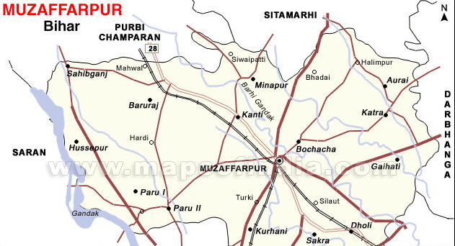

**S/s**

**By**

**Prof. A. N. Singh**

**Faculty of Social Work, M.G. Kashi Vidyapith,**

**Varanasi**

**For and On Behalf**

**Of**



**ENVIRONMENT AND SOCIAL MANAGEMENT DEPTT.**

**Power Grid Corporation of India Ltd.**

**(A Government of India Enterprise)**

***PGCIL/ESMD/DRAFT/MUZAFFARPUR/11* *NOV’11***