Location Map of Solapur Sub station
Location Map of Indore Substation
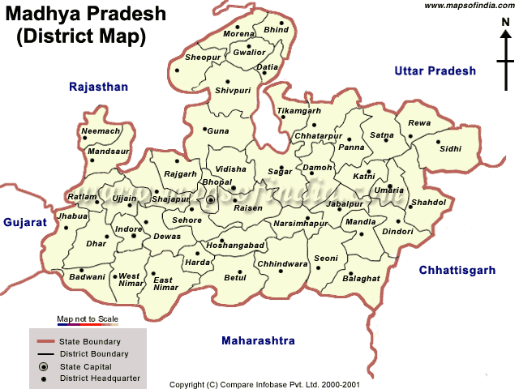
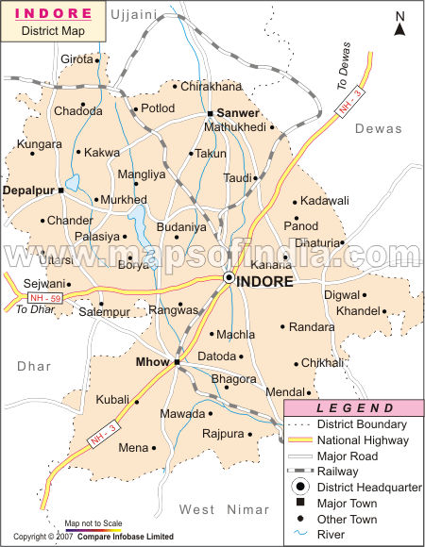
Project Area

