SECTION-1 : BASELINE DATA AND SOCIAL ASSESSMENT

1.0 Introduction

Power Grid Corporation of India Ltd. (POWERGRID), the Central Transmission Utility of the country, is one of the largest electrical power transmission utilities in the world. It constructs, owns and operates Extra High Voltage (EHV) transmission network in India and carries out real time supervision and monitoring of the grid, on round the clock basis. It is working towards achieving its mission of “Establishment and Operation of Regional and National Power Grids to facilitate transfer of power within and across the regions with reliability, security and economy, on sound commercial principles”. Construction and improvements in infrastructure projects including power projects is not purely a technical issue but has wider socio economic implications in the over all development of the economy. Acquisition of lands from people necessitated by improvements in power sector such as construction of sub- stations may result in the involuntary displacement of the people from areas where they live and work. Such a change may lead to economic and cultural disruption to the affected people. Thus to address these issues a Rehabilitation Action Plan (RAP) is essential for the project affected persons to offset the trauma and to develop and implement programmers which are meaningful and workable such that the affected persons will not become worse off economically than before.

POWERGRID in recognition of this, has incorporated the preparation of the Rehabilitation Action Plan (RAP) and its implementation an integral part of the Social Assessment process described in its Environmental and Social Policy & Procedures (ESPP). The need for the RAP had been identified by the initial assessment and the analysis of expected social impacts which require appropriate mitigative measures for all PAPs who, on the basis of an established cut-off-date, will be losing land or other assets or livelihood, as a result of project implementation. In this context POWERGRID had invited and awarded M/s Centre for Management and Social Research (CMSR), Hyderabad for undertaking a verification and socio-economic survey to obtain accurate information on the Socio-economic profile of PAPs/PAFs to prepare the Rehabilitation Action Plan (RAP) for the proposed 765/400/220 kV Sub-station under its Transmission System associated with Sasan Ultra Mega Power Project (UMPP). The present report deals with the baseline socio-economic condition of area and people who will be affected by land acquisition for the construction of 765/400/220 kV sub-station at Indore in Madhya Pradesh State and the plan for their rehabilitation.

  - Project Description

For transfer of power from Sasan UMPP, transmission corridor right from Sasan to Bina (PG) via Satna has been planned. However, system strengthening is required beyond Bina in Madhya Pradesh for transfer of power to the load centres of WR for which a separate high capacity 765 kV transmission corridor from Bina to Indore, a major load center in Madhya Pradesh along with establishment of new 765/400 kV substation at Indore, has been proposed. Further, establishment of 765/400 kV substations at Bina and Gwalior is also proposed as part of this scheme so as to facilitate charging of 765kV lines interconnecting Bina and Gwalior substations. As per load flow studies carried out for “System Strengthening in Western Region for Sasan UMPP” scheme, there would be reduction of losses of about 285 MW in the grid.

Further, substantial power transfers are envisaged from eastern part to western part of Western Region in view of addition of a number of proposed generation projects in Chhattisgarh, Jharkhand and Orissa. A long term perspective plan towards this has been formulated. Bina-Indore 765kV corridor dovetails into this long-term transmission plan which envisages high capacity 765 kV corridor from Bina to Vadodara via Indore.

1.2 Project Highlights

Table 1.1 below gives the project details:

a) | Project Name | : | System Strengthening in Western Region for Sasan UMPP
b) | Location | : | Madhya Pradesh
c) | Beneficiary States | : | Constituents of Western Region
d) | Project Cost | : | Rs. 8922.68 million (USD 190.89 million) excluding IDC

1.3 Project Scope

The scope of the transmission lines and Substations to be implemented under the above scheme is as follows:

Transmission line

- Bina (PG)-Indore(PG) 765kV S/C line, 320 Km;
- Indore(PG)-Indore(MPPTCL) 400kV D/C line (Quad), 50 Km.

Substations

- Establishment of 765/400kV, 2x1500 MVA substation at Indore (PG),
- Upgrading Gwalior Substation to 765kV by 765/400kV, 2x1500 MVA transformers,
- Upgrading Bina Substation to 765kV by 765/400kV, 2x1000 MVA transformers.

A map showing Transmission system associated with Sasan UMPP (WR) is placed as Exhibit -1.

Exhibit -1

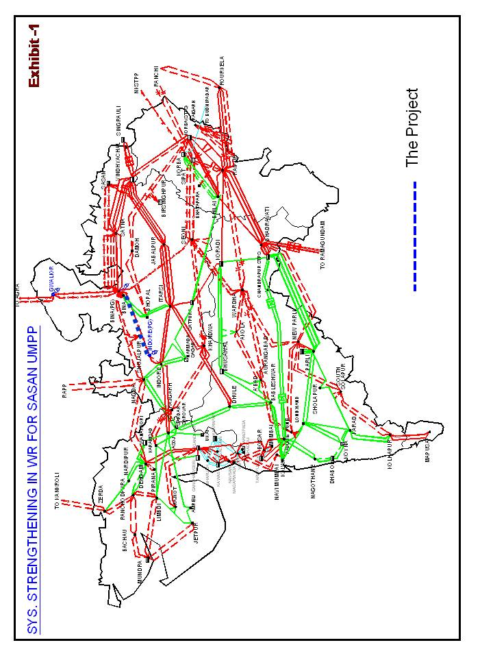

  - Project Area- 765/400/220 Substation at Indore

1.4.1 Project District- Indore

The proposed substation shall be a new substation located at Indore district in Madhya Pradesh to be constructed and owned by POWERGRID. Indore, situated in the Malwa plateau is the largest city in Madhya Pradesh in central India. Indore is bounded by the districts of Ujjain to the north, Dewas to the east, Khargone (West Nimar) to the south, and Dhar to the west. The geographical area of the district is 3898 sq.kms. The administrative setup of Indore district constitutes 4 Tehsils, 4 Blocks, 335 Panchayat Samities, and 676 revenue villages in 4 tehsils and 649 development villages in 4 blocks.

Table 1.2 Administrative setup for Indore District
Total No. Of Blocks - 4
Total No. Of Tehsils - 4
Name of Block | PANCHAYAT | VILLAGE
DEPALPUR | 100 | 149
SANWER | 78 | 128
INDORE | 84 | 161
MHOW | 73 | 177
HATOD | - | 62
TOTAL FOR DISTRICT | 335 | 677

As per census 2001, the population of the district is 24.6 lakhs. Of these 17.3 lakh constitute urban population and 7.35 lakh of rural population. Observed across the gender males constitute 52.28 percent and female population is 47.7 percent. The sex ratio is about 912 females per 1000 males. The proportion of SC population in the district is around 15.8 percent and ST population consists of 6.6 percent. The density is 632 persons per square kilometer. The work participation rate of the district is around 36.2 percent .Main workers constitute of 31.1 percent and marginal workers constitute of 5.1 %. The proportion of cultivators to total workers is 16.2 percent. Agricultural labourers constitute of 14.9 percent, household industries workers constitute of 5.1 percent and other workers to total workers constitute of 65.1percent. (Refer Exhibit-2).

    - Project Village – Hatunia

The location for the proposed Indore sub-station is in Hatunia Village, under Sanver Tehsil which falls in the Indore district of Madhya Pradesh. The proposed site is located on approximately 24 km from city of Indore (MP) on Mangliya-Sanver road at Village Hatunia Police station Kshipra, Tehsil Sanver, District Indore. (Refer Location Map)
Exhibit-2
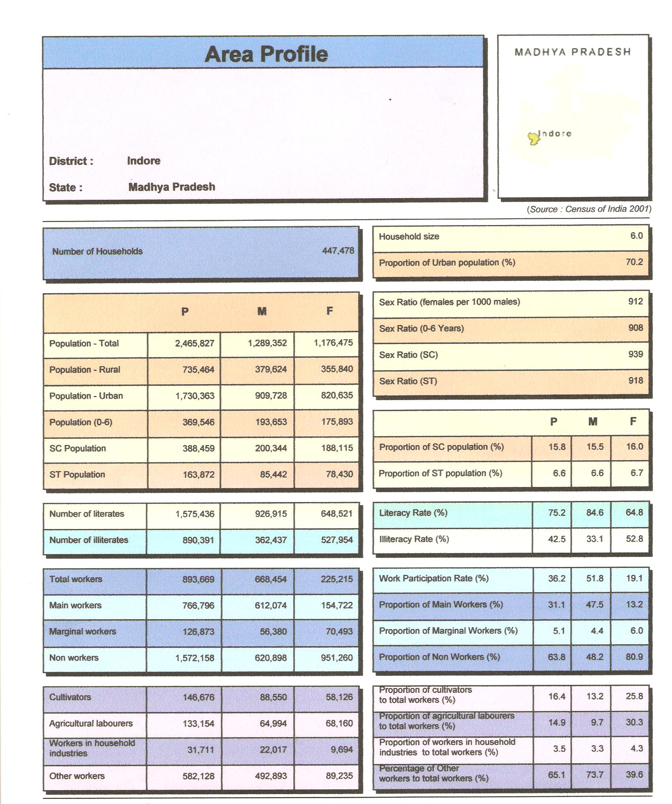

1.4.2.1 Physiography and Socio-Demographic profile of project village

A majority of the affected families are residing in project village Hatuniya and the other families are residing in near by neighboring villages special emphasis is given for the Hatuniya village and an analysis of the socio-demographic profile of the project village is presented below.

The total number of Households of Hatuniya village is 244 with a population of 1416. Observed across gender the population evenly distributed among males and females. The literacy rate for the village population is 51.9%. of the total workers in the village 58.1 percent of them are agricultural labourers, 23 percent are cultivators. The work participation rate of the village is around 38.7 percent. Proportion of workers in household industries to total workers is 0.7 percent and percentage of other workers to total workers is 17.2 percent. The Table 1.3 below gives the details of Physiography and socio-demographic particulars of the affected village (Refer Exhibit-3).

Table 1.3: Physiography and Socio-Demographic Characteristics of

Hatuniya village
Sl.No | Item | Number
Physiography
1 | Total Land | 931.611 ha
2 | Private Land | 812.812 ha
3 | Government Land | 118.799 ha
Population
5 | Number of households | 244
6 | Persons per Household | 6.0
7 | Total population | 1416
8 | Male population | 713 (50.3 %)
9 | Female population | 703 (49.6 %)
10 | Sex Ratio | 986
11 | SC Population | 481 (34%)
12 | ST Population | 30 (2.1%)
Literacy
13 | Total Literacy rate | 51.9%
14 | Male literacy Rate | 72.5%
15 | Female literacy rate | 30.2%

1.4.2.2 Infrastructure facilities in project village

The facilities that are available in the village include Panchayat building, Government primary school, high school, bus shelter, Health sub-center. Primary Health Center is available within 5 Kms away from the village. For all the other facilities such as College, Government Hospital, Police Station, Banks, Patwari head Quarters, Development Block office and market facility are available at Sawer, which is 18 kms from the village. The Table 1.4 gives the details of infrastructure facilities in project village.
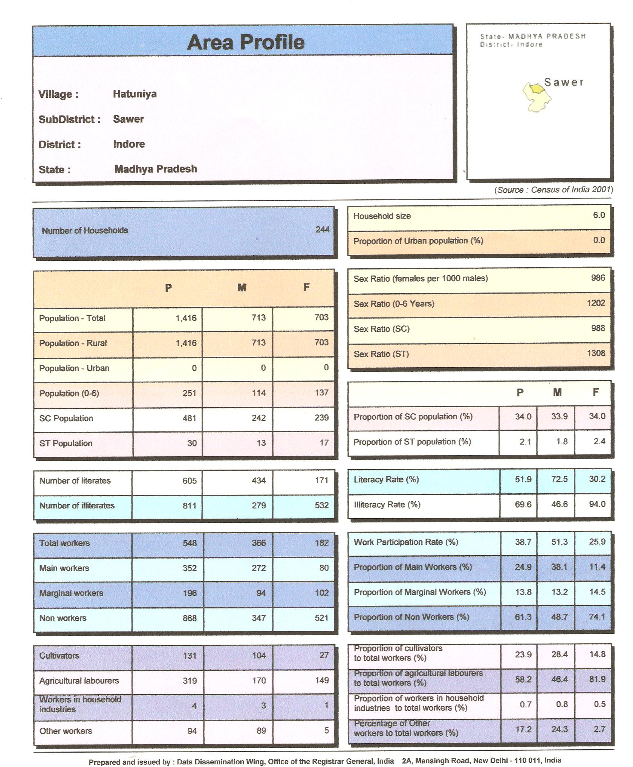
Exhibit-3

Table 1.4: Infrastructure and other community facilities in Hatunia Village
Sl.No | Item | Details (Type/Number)
1 | School facility | High School, Primary School
2 | Health facility | More than 10 kms away at Sanver
3 | Primary Health centre | Within 5 kms
4 | Drinking water facility | Tube well and Hand pump
5 | Sewerage and sanitation | Open pucca drains-60%
6 | Approach Roads | Paved Roads
7 | Community toilets | None
8 | Community hall facility | None
9 | Banking facilities | Available
10 | Anganwadi and Balwadi | One each
11 | Village electrified | Yes
12 | Post Office | Available

1.5 Land Requirement

Land measuring about 39 ha is required for setting of 765/400/220 kV sub-station. Accordingly a private land measuring 36.435 ha and government land measuring 2.541 ha was selected for acquisition for proposed sub-station. (Plate-1) Out of the total private land a land measuring 2.110 ha belongs to a local temple trust by name Bagori Mata Mandir under the trusteeship of District Collector.

1.6 Measures to Avoid or Minimize Social Impacts

It has always been the endeavor of the POWERGRID to minimize resettlement and rehabilitation by using government land wherever possible for its infrastructure development. In the absence / non-availability of government land private land may be selected but to minimize the social impact associated with land loss, POWERGRID has a well developed process of selection of site for new substation apart from reducing the extent of land requirement through improvement in design and other parameters. The site selection process is detailed below:

1.6.1 Site Selection and Analysis of Alternatives

The site for the construction of Hatunia Sub-station has been selected by the POWERGRID after studying the different alternatives keeping in view its principles of avoidance and minimization of social impacts where the land acquisition has been limited to bare minimum. On the basis of data collected for the various parameters a comprehensive analysis for each alternative is carried out by a team comprising representatives of Engg (CC), ESMD (CC), Engg (RHQ, Vadodara) and construction site. Weightage was given to the various parameters is often site specific and due consideration is given to infrastructure facility such as access to roads, railheads etc, availability of corridor for incoming and outgoing lines; soil type; type of land viz Govt, revenue, private land, agricultural land; social impacts such as number of families getting affected and cost of compensation and extent of rehabilitation. The following are the different alternatives considered before finalizing the site for the proposed sub-station.

Four sites in the Tehsil Sanver were identified based on the suggestions from local administration and survey made by local officials. Based on the report from Indore Construction Office, the above said committee visited four locations to finalize the site for construction of proposed Indore sub-station.

- Barlai Sugar Factory, Kshipra-Sanver Road (1Km from AB road): The site is located 25 km from Indore. This site was not selected as the liquidation of the Barlai Sugar factory is under process and its case is pending with labour courts. In addition the demolition and disposal of structures was considered to be time consuming and have resistance from the dwellers of factory township. Due to such uncertainty, Committee did not prefer this site for construction Sub-station.

- Village Ringnodiya Opposite, Rajshree Vidyapeeth, Sanver Road: The site is located 16 km from Indore. The land is mainly hilly and uneven area. Approx only 50 area would be available as plain land which is about 500mtr x 400 mtr. Some part of the land has been diverted into non agriculture land and the same is proposed for commercial purpose i.e. Education Institution, Hotel, Resorts etc. A 220 kV line of MPPTCL is passing over the site. This site was not selected as about 3 km length of the 220 kV line may need shifting. Also the area of the land identified was considered not sufficient for the proposed substation.

- Village Shahna, Behind Rama Phosphate (2km from Indore-Ujjain Road): This site is located 23 km from Indore. The proposed land was extensively used for agriculture purpose by the locals. The site was not considered as the land was irrigated and fertile. Another reason for not selecting this site was the pollution from nearby phosphate factory.

- Village Hatunia, Sanver- Mangliya Road (12 km from AB road (NH-3) at Mangliya) 24 km from Indore: This site was selected for the following reasons.
- Area (approx 39 hectare) and size of land is suitable for G.A. drawing received from CC.
- Majority of the proposed land is un irrigated land with moorum soil.
- Availability of corridors for incoming and outgoing transmission lines from three sides. No obstruction or hindrance for TL corridors.
- Availability of 33 kV/11 kV MPPKBVL Substation for power supply within 2kms distance from the land.
- Support from local administration as it might lead to lesser confrontation against land acquisition being mostly un-irrigated land.
- This land is situated in the Northern part of Indore which is suitable for incoming and outgoing lines.

1.7 Land Acquisition Status

The land at village Hatunia, Tahsil Sanwer was identified and proposal for acquisition of land was forwarded by the Collector, Indore on 16.12.08. Meanwhile the investment approval for the above project was accorded on 17.11.2008 with completion time of 48 months. Earlier the site for proposed substation was identified and approved by State Government at village Rajoda , Tehsil Sanver, District Indore and an amount of Rs 3 crore was also deposited with the competent authority towards land compensation. However due to local opposition the district administration advised POWERGRID to choose an alternative site. As considerable time had passed in the process of approval of land and very limited time was available to complete the project as per schedule of investment approval, the request of the Notification for Section 4 (1) & (2) and Section 17(1) under the Land Acquisition Act 1894 for preliminary notification to acquire the land for Public Purpose with urgency clause was made to the State Government and such Notification was published in the Gazette of Madhya Pradesh State Government on 13.03.09 and the details of which are given on page no. 796 of the Gazette and published in the local newspapers Naiduniya on 16.03.2009 and Agnibaan 16.03.2009. An amendment and corrigendum for the said notification was published in Madhya Pradesh Gazette on 27th March, 2009 on page no 892 and in the local news appears Naiduniya on 28th March, 2009. A copy of the gazette notification and news paper advertisements is presented in Annexure-1. Section –6 notification was issued and the details were published in Madhya Pradesh Gazette on 03-04-2009 on page no. 995 and in local news papers Naiduniya on 5th April 2009 and Agnibaan on 05-04-2009. A copy of the gazette notification and newspaper advertisements is presented in Annexure-2.

After the joint measurement and marking of the land under section 7 and 8 the Section-9 notification along with individual notices to interested persons were issued. Inspection/spot verification by Land Acquisition Officer was completed in April, 2009 for fixing the rate of compensation. Interim award for through Section-11 by Land Acquisition Officer for issuing 80% of compensation was issued in May, 2009. A copy of the interim award with details of compensation amounts for all the affected person is presented in the Annexure-3. However during the inspection certain discrepancies were reported by way of location of the identified affected plots and ownership of some of the affected plots. Subsequently the Section -6 notification was amended and new notification was issued and the details were published in Madhya Pradesh gazette on 7th August, 2009 on page no 1929 and 1930 and in local news papers Agnibaan on 9th August, 2009 and Naiduniya on 8th August, 2009. A copy of the amended Section-6 Notification and news paper advertisements is presented in the Annexure-4. The process for the declaration of final award is completed and issued in month of February, 2010. A copy of the Final Award with compensation details is presented as Annexure-5.

1.8 Social Assessment
In order to assess the basic socio-economic condition of the area and the resultant impact of land acquisition for Indore substation on the local population, a socio-economic survey has been carried out by M/s Centre for Management and Social Research (CMSR), Hyderabad. The objectives of these socio-economic investigations are two folds. The first one is to identify, assess and evaluate the broad socio-economic resource base and socio-economic profile of the immediate region (I.e village) with an implicit purpose of assessing the absorption capacity of the immediate local region. The second objective is to know and understand the socio-economic characteristics features if the affected households, as also their aptitude and preferences for rehabilitation. The study tools of Household Questionnaire and Focused Group Checklist that has been used for the socio-economic survey is presented as Annexure-6. The above objective can be summarized as follows:

- To collect base line demographic and socio-economic characteristics of affected household whose lands are being acquired
- To categorize the project affected persons under different categories for various benefits and entitlements as per POWERGRID’s Social Entitlement Framework.
- To assess the peoples reaction towards the project and ascertain their preference for resettlement and rehabilitation, and
- To suggest an appropriate rehabilitation action plan for improving/restoring the living standards of affected families.

Figure 1.1: Land Acquisition and social assessment Process

Land Acquisition
Process
R&R Framework

Selection of Substation Site
Preliminary assessment

Socio-economic survey
(in house if PAFs < 40 or 3rd party if PAF> 40)
Application for Land acquisition to state govt. through DM/DC
SEC-4 Notification
SEC-6 Notification
SEC-9 Notification
SEC-11 Award
Disbursement of Compensation
SEC-16 possession of land
Commencement of construction activity
Monitoring by RHQ / ESMD
Preparation for survey
(Finalisation of Consultant for survey, if required)
Commencement of survey
Survey Completion
Draft RAP/SAMP based on survey findings
Finalisation of RAP/ SAMP
Implementation of RAP/ SAMP at site
Completion of RAP / SAMP implementation
Public consultation on Draft RAP
3 months

The substations covered under this project are proposed for funding under the World Bank proposed PSDP-V loan. The transmission lines are constructed under domestic funding.

