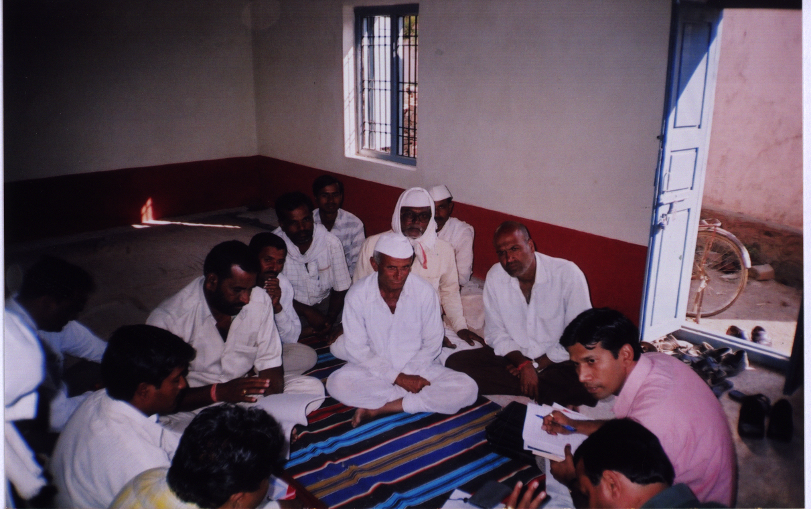
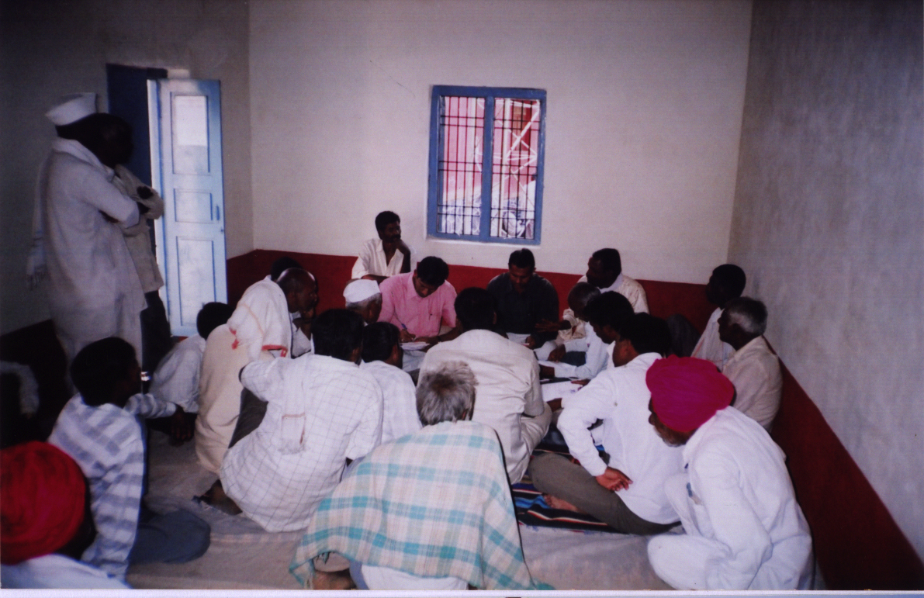

VILLAGE LEVEL CONSULTATION ON RAP FINDINGS

