REHABILITATION ACTION PLAN (RAP)
of
+500 KV HVDC TERMINAL AT
BHIWADI (RAJASTHAN)

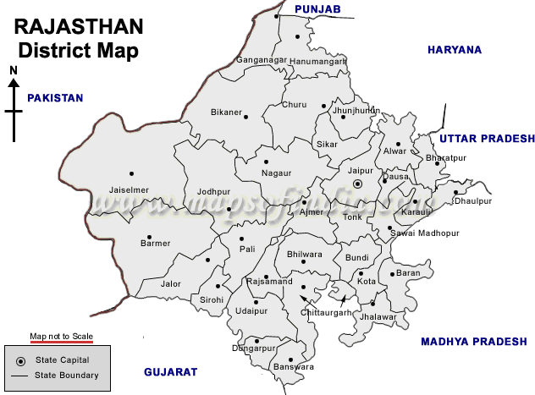

ENVIRONMENT AND SOCIAL MANAGEMENT
POWER GRID CORPORATION OF INDIA LTD.

( A GOVERNMENT OF INDIA ENTERPRISE)

PGCIL/NR-I/BHIWADI/FINALRAP/06 Dec’06

