SECTION-2 : SOCIO-ECONOMIC PROFILE OF PAPs

- Introduction

Socio-economic survey and verification of the affected persons were undertaken to address any such adverse impacts that may emerge during the course of the project implementation. The socio-economic survey is carried and acts as baseline information and provides a cut-off point for eligibility to compensation or assistance for loss of assets.

A total of 41 landowners/ titleholders are getting affected due to 22.24 ha acquisition of private land in village of Limbi-Chincholi. Amongst them some of the land owners are found to be joint titleholders of the affected plots. Of the total 41 PAPs 35 of them represent 6 joint land holdings. At the time of notification 41 PAPs name was in list of titleholders. During the process of land acquisition 3 PAPs who were joint family members have died. There by reducing the land owners to 38 PAPs. Since name of their family member are already there in PAP list, so socio- economic study of 38 PAPs covered all the affected population. Shri Revansiddheshwar Devasthan Panch (trust) land is also included in survey for analysis considering as one of the PAP.
.
As per the definition of “family” considering adult married sons of affected persons as separate family under Environmental and Social Policy & Procedures (ESPP) of the POWERGRID and other provisions the total number of Project Affected Families (PAFs) is 51. The detailed profile of the surveyed affected families is enclosed as Appendix-I.

2.1 Extent of impact on the affected village

It can be seen from the Table 2.1 that about 5.54 percent of the total population in Limbi-chincholi are affected by the land acquisition. On the whole 161 persons are affected out of the total population of 2278. As the affected number is relatively small, it would be possible to absorb these people in income generating activities fairly within the village itself. The percentage of the affected households in the village is about 5.54.

Table 2.1 Impact on the affected village
SlNo | Item | Number
1 | Total Number of Households in the village | 487
2 | Number of Households affected by sub-station | 27
3 | Percentage of Households affected to total village | 5.54
4 | Total Village population | 2278
5 | Population of the affected households | 161
6 | Percentage of population affected to total village | 7.06
7 | Average household size (per HH) | 5.96

  - Demographic Profile of the Affected Population

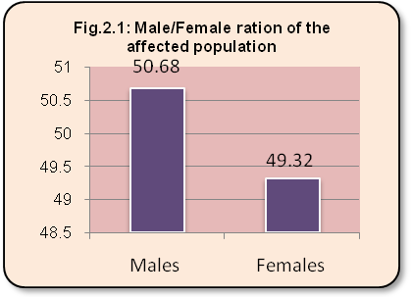
Table 2.2 on the demographic features of the affected population shows that the total population affected amongst the 27 households is 161. The average size of the affected households is around 5.96 persons per household. All (100%) the affected households are listed in the voter list and also have ration cards. With regard to the sex ratio of the population, Figure 2.1 shows that of the total population around 51 percent are males and around 49 percent are females. Among the affected population a majority (68.94%) of them are found to be adults who are 18 years and above. Out of the total affected women headed households are about 4 (14.81%).

Table 2.2 Demographic particulars of the affected population
Sl.no | Item | No of HH | % to total
1 | Number of household affected | 27 | --
2 | Total population affected | 161 | --
3 | Average household size (per HH) | 5.96 | ---
4 | Males | 74 | 50.68
5 | Females | 72 | 49.32
6 | Children below 18 years | 50 | 31.05
7 | Adults 18 years and above | 111 | 68.94
8 | Children up to 5 years | 16 | 9.93
9 | Women headed affected households | 4 | 14.81

  - Social profile of the Affected Population

Table 2.3 shows that out of the 27 house holds religion wise 20 represent Hindus (74.07%), 6 represent Muslims (22.22%) and 1 represent Jain. Social group wise a majority 21 households (77.77%) represent the General castes. Most of them represent the Community of Lingayat which is also the predominant community in the village. Out of the rest 4 HH represent Scheduled Caste and two households represent other backward caste group. The analysis of the family type for the affected households showed that a majority (62.96%) of the households are found to live together as a joint family.
Table 2.3: Social group of the affected households
Item | Description | Number | % to total
Social group  (Caste) | Gen* | 21 | 77.77
Social group  (Caste) | OBC | 2 | 7.40
Social group  (Caste) | SC | 4 | 14.48
Social group  (Caste) | Total | 27 | 100.00
Religious Group | Hindus | 20 | 74.07
Religious Group | Muslims | 6 | 22.22
Religious Group | Jain | 1 | 3.70
Religious Group | Total | 27 | 100.00
Family type | Joint | 17 | 62.96
Family type | Nuclear | 9 | 33.33
Family type | Individual | 1 | 3.70
Family type | Total | 27 | 100.00
*Including Muslim households

  - Age profile of the affected Population

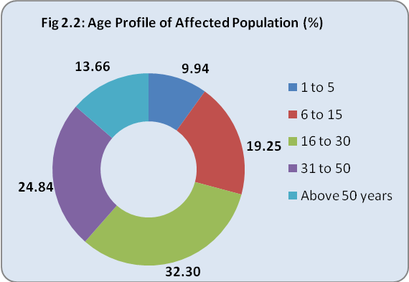
Figure 2.2 depicts the age profile of the total affected population across various age groups. It is seen from the figure that a majority of the affected population is observed in the young age category of 16 to 30 years (32.30%), followed by people in the middle age group of 31 to 50 (24.84%). Aged population is represented by around 13.66 percent who are above 50 years.

Table 2.4 shows the age profile of the affected population across the gender. It is seen from the table that observed across gender the distribution among all the age groups is similar to both males and females. Population in the age groups of 6-15 is either school going children or those who remain at home helping the family.

Table 2.4 Gender wise age profile of the affected population
Age Group | Male |  | Female |  | Total
Age Group | No | % | No | % | No | %
1 to 5 | 6 | 7.5 | 10 | 12.35 | 16 | 9.94
6 to 15 | 16 | 20 | 15 | 18.52 | 31 | 19.25
16 to 30 | 29 | 36.25 | 23 | 28.40 | 52 | 32.30
31 to 50 | 19 | 23.75 | 21 | 25.93 | 40 | 24.84
Above 50 years | 11 | 13.75 | 11 | 13.58 | 22 | 13.66

  - Literacy profile of the affected population

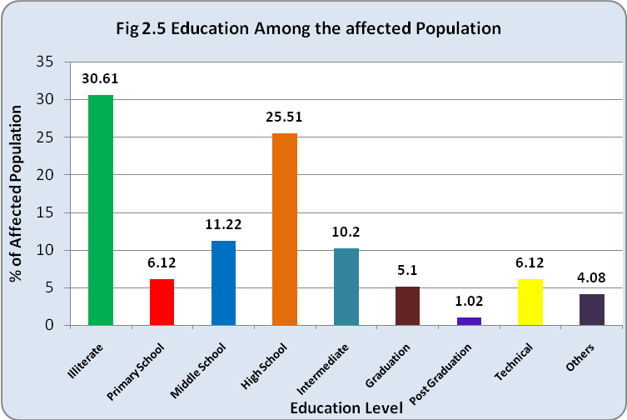
Figure 2.3 on literacy levels shows that of the total population above 5 years of age around 30.61 percent of them are illiterate. The education levels however are very moderate where; out of total population a majority 25.51 percent of them has completed High School. The higher education level is represented by 5.1 percent who are Graduates and only 1.02 percent being postgraduates. Others include Professionals (Doctors) (4.08%), intermediate (10.2%) and technical (6.12%).

For an in-depth understanding of the education levels Table 2.5 gives the analysis of the education levels among the adults who are 18 years and above.

Table 2.5 Gender wise education Level among the affected adult population
Literacy Level | Male |  | Female |  | Total
Literacy Level | No | % | No | % | No | %
Illiterate | 9 | 17.65 | 21 | 44.68 | 30 | 30.61
Primary School | 2 | 3.92 | 4 | 8.51 | 6 | 6.12
Middle School | 6 | 11.76 | 5 | 10.64 | 11 | 11.22
High School | 14 | 27.45 | 11 | 23.40 | 25 | 25.51
Intermediate | 7 | 13.73 | 3 | 6.38 | 10 | 10.20
Graduation | 4 | 7.84 | 1 | 2.13 | 5 | 5.10
Post Graduation | 0 | 0.00 | 1 | 2.13 | 1 | 1.02
Technical | 5 | 9.80 | 1 | 2.13 | 6 | 6.12
Others | 4 | 7.84 | 0 | 0.00 | 4 | 4.08

  - House ownership and other amenities

Table 2.6 below presents the economic status of the affected families by way of indicators such as ration card, house ownership and access to other basic facility such as electricity, drinking water, cooking facility. It is seen from the table that exactly half of them (44.44%) are having ration card issued for Below Poverty Level (BPL) family. However most of them are living in pucca houses (51.85%) and dependent on Fuel Wood (62.96%) for cooking purpose.

Table 2.6: House ownership and others of affected households
Item | Description | No of HH | % to total
Type of House | Pucca | 14 | 51.85
Type of House | Semi Pucca | 8 | 29.69
Type of House | Kutcha | 5 | 18.51
Type of House | Total | 27 | 100.00
Electricity connection | Yes | 27 | 100.00
Electricity connection | Total | 27 | 100.00
Cooking facility | LPG | 9 | 33.33
Cooking facility | Kerosene | 1 | 3.70
Cooking facility | Fuel wood | 17 | 62.96
Cooking facility | Total | 27 | 100.00
Drinking water facility | Municipal water tank | 3 | 11.11
Drinking water facility | Panchayat tap | 17 | 62.96
Drinking water facility | Public tap | 7 | 2.59
Drinking water facility | Total | 27 | 100
Ration Card | APL | 14 | 51.85
Ration Card | BPL | 12 | 44.44
Ration Card | Yellow (antyodaya) | 1 | 3.70
Ration Card | Total | 27 | 100.00

2.7 Occupation profile of the affected population

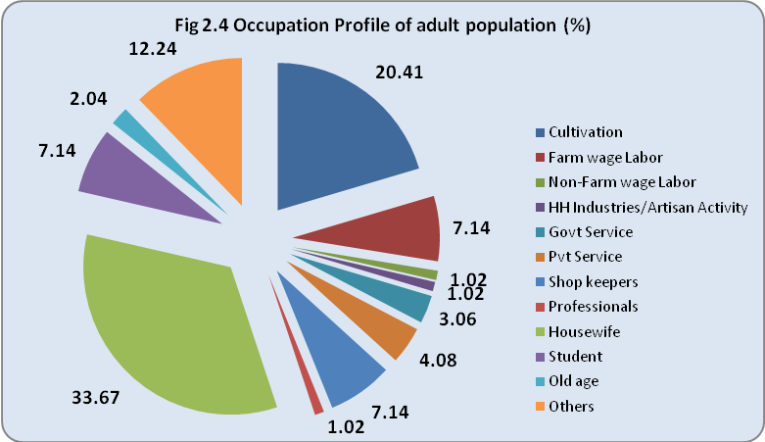
When observed across the usual activity or occupation profile of the total working adult population above 18 years Figure 2.4 shows that a majority (20.41%) are into cultivation. Some are into private and government services. Few are self employed and are lorry/auto drivers, workers in private business establishment etc. This shows that most of the population is also dependent on occupations other than agriculture for their livelihood. A considerable number of them are non working population and are young children, school-going children, aged people and women who are housewives dominate a majority of the population. The women folk in the household stay at home and manage household day-to-day chores.

Table 2.7 below gives the details of the gender wise occupation profile of the total adult affected population who are 18 years and above.

Table 2.7: Gender wise occupation Profile of the affected adult population
Sl.No | Occupation | Male |  | Female |  | Total
Sl.No | Occupation | No | % | No | % | No | %
1 | Cultivation | 19 | 37.25 | 1 | 2.13 | 20 | 20.41
2 | Farm wage Labor | 5 | 9.80 | 2 | 4.26 | 7 | 7.14
3 | Non-Farm wage Labor | 0 | 0.00 | 1 | 2.13 | 1 | 1.02
4 | HH Industries/Artisan Activity | 0 | 0.00 | 1 | 2.13 | 1 | 1.02
5 | Govt Service | 3 | 5.88 | 0 | 0.00 | 3 | 3.06
6 | Pvt Service | 3 | 5.88 | 1 | 2.13 | 4 | 4.08
7 | Shop keepers | 6 | 11.76 | 1 | 2.13 | 7 | 7.14
8 | Professionals | 1 | 1.96 | 0 | 0.00 | 1 | 1.02
9 | Housewife | 0 | 0.00 | 33 | 70.21 | 33 | 33.67
10 | Student | 6 | 11.76 | 1 | 2.13 | 7 | 7.14
11 | Old age | 1 | 1.96 | 1 | 2.13 | 2 | 2.04
12 | Others | 7 | 13.73 | 5 | 10.64 | 12 | 12.24
 | Total | 51 | 100.00 | 47 | 100.00 | 98 | 100.00
2.8 Income levels of the affected Families

Figure 2.5 on the income levels of the affected households shows that out of the total 27 households a majority (25%) each are coming under lower income and higher income group categories of 40,000 to 60,000 rupees and above 90000 rupees per annum. This is followed by 20.83 percent of them who are earning between 60,000 to 90,000 rupees per annum.

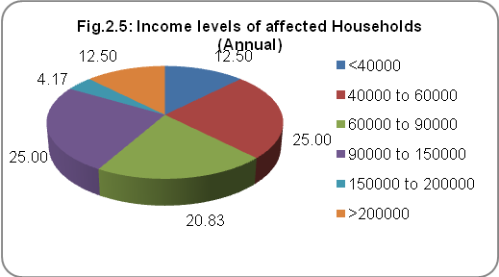
Table 2.8 below gives an in depth understanding of the income from the various sources for the affected households. It is seen from the table that the most important source of income is cultivation (31%) followed by professional services (26.21%).

Table 2.8: Income from various sources for the affected Households
Sl. No | Source of Income | Amount | Percentage to Total
1 | Cultivation | 1017000 | 31.00
2 | Farm wage Labor | 90000 | 2.74
3 | Non-Farm wage Labor | 11400 | 0.35
4 | Shop Keeping | 60000 | 1.83
5 | Business | 172000 | 5.24
6 | Professional | 860000 | 26.21
7 | Govt. Service | 720000 | 21.95
8 | Private Service | 350400 | 10.68
 | Total | 3280800 | 100.00

2.9 Average Land Holding: Before and After Acquisition

With regard to the agricultural land holding, the details shown in Table 2.9 indicate a comparative picture of the land owned by the households before and after the acquisition of land for the sub-station. With regard to the landholding among the affected households it was observed that none of them are becoming land less. However a majority of them before and after acquisition represent marginal farmers holding up to 1 hectare. The total land owned by the affected persons was 58.139 ha and after acquisition it is 37.488 ha with a 36 percent reduction in the total holding.

Table 2.9: Land holding particulars of the affected persons (ha)
Sl. no | Land holding particulars | Before Acquisition |  | After Acquisition
Sl. no | Land holding particulars | No of persons | % to total | No of persons | % to total
1 | Land less | -- | -- | -- | --
2 | Upto 1 hectare | 25 | 65.79 | 26 | 68.42
3 | 1 to 2 hectare | 2 | 5.26 | 7 | 18.42
4 | > 2 hectares | 11 | 28.95 | 5 | 13.16
5 | Land owned before acquisition | 58.139ha
6 | Private Land acquired | 21.14 ha (36.36% of total)
7 | Land owned after acquisition | 36.999 ha
2.10 Asset ownership
Table 2.10 Domestic material assets
Asset name | No of HH | % to total
Kerosene Stove | 13 | 48.15
LPG gas stove | 9 | 33.33
Electric fan | 17 | 62.96
TV | 17 | 62.96
Refrigerator | 7 | 25.93
Computer | 2 | 7.41
Telephone | 6 | 22.22
cell phone | 9 | 33.33
Bicycle | 13 | 48.15
Scooter/motor bike | 6 | 22.22
Others (Sewing Machine) | 1 | 3.70

From Table 2.10 on domestic asset ownership of the affected household it can be seen that a majority own Television (62.96%), electric fan (62.96%), Bicycle (48.15%) and Kerosene stove (48.15%). The ownership of assets such as Refrigerator, computer and others is very low. The ownership of farm-based implements is found to be low. Most of the people for their agricultural activity are found to hire the other farm based implements such as thresher, sprayer and even irrigation pump sets.

2.11 Livestock ownership

The livestock ownership among the affected households are presented in the Table 2.11 below. It is seen from the table that of the total 27 households only 14.81% of them have Buffalo, followed by 7.41 percent of them who have Cows and Bullocks.

Table 2.11: Livestock ownership among the affected households
Livestock name | No of HH | % to total | Total no owned | Average per HH
Buffalo | 4 | 14.81 | 7 | 1.75
Cows | 2 | 7.41 | 3 | 1.50
Bullocks | 2 | 7.41 | 4 | 2.00

  - Indebtedness of the affected households

Another important indicator for the economic status is the indebtedness of the affected family. Table 2.12 shows that out of the 27 households around 5 are found to have outstanding debts. Most of these people have taken the Crop loans and loans for household expenses from local Banks and Co-operative societies.
Table 2.12 Indebtedness of Affected household
Item | No | % to total
Have outstanding loans | 5 | 18.51
Do not have outstanding loans | 22 | 81.48
Total | 27 | 100.00
Total amounts taken | 396000 | xxx
Amounts Repaid | 105000 | 26.52
Amounts Balance | 291000 | 73.48

  - Health profile of affected households

Table 2.13 presents the health status of the affected households. It is seen from the table that around 4 have experienced some health problem in their households. The health problems include Leprosy, Tuberculosis, and Stones in Kidneys.
Table 2.13 Health problems in affected households
(last 3 months)
Item |  | No | % to total
Health problem | Yes | 4 | 14.8
Health problem | No | 23 | 85.15
Health problem | Total | 27 | 100.00
Type of Problems (TB-1, Leprosy-1, Stones in Kidney-1)

  - Summary of the Socio-Economic Survey Findings

The major findings from the socio-economic survey are summarized below. These factors are given due consideration in the preparation of the rehabilitation action plan.

- The impacts associated with the acquisition of 22.2 ha proposed for Solapur sub-station will result in affecting about 27 households who are the owners of the land proposed for acquisition.

- The total affected population is 161 and the average size of the affected households is around 5.96 persons per household. Among the affected population a majority (68.94%) of them are found to be adults who are 18 years and above.

- Religion wise 20 HH represent Hindu community, 6 HH are Muslims and 1HH is Jain. Social Group wise a majority represent the General castes and rests are other backward castes and Scheduled Castes.

- The education levels are moderate as majorities 25.51 percent of them have completed their High School.

- Occupation wise a majority (20.41%) are into cultivation. A considerable number of them are engaged in informal private services such as lorry/auto drivers, workers in private business establishment etc. This shows that most of the population is also dependent on occupations other than agriculture for their livelihood.

- Income levels of the affected households shows that most of them are coming under lower middle income and higher middle income group categories of 40,000 to 60,000 rupees and above 90000 rupees per annum. This is followed by people who are earning between 60,000 to 90,000 rupees per annum.

- All of them have own houses mostly pucca houses and are dependent on Fuel wood for cooking purpose.

- With regard to the landholding among the affected households it was observed that none of them is becoming land less after the acquisition and a majority of them before and after acquisition represent marginal farmers holding up to 1 hectare.

- Domestic asset ownership is seen with a majority own Television (62.96%), electric fan (62.96%), Bicycle (48.15%) and Kerosene stove (48.15%).

- Out of the 27 households around 5 are found to have outstanding debts. Most of these people have taken the Crop loans and loans for Household expenses from local Banks and Co-operative societies.

