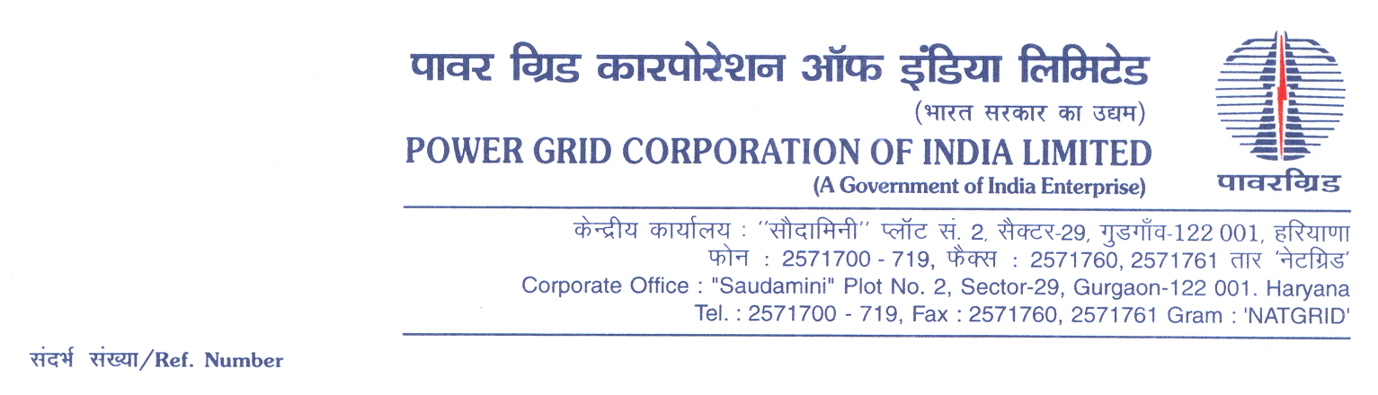

Ref No.: 5002001922/OTHERS/DOM/A04-CC CS -5/OBD Extn-1 **Date:** 03.11.2021

To,

*All prospective Bidders.*

Subject : Rural Electrification Work under Prime Minister’s Development Project (PMDP) in Leh & Kargil Districts of UT of Ladakh

[Spec No.: 5002001922/OTHERS/DOM/A04-CC CS -5]

-***Regards OBD Extension-1***

It may be mentioned here that the subject package tender dates i.e. Bidding Documents downloading, Bids submission and opening dates have been extended as follows:

1) Bidding documents downloading is extended upto 1100hrs on 17.11.2021.

2) Last date for Soft copy part Submission is upto 1100hrs on 17.11.2021

Accordingly, you are requested to keep Bid Security validity as per requisite clause in ITB/BDS.

Thanking You,

Yours Sincerely,

**(C.K.Kamat)**

**Ch. Manager (CS)**