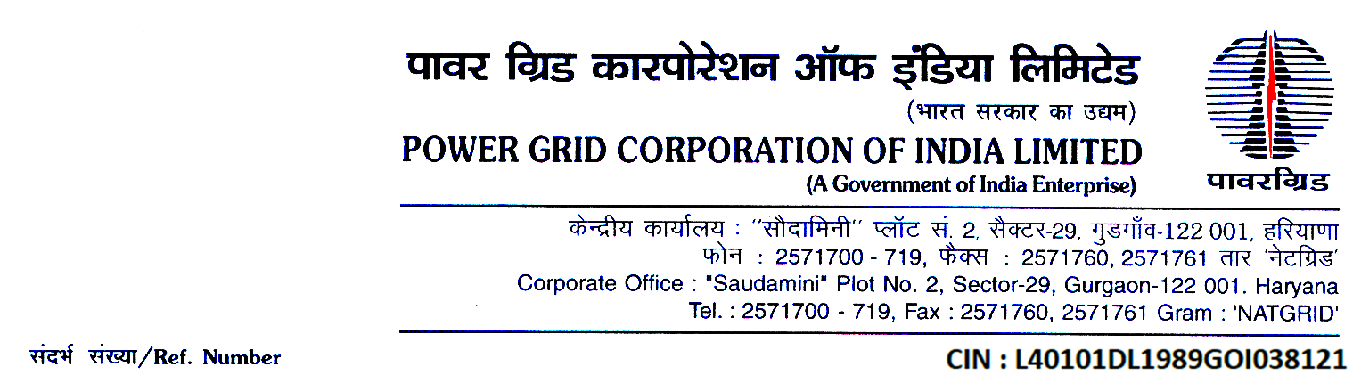

Ref. No.: CC-CS/G2/SS34/ Errata-I Date: 19/08/2019

<< Issued to all bidders through portal https://pgcileps.buyjunction.in>>

Subject: Substation package SS-34 for (i) Extension of 400kV Kanpur S/s including 6 nos. 400 kV, 12 Ohm, 1 ph., Series line reactors. (ii) Extension of 400kV Bhiwani S/s including 3 nos. 400 kV, 12 Ohm, 1 ph. Series Bus reactors & (iii) Extension of 400kV Hissar substation under Scheme to control fault level in Northern Region (Phase - II)”.
Specification No.: CC-CS/932-NR1/SS-3970/3/G2

(Domestic Competitive Bidding; Funding: Domestic)
[Single Stage Two Envelope System (under e-Procurement)]

...Reg. Errata No. I to the Bidding Documents

Dear Sir(s),

- This has reference to Clarification No-II & Amendment No-II to the bidding documents for the subject package uploaded on the portal https://pgcileps.buyjunction.in on 26/07/2019.

- Wherever “Amendment-I” or “Amendment no-1” is appearing in said Clarification No. II, the same shall be read as “Amendment No-II”.

- Save and Except for the changes brought-out in the above mentioned Errata No-I, all other terms and conditions of the original bidding documents along with subsequent Amendments shall remain unaltered.

Thanking you,

For and On behalf of
Power Grid Corporation of India Limited

