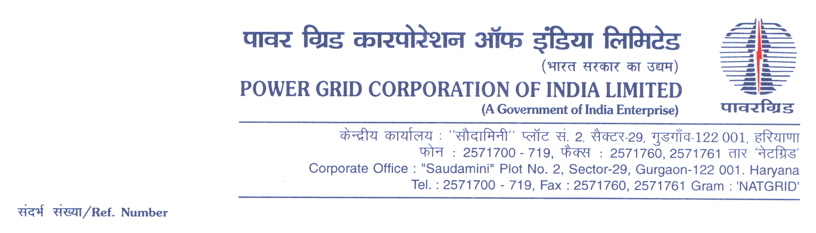

Ref No.: CC-CS/G4/TW31/OBD Extn-1 **Date:** 18.02.2021

To,

*All prospective Bidders.*

Subject : Transmission Line Package TW31 including tower, conductor, insulators, OPGW (INSTALLATION AND COMMISSIONING ONLY), hardware fitting and accessories for conductor for (i) 132kV S/C (on D/C towers) Khupi – Bomdila, (ii) 132kV S/C (on D/C towers) Bomdila –Tawang, (iii) 132kV S/C (on D/C towers) Bomdila – Kalaktang and EHV Substations: (i) 132/33 kV Bomdila (New) S/S, (ii) 132/33 kV Kalakthang (New) S/S, (iii) 132/33 kV Tawang (New) S/S and (iv) 132kV Khupi (extension) S/S associated with Comprehensive Scheme for Strengthening of Transmission & Distribution system in Arunachal Pradesh-***Regards OBD Extension-7***

It may be mentioned here that the subject package tender dates i.e. Bidding Documents downloading, Bids submission and opening dates have been extended as follows:

1) Bidding documents downloading is extended upto 1100hrs on 26.02.2021.

2) Last date for Soft copy part Submission is upto 1100hrs on 26.02.2021

3) Last date for Hard copy part Submission is upto 1100hrs on 02.03.2021

Accordingly, you are requested to keep Bid Security validity as per requisite clause in ITB/BDS.

Thanking You,

Yours Sincerely,

**(C.K.Kamat)**

**Ch. Manager (CS)**