 |  | 
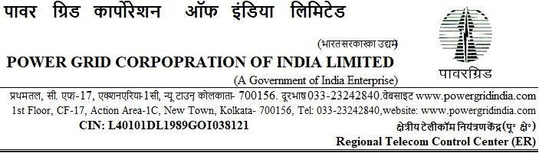

Ref: ERTCC/CS/20-21/I-236/T-175/AFSS (RFx 5002001381) /Amnd.I & Clar I Date: 23.09.2020

To

<< Issued to all bidders through portal https://etender.powergrid.in>>

Subject: Supply, installation & commissioning of Automatic Fire Suppression System at 10 nos. telecom locations under ERTCC

-Regarding Amendment No. I & Clarification No. I to the RfP Documents.

Tender Specification ref: ERTCC/CS/20-21/I-236/T-175/AFSS (RFx 5002001381).

Dear Sir,

- This has reference to the RfP documents for the subject Package which was uploaded on the portal https://etender.powergrid.in.

- Please find enclosed herewith Amendment No. I & Clarification No. I to the RfP Documents. The Amendment No. I & Clarification No. I shall be read in conjunction with the RfP Documents, referred to at para 1.0 above, and shall become an integral part thereof as though it has occurred therein.

- Save and except for the changes brought-out in the above mentioned Amendment No. I & Clarification No. I all other terms and conditions of the original RfP documents, shall remain unaltered.

Thanking you,

Yours faithfully,

(Nand Jee)
Ch. Manager (CS), ERTCC, Kolkata

