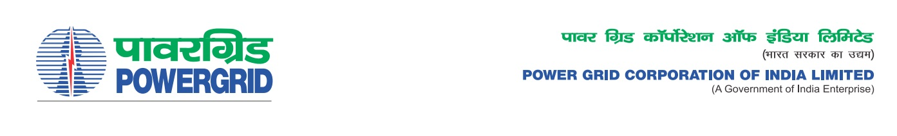****

Ref No.: TBCB/U-NMS/G4/OBD Extn-4  **Date:** 11.01.2021

To,

*All prospective Bidders.*

Subject : Package – I :Unified Network Management System (U-NMS) for Central Sector & State Sector Communication in NER under Establishment of State of Art Unified Network Management System (U-NMS) for ISTS & State Utility Communication network in North Eastern Region (NER)

[Spec No.: CC-CS/1057-NER/CommEqp-4167/3/G4]

-***Regarding Extension of deadline of bid submission/ Opening***

It may be mentioned here that the subject package tender dates i.e. Bidding Documents downloading, Bids submission and opening dates have been extended as follows:

1) Last date for Soft copy part Submission is upto 1100hrs on 22.01.2021

2) Last date for Hard copy part Submission is upto 1100hrs on 27.01.2021 and

3) Bids will be opened at 1130Hrs on 27.01.2021

Thanking You,

Yours Sincerely,

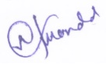

**(Naba Kumar Mondal)**

**DGM (CS)**