Ref. No.: CC/T/W-TW/DOM/A00/26/04468 Date: 17/06/2026

<< Issued to all bidders through portal https://etender.powergrid.in >>

Sub: Transmission Line Package TL07 for ±800 kV HVDC Bipole line (Hexa lapwing) between Barmer-II (HVDC) & South Kalamb(HVDC) (Part-VII) associated with Transmission system for evacuation of power from Rajasthan REZ Ph-IV (Part-5 :6 GW) [Barmer Complex] Barmer-II: 6 GW (Solar) through tariff based competitive bidding (TBCB) route.

Spec. No. CC/T/W-TW/DOM/A00/26/04468
(Domestic Competitive Bidding; Funding: Domestic)
[Single Stage Two Envelope System (under e-Procurement)]

...Reg. Extension of Date of submission of request reg. issuance of Bidding Documents and deadline of Bid Submission Date.

Dear Sir(s),

1.0 This has reference to the NIT/IFB for the subject package uploaded on the portal https://etender.powergrid.in.
1.1 The dates of submission of request reg. issuance of Bidding Documents and deadline for Bid Submission Dates are hereby extended and rescheduled as per the following program:
 | Existing Schedule | Revised Schedule
Last date of Submission of request reg. issuance of Bidding Documents | Up to 15/06/2026 | 17/06/2026
Bid Submission:
For Soft Copy part of bids: | Up to 17/06/2026 | 19/06/2026

2.0 Except for the above, all other terms and conditions of the Bidding Documents thereof remain unchanged.

Thanking you,
For and on behalf of
Power Grid Corporation of India Limited

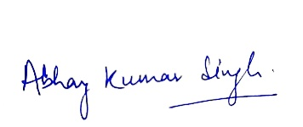
Abhay Kumar Singh
Ch Manager (CS-G1)

