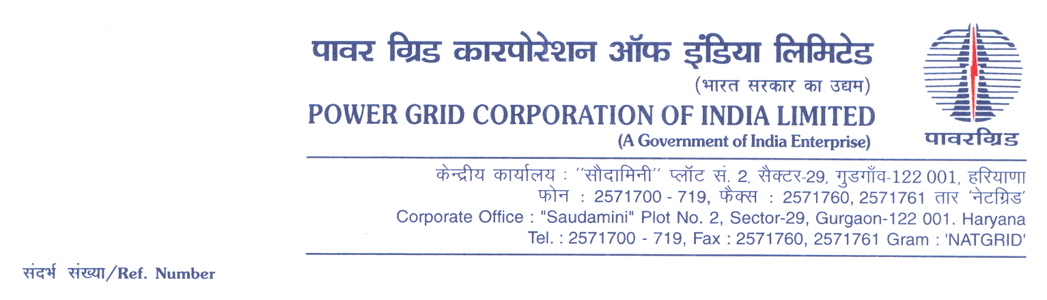

Ref No.: CC-CS/G5/SS75/OBD Extn-01 **Date:** 03.03.2022

To,

*All prospective Bidders.*

Subject : 220kV GIS Substation Package SS-75: For

(i) Extension of 220kV Drass (GIS) Substation & Extension of 220kV Alusteng (AIS) Substation under Transmission System Strengthening of Srinagar Leh Transmission System and

(ii)Extension of Drass and 66/11kV New Zoji la East (GIS) S/S under consultancy services to NHIDCL.

[Spec No.: 5002002162/GIS-EXCLUDING/DOM/A04-CC CS -5]

-***Regards OBD Extension-01***

It may be mentioned here that the subject package tender dates i.e. Bidding Documents downloading, Bids submission and opening dates have been extended as follows:

1) Bidding documents downloading is extended upto 1100hrs on 11.03.2022.

2) Last date for Soft copy part Submission is upto 1100hrs on 11.03.2022

3) Last date for Soft copy part Submission is upto 1100hrs on 15.03.2022

Accordingly, you are requested to keep Bid Security validity as per requisite clause in ITB/BDS.

Thanking You,

Yours Sincerely,

**(C.K.Kamat)**

**Ch. Manager (CS)**