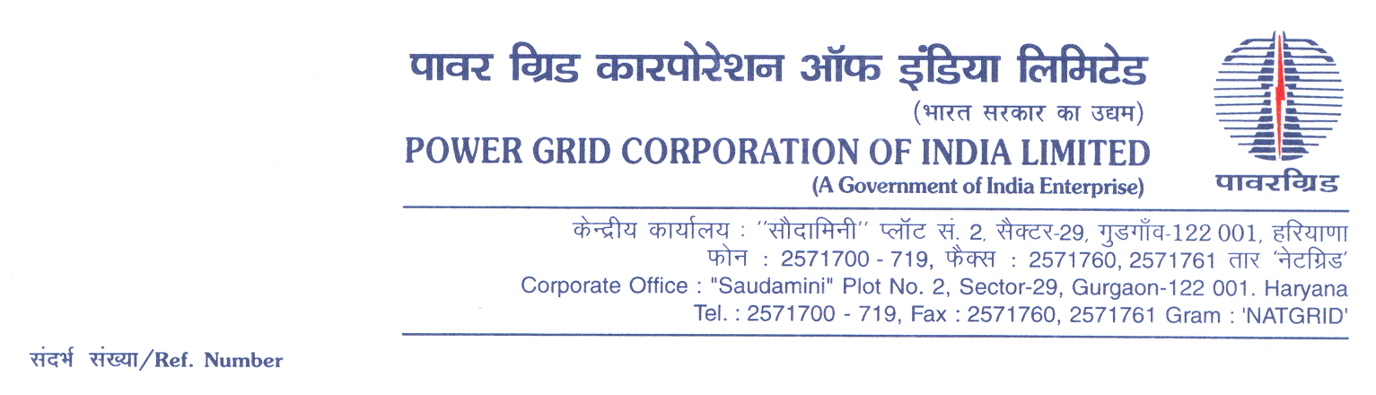

**Ref No.: CC-CS/906-NR2/RT-3926/3/G4/OBD Extn-2 Date 26.02.2019**

To,

*All prospective Bidders.*

Subject : **220 kV, 25 MVAr 3-Ph, Bus Reactor Package -RT- 07** for (i) 1x25MVAr, 220kV Bus Reactor at Jind Sub-Station, (ii) 1x25MVAr, 220kV Bus Reactor at Fatehabad Sub-Station, (iii) 1x25MVAr, 220kV Bus Reactor at Kishenpur Sub-Station (iv) 1x25MVAr, 220kV Bus Reactor at Jallandhar Sub-Station, (v) 1x25MVAr, 220kV Bus Reactor at Amritsar Sub-Station and (vi) 1x25MVAr, 220kV Bus Reactor at Mandola Sub-Station under Northern Region Strengthening Scheme (NRSS) - XL [Spec No.: CC-CS/906-NR2/RT-3926/3/G4)].

-***Regards OBD Extension-1***

It may be mentioned herethat the subject package tender dates i.e. Bidding Documents downloading, Bids submission and opening dates have been extended as follows:

1) Bidding documents downloading is extended upto 1055hrs on 06.03.2019.

2) Last date for Soft copy part Submission is upto 1100hrs on 06.03.2019

3) Last date for Hard copy part Submission is upto 1100hrs on 08.03.2019 and

4) The Bids will be opened at 1130Hrs on 08.03.2019

Accordingly, you are requested to keep Bid Security validity as per requisite clause in ITB/BDS.

Thanking You,

Yours Sincerely,



**(C.K.Kamat)**

**Manager (CS)**