S.No | Ref Clause No. | Provision in Bidding documents | Bidder’s Queries | POWERGRID Reply
1 |  | 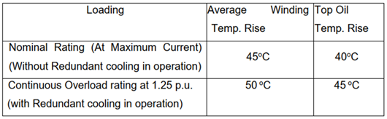 | 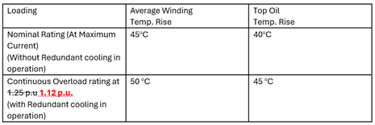  This needs to be modified: 1.25 p.u  The losses will increase in square proportion | Refer an Amendment No. 2 to the bidding documents attached herewith.
  The technical specifications for overload requirement specifies as follows:

