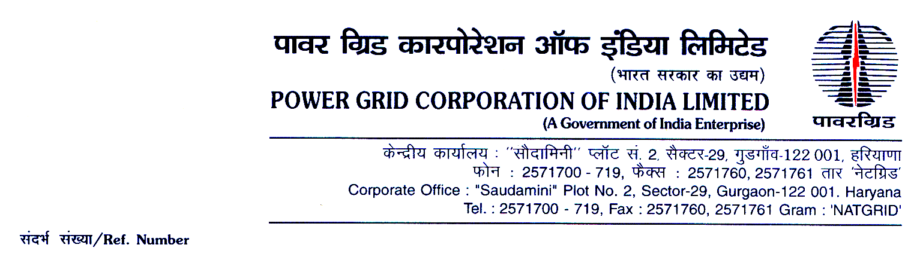

Ref. No.: CC-CS/93-NER/SS-4007/3/G2/ Clarification-VII Date: 31/10/2019

<< Issued to all bidders through portal https://pgcileps.buyjunction.in>>

Subject: Substation Package SIK-SS01 for (i) 220/132kV Legship Pool (New) s/s, (ii) 132/66/11kV Dikchu pool (new) s/s, (iii) 66/11kV Makha (New) s/s, (iv) 66/11kV Temi (New) s/s, (v) 66/11kV Khamdong (New) s/s, (vi) 66/11kV Kumrek (New) s/s, (vii) 66/11kV Namthang (New) s/s, (viii) 66/11kV Rorathang (New) s/s & (ix) 66/11kV Mamring s/s Extn. associated with Comprehensive Scheme for Strengthening of Transmission and Distribution System in Sikkim.
Specification No.: CC-CS/93-NER/SS-4007/3/G2

- Regarding Clarification No-VII to the Bidding Documents

Dear Sir,

- This has reference to Amendment No. III to the bidding documents of the subject Package which was uploaded on the portal https://pgcileps.buyjunction.in on 17/10/2019.

  - Please note that as per Sl. No. 10 of above said Amendment No-III, items pertaining to Power & Control Cables System for Extn. of 66kV Mamring S/S has been deleted.

  - In line with 1.1 above, the said items have also been removed from Schedule-1 (i.e. Ex-works Schedule) and Schedule-2 (i.e. F&I Schedule) of revised price schedule uploaded along with Amendment No. IV dated 23/10/2019 (Second Envelope Price Schedules_SS01-Sikkim(Rev02))

  - However, inadvertently the above referred items [listed at Sl. Nos. 986, 987, 988, 989, 990, 991, 992, 993, 994, 995, 996 & 997 in Schedule-3 of Second Envelope Price Schedules_SS01-Sikkim(Rev02)] were not deleted from Schedule-3 (i.e. installation charges).

2.0 In view of the above, you are requested to note that through this communication the above said items (i.e. at Sl. Nos. 986, 987, 988, 989, 990, 991, 992, 993, 994, 995, 996 & 997 of Schedule-3 in Second Envelope Price Schedules_SS01-Sikkim(Rev02)) stands deleted from the Price Schedule. You are requested not to quote against the said items in Schedule-3.

Please note in the event of a bidder quoting its prices against any of the above referred items in Schedule-3, the same shall not be considered for working out their Net Corrected Price for the purpose of evaluation.

- Save and Except for the changes brought-out in the above mentioned Clarification No-VII all other terms and conditions of the original bidding documents, shall remain unaltered.

Yours faithfully,

