S. No. | Clause No. | Bidder Query | Clarification
 | Price Schedule in Vol-III of Bidding document | This has reference to the discussion, undersigned had with your Commercial as well as Technical team regarding price schedule item HYBRID GIS (Row No. 70/71/72(under s.no. D- Bay works at Bhadla PS).  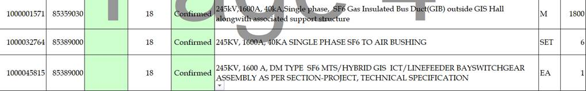  In this reference we would like to inform you that these product specs are complied by just one manufacturer which is not giving us offer for this item in spite of repeated requests.  We also manufacture the product (outdoor GIS), but comply the below-  “If 220 kV AIS bus bar is extended with GIS bus-bar and if it is required to carry out online bus transfer switching then rated bus transfer voltage for disconnectors shall be as per Gas Insulated Disconnectors i.e. 20 V as per IEC 62271-102”.  So, request please confirm the above specs to offer our product for the project. | The requirement of bidding documents shall prevail.

