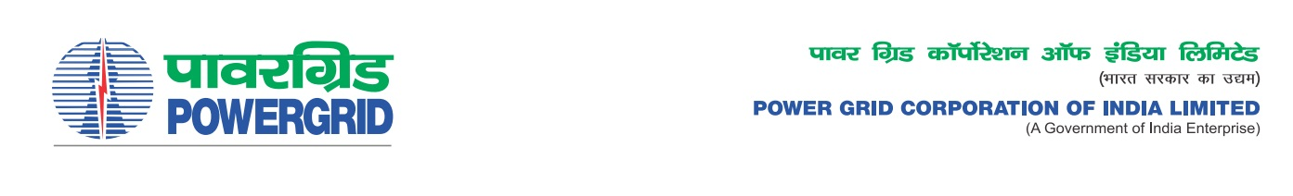****

Ref No.: CC-CS/G5/ISTS/TR-34/OBD Extn-2  **Date:** 06.10.2021

To,

*All prospective Bidders.*

Subject : Transformer Package TR34 for a) Supply of 1X 500MVA, 420/220/33kV Auto transformer at Bhadla pooling S/S including associated bays, b) Supply of 1X 500MVA, 420/220/33kV Auto transformer at Shujalpur S/s including associated bays, c) Extension of 220kV Shajhanpur S/S, d) Implementation of 1X 80 MVAR , 765kV Spare Reactor at Bhadla S/S, e) Supply of 1X 500MVA, 420/220/33kV Auto transformer at Kohchi S/S, f) Supply of 1X 500MVA, 420/220/33kV Auto transformer at Hiriyur S/S under New ISTS Schemes to be developed under RTM mode. Spec. No.: 5002001872/TRANSFORMER/DOM/A03-CC CS-4

-***Regarding Extension of deadline of bid submission/ Opening***

It may be mentioned here that the subject package tender dates i.e. Bidding Documents downloading, Bids submission and opening dates have been extended as follows:

1) Last date for bid submission is upto 1100hrs on 20.10.2021

2) Bids will be opened at 1130Hrs on 20.10.2021

Thanking You,

Yours Sincerely,

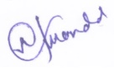

**(Naba Kumar Mondal)**

**DGM (CS-G5)**