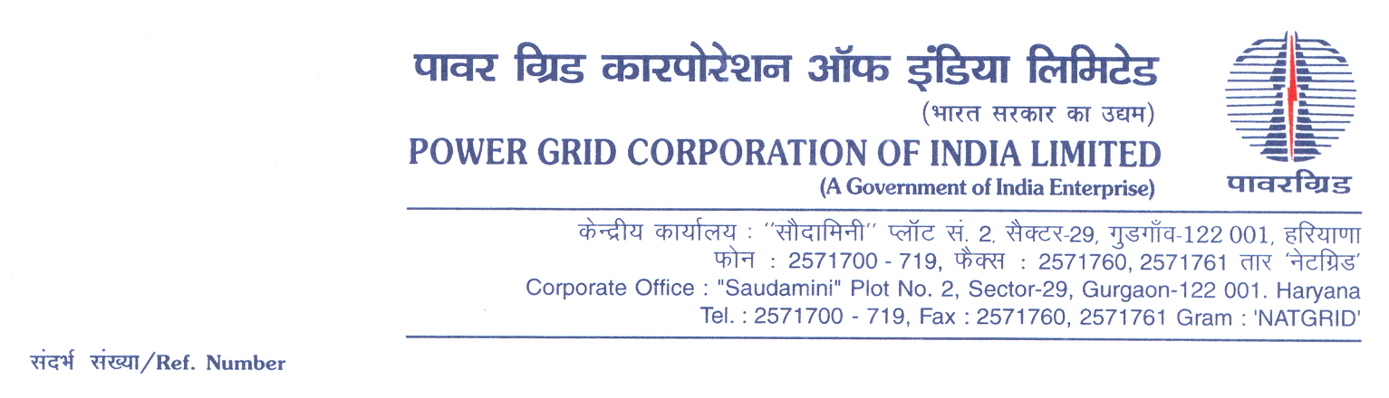

**Ref No.: CC-CS/906-NR1/RT-3925/3/G4/OBD Extn-2 Date 26.02.2019**

To,

*All prospective Bidders.*

Subject : **Reactor Package -RT- 06 for (i) 1x125MVAr, 400kV Bus Reactor at Kishenpur Sub-Station, (ii) 1x125MVAr, 400kV Bus Reactor at Maharanibagh (GIS) Sub-Station, (iii) 1x125MVAr, 400kV Bus Reactor at Mandola Sub-Station (iv) 1x125MVAr, 400kV Bus Reactor at Hissar Sub-Station, (v) 1x125MVAr, 400kV Bus Reactor at Chamera (GIS) Pooling Sub-Station, (vi) 1x125MVAr, 400kV Bus Reactor at Moga Sub-Station, (vii) 1x125MVAr, 400kV Bus Reactor at Sikar Sub-Station, (viii) 1x125MVAr, 400kV Bus Reactor at Allahabad Sub-Station, (ix) 1x125MVAr, 400kV Bus Reactor at Meerut Sub-Station, (x) 1x125MVAr, 400kV Bus Reactor at Jallandhar Sub-Station and (xi) 1x125MVAr, 400kV Bus Reactor at Patiala Sub-Station under Northern Region Strengthening Scheme (NRSS)- XL**[Spec No.: CC-CS/906-NR1/RT-3925/3/G4)].

-***Regards OBD Extension-1***

It may be mentioned herethat the subject package tender dates i.e. Bidding Documents downloading, Bids submission and opening dates have been extended as follows:

1) Bidding documents downloading is extended upto 1055hrs on 06.03.2019.

2) Last date for Soft copy part Submission is upto 1100hrs on 06.03.2019

3) Last date for Hard copy part Submission is upto 1100hrs on 08.03.2019 and

4) The Bids will be opened at 1130Hrs on 08.03.2019

Accordingly, you are requested to keep Bid Security validity as per requisite clause in ITB/BDS.

Thanking You,

Yours Sincerely,



**(C.K.Kamat)**

**Manager (CS)**