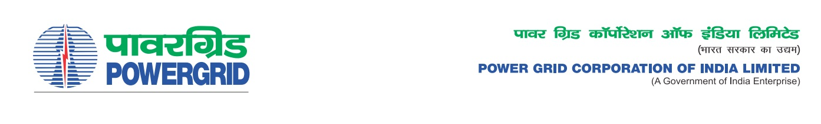****

Ref No.: CC-CS/G5/NERPSIP/PKG-B/OBD Extn-3

**Date:** 18.02.2022

To,

*All prospective Bidders.*

Subject : **Township Works Package-B** for construction of Residential and Non-residential buildings including external infrastructural development in various substations of **Tripura state** associated with NER Power System Improvement Project. Spec. No.: 5002001951/CONSULTANCY GIVEN/DOM/A04-CC CS -5

-***Regarding Extension of deadline of bid submission/ Opening***

It may be mentioned here that the subject package tender dates i.e. Bidding Documents downloading, Bids submission and opening dates have been extended as follows:

1) Last date for bid submission is upto 1100 hrs on 25.02.2022

2) Bids will be opened at 1130 Hrs on 25.02.2022

Thanking You,

Yours Sincerely,

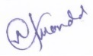

**(Naba Kumar Mondal)**

**DGM (CS-G5)**