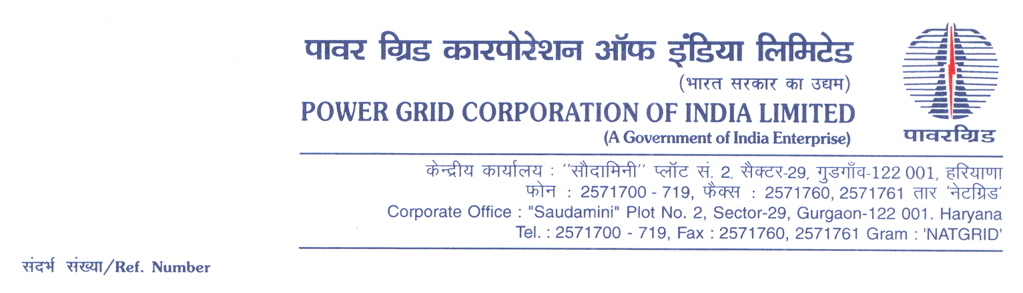

Ref No.: CC-CS/950-ER1/GIS-3977/3/G4/OBD Extn-1 **Date:** 03.07.2019

To,

*All prospective Bidders.*

Subject: **GIS Substation package – SS-28 for the Consultancy Services to BGCL for Augmentation of Bus Reactors & ICT under Transmission System associated with BGCL Phase – IV, Part-II**

[Spec No.: CC-CS/950-ER1/GIS-3977/3/G4]

-***Regarding OBD Extension-1***

It may be mentioned here that the subject package tender dates i.e. Bidding Documents downloading, Bids submission and opening dates have been extended as follows:

1) Bidding documents downloading is extended upto 1055hrs on 17.07.2019.

2) Last date for Soft copy part Submission is upto 1100hrs on 17.07.2019

3) Last date for Hard copy part Submission is upto 1100hrs on 19.07.2019 and

4) The Bids will be opened at 1130Hrs on 19.07.2019

Accordingly, you are requested to keep Bid Security validity as per requisite clause in ITB/BDS.

Thanking You,

Yours Sincerely,



**(C.K.Kamat)**

**Manager (CS)**