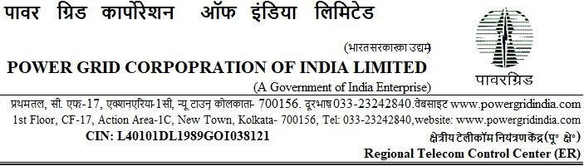
Ref: ERTCC/CS/19-20/I-161/T-155/Pkg I-2/Bid Sub-Extn Date: 07.06.2019

To

<< TO ALL THE BIDDERS >>

Subject: Repeater Shelter and Air Conditioners package for augmentation of Telecom Backbone and Access Network (Pkg:I-2),

Tender Specification ref: ERTCC/C&M/19-20/I-161/T-155/Shelter_AC/Pkg I-2.

(Open Tendering under e-procurement)
[Single Stage Two Envelope System]

...Reg. Extension of deadline of Submission of Bids.

Dear Sir(s),

1.0 This has reference to the biding documents for the subject package uploaded on the portal https://pgcileps.buyjunction.in.

1.1 The deadline for submission of Bids are hereby extended and rescheduled as per the following program:

Bid Submission:
Soft Copy Part of bids:
extended upto: Date: 19.06.2019, Time: 1100 Hrs (IST)
Hard Copy part of bids:
Date: 21.06.2019, Time: upto 11:00 Hrs (IST)

Bid Opening (First Envelope):
Date: 21.06.2019, Time: at 11:30 Hrs (IST)

1.2 You are requested to ensure validity of Bid, to be submitted by you, based on the above revised schedule.

2.0 Except for the above, all other terms and conditions of the RfP Documents thereof remain unchanged.

Thanking you,
Yours faithfully,

(Nand Jee)
Ch. Manager (CS), ERTCC, Kolkata

