EXPRESSION OF INTEREST (EoI)
FOR
PROCUREMENT OF HEAVY LIFT PROGRAMMABLE DRONE

 | 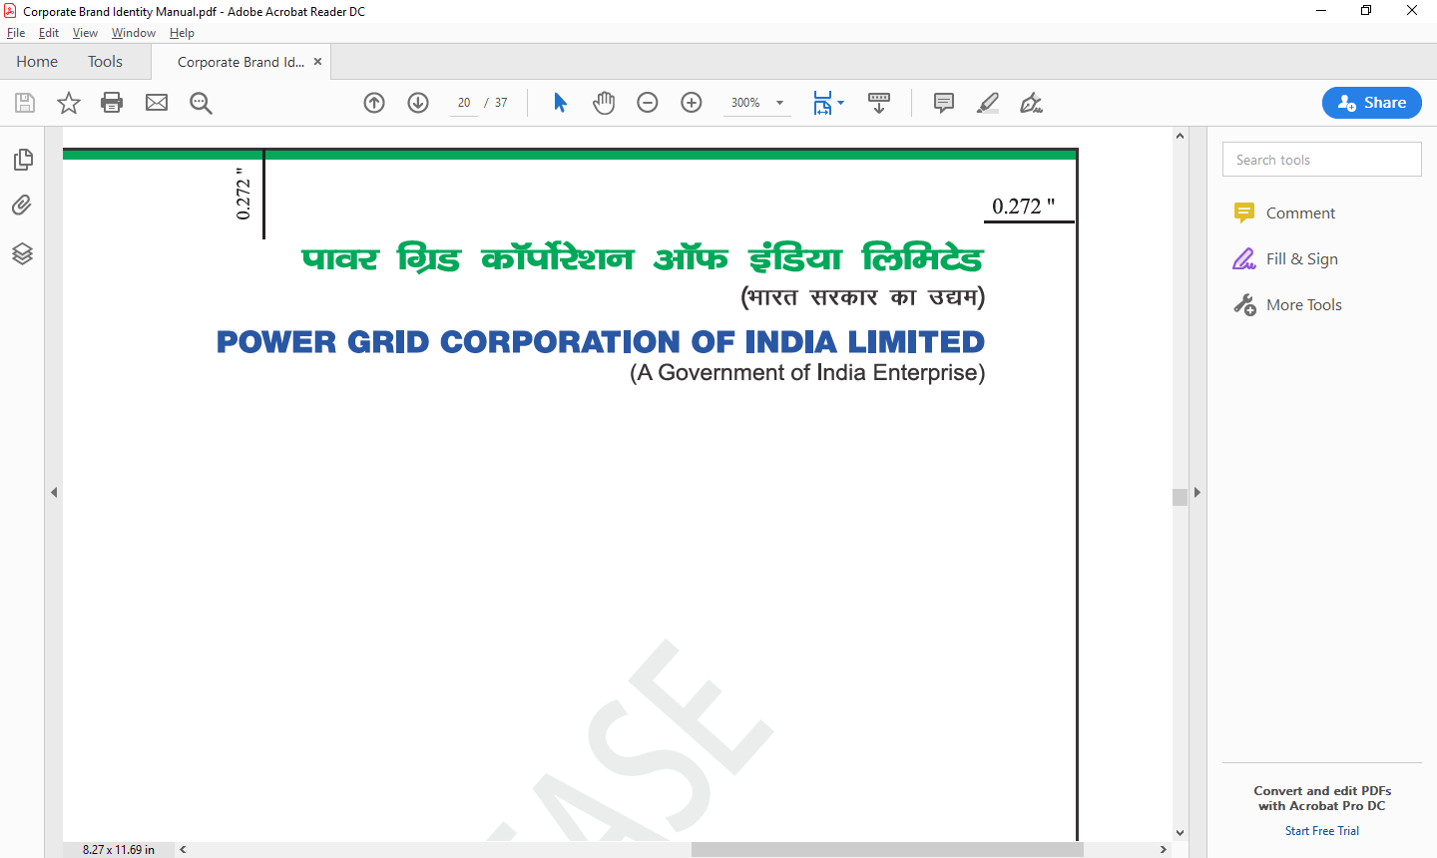

POWER GRID CORPORATION OF INDIA LIMITED
(A Govt. of India Undertaking)

NOTICE INVITING EXPRESSION OF INTEREST (EOI) FOR PROCUREMENT OF HEAVY LIFT PROGRAMMABLE DRONE

Power Grid Corporation of India Ltd. (A Government of India Enterprise) incorporated under the Companies Act, 1956, having its Registered Office at B-9, Qutab Institutional Area, Katwaria Sarai, New Delhi – 110016 (hereinafter referred to as ‘POWERGRID’/’Owner’/’Employer’) has decided to set up, as an Owner, “Expression of Interest (EoI) for Procurement of Heavy Lift Programmable Drone”.
1.0 This Notice Inviting Expression of Interest follows the e-procurement notice which appeared in National and Regional Newspapers on 05.01.2024. This shall also be available on POWERGRID’s website (http://www.powergrid.in), on Government of India’s Central Public Procurement Portal (https://eprocure.gov.in) and e-procurement portal given at para 2.0 below on the same date
2.0 Important Instruction for participation in subject EoI:
- The complete EoI Documents are available at POWERGRID’s website http://www.powergrid.in.
- Applicants shall ensure that their Application, complete in all respects, are submitted online through portal only. No DEVIATION in this regard is acceptable.
3.0 Interested Applicants may obtain further information regarding this EoI from the office of Sr. General Manager (TD-Deptt)/ Manager (TD-Deptt), POWERGRID at the address given at para 5.0 below from 15:00 hours to 17:00 hours on all working days.
For proper uploading of the Application, it shall be the sole responsibility of the Applicants to apprise themselves adequately regarding all the relevant procedures and provisions as detailed at the portal as well as by contacting from POWERGRID, as and when required, for which contact details are mentioned below. POWERGRID in no case shall be responsible for any issues related to timely or properly uploading/submission of the Application in accordance with the relevant provisions of the EoI Documents.
4.0 Soft Copy Part of the Applications must be emailed to abhishek@powergrid.in/pradeep.7@powergrid.in at or before 20.01.2024.
The Applicants may please note that there is no Application fee for this EoI process.
Applicants shall submit details after ensuring that they are meeting all our requirements stipulated in EoI Document. The application shall be submitted strictly as per POWERGRID’s format (Section–4).
5.0 All correspondence with regard to the above shall be marked to the following:
Sr. General Manager (TD-Deptt)/ Manager (TD-Deptt),
Power Grid Corporation of India Limited,
Mobile: +91- 9910379471/ 7042892657
Telephone: 0124-286-3611
Email: abhishek@powergrid.in/pradeep.7@powergrid.in
6.0 Notwithstanding anything stated herein above, POWERGRID also reserves the right to annul the aforesaid EoI process any time and may, at its option without assigning any reason, and shall bear no liability whatsoever consequent upon such a decision.

SECTION – 1: INTRODUCTION
1.0 Purpose of this EoI
1.1 India is targeting for 500GW of non-fossil fuel installed capacity by 2030. About 50,890 ckm of transmission lines and 4,33,575 MVA of substation capacity is required in next 6-7 years for integration of this additional capacity at an estimated cost of 2,44,200 Crore. As the capacity additions are expected in remote hot and cold deserts, the transmission systems may have to traverse through difficult terrains like mountainous and hilly areas, wide water bodies, large forest areas etc. to connect with load centres. Also, the transmission system needs to be established in a short time frame due to the low gestation periods of solar and wind generation projects. However, transportation of construction materials to difficult terrains for facilitating construction at a fast pace is challenging.
1.2 To address these challenges and difficulties, the use of Heavy Lift Programmable Drones with a payload of 100kg is envisaged. Further, considering heavy lift drone as emerging technology and its operation is to be programmed as well as customized for lifting to high altitudes, POWERGRID vide this EoI intends to identify indigenous heavy lift programmable drone manufacturers for procurement of such technological device.
1.3 This Heavy Lift Programmable Drone shall be used for transporting transmission line construction material such as Tower parts of transmission line (approx. length around 6-7meter), Cement Bag, Sandbag, Insulator string along with hardware (approx. length 4-5m) to required location in hilly terrain and inaccessible areas.

- End -

SECTION – 2: ELIGIBILITY CRITERIA & BROAD TECHNICAL REQUIREMENT

- ELIGIBILITY CRITERIA

This EoI is open to all firms who are registered and incorporated in India as per the local act, barring firms against whom sanction for conducting business is imposed by Government of India and barring those firms with whom business is banned by POWERGRID.
Eligibility criteria includes the following:
- Certification in compliance of DoE Order in line with CC-CS Circular No. 09/2023 dated 12.04.2023 (titled 'Restriction under Rule 144(xi) of the General Financial Rules, 2017').
- Vendors who has supplied at-least 50kg payload drone.
- Applicant shall disclose information regarding status of local content (viz. Class-I Local Supplier, Class-II Local Supplier or Non-Local Supplier) along with MLC with respect to PPP-MII Order, Iron & Steel policy.
- The Applicant must be registered and incorporated in India under Indian Company Act 1956 or 2013, as the case may be/ Indian Partnership Act 1932/The Indian Factories Act 1948/Any relevant Indian Laws, whichever is applicable.
- The Applicant must have GST Registration No. / Permanent Account No. (PAN)/ PF code no., whichever applicable.

- BROAD TECHNICAL REQUIREMENT

Objective | To transport construction material to required location in hilly terrain and inaccessible areas
Type of Material to transported | - Tower parts of transmission line (approx. length around 6-7 meter)  - Cement Bag  - Sandbag  - Insulator string along with hardware (approx. length 4-5m)
Take-off and Landing | VTOL (Vertical Take-Off and Landing)
Power type | Electric/batteries
Payload | Min 100 kg
Operating Altitude | 3500-5000m from AMSL
Operating Temperature | -30⁰C to +50⁰C
Safety & redundancy | - Redundant Propeller  - Redundant Motor, Redundant Power Source  - Reliable communication link between the aircraft & ground control Station  - Flight Display, Flight Control, Flight Joystick  - Low Battery Alarm, Low Link Alarm, Thermal Alarm  - Battery Health Monitoring  - High Vibration Alert  - Redundant GNSS Sensors  - Sensor Health Indication  - Ballistic Parachute
Endurance | Min 45 Minutes
Sensors | - Gyroscope  - Acceleration Sensors  - Magnetic Field Measurement Sensors  - Barometer  - Lidar Sensors
Modes | - Hover  - Joystick Roll  - Joystick Pitch  - Joystick Yaw  - Emergency Control
Power
Batteries | Rechargeable Lithium Batteries
Cooling | Active Air Cooling
Charging time | < 120 minutes
Fast Charging | < 60 minutes
Performance
Flight Range | Min 20 km
Cruise Speed | 10 m/s

SECTION – 3: INSTRUCTIONS TO APPLICANTS

1. There is no Application fee for this EoI process. Applicants shall submit the Application to this EoI in the prescribed Forms and Formats as contained in Section - 4.
1.1 The EoI Documents are available at POWERGRID’s website http://www.powergrid.in, as well as on Government of India’s Central Public Procurement Portal (https://eprocure.gov.in). Interested Applicants can download the EoI Documents and commence preparation.
1.2 The amendment/clarification, if any, to the EoI documents will be notified only through the portal.
1.4 Applicants are requested to provide complete and precise information in the space provided along with supporting documentary evidences, as applicable. The Applicants should attach separate sheet(s) in case the space provided is not sufficient. POWERGRID will consider the Applications solely on the basis of information/details/data/documentary evidences etc. provided by the Applicants in the Applications only without seeking further clarifications from the Applicants in normal circumstances. Accordingly, the Applicants are required to furnish complete and precise information along with supporting documentary evidences as applicable in the Applications as the same shall be treated as final and no further clarifications may be sought by POWERGRID from the Applicants for qualification or evaluation purposes.
Incomplete, partially complete, not clearly filled forms giving incorrect information are liable to be rejected without any consideration.
Where the answer is a statement of fact, it must be accurate and supported by documentary evidence wherever required. It is the Applicant’s responsibility to respond with such clarity that will ensure POWERGRID not to misinterpret any of the Applications.
1.5 The Application to be submitted alongwith relevant supporting documentary evidences etc. must be signed and stamped with company seal by a person duly authorized to sign on behalf of the Applicant.
2. Deadline for submission of Applications:
Deadline for submission of Application complete in all respect through email on or before 20/01/2024.
3. The EoI Document is meant for the exclusive purpose of facilitating POWERGRID and shall not be transferred to any other party or reproduced or used otherwise for any purpose other than for which they are specifically provided.
Further, all the costs associated with preparation of Applications, submission of the same to POWERGRID etc. shall be borne by the Applicants only.
4. Others
4.1 POWERGRID reserves the right to call for additional information and/or check, verify all the information furnished in the Application. POWERGRID also reserves the right to inspect all premises / facilities to confirm the authenticity of information furnished / capabilities mentioned in the Application.
4.2 POWERGRID reserves the right to reject any or all the Applications without assigning any reasons whatsoever.
4.3 POWERGRID’s decision shall be final on all matters.
4.5 Applicants to note that Applications with conditions unacceptable to POWERGRID shall be rejected.
GENERAL TERMS AND CONDITIONS
- POWERGRID reserves the right to reject the EoI in case of any discrepancies/mismatch.
- The EoI should be unconditional. Conditional EoI shall be out rightly rejected.
- POWERGRID shall not compensate in any manner for the expenses incurred in connection with preparation and submission of EoI.

- End –
SECTION – 4: FORMATS

FORM A: COMPLIANCE of BROAD TECHNICAL REQUIREMENT
(TO BE SUBMITTED ONLINE ONLY)

Description | Requirement | Compliance (Yes/No)
Type of Material transported | - Tower parts of transmission line (approx. length around 6-7 meter)  - Cement Bag  - Sandbag  - Insulator string along with hardware (approx. length 4-5m)
Take-off and Landing | VTOL (Vertical Take-Off and Landing)
Power type | Electric/batteries
Payload | Min 100 kg
Operating Altitude | 3500-5000m from AMSL
Operating Temperature | -30⁰C to +50⁰C
Safety & redundancy | - Redundant Propeller  - Redundant Motor, Redundant Power Source  - Reliable communication link between the aircraft & ground control Station  - Flight Display, Flight Control, Flight Joystick  - Low Battery Alarm, Low Link Alarm, Thermal Alarm  - Battery Health Monitoring  - High Vibration Alert  - Redundant GNSS Sensors  - Sensor Health Indication  - Ballistic Parachute
Endurance | Minimum 45 Minutes
Sensors | - Gyroscope  - Acceleration Sensors  - Magnetic Field Measurement Sensors  - Barometer  - Lidar Sensors
Modes | - Hover  - Joystick Roll  - Joystick Pitch  - Joystick Yaw  - Emergency Control
Power
Batteries | Rechargeable Lithium Batteries
Cooling | Active Air Cooling
Charging time | 120 Minutes or less
Fast Charging | 60 Mins or less
Performance
Flight Range | Minimum 20 Km
Cruise Speed | 10 m/s

Note: The Applicant is required to fill (Yes/No) against each aforesaid requirement.
FORM B - Additional Information

(TO BE SUBMITTED ONLINE ONLY)

- Name of the Applicant:

- Details of Head Office & Branch Office(s):

Head Office:
Address | State / UT of Head Office of Applicant | Contact No(s)/ Mobile No. | E-mail

Manufacturing facility
Address | State / UT of Head Office of Applicant | Contact No(s)/ Mobile No. | E-mail

- Details of Experience in Drone manufacturing and supply:

Sl. No. | Name of the Customer  (Address, Email, Contact person and mobile number) | Date of Supply | Quantity | Payload/capacity (in Kgs) | Type of Drone supplied
1.
2.
3.
Highest Payload Supply & Year of latest supply along with relevant experience document

Additional Details:
(TO BE SUBMITTED ONLINE ONLY)

- Experience in innovation activities/development of Data analysis tool:

Sl. No | Type of Innovation or service offered | Year | Payload/capacity | Type of Innovation or service offered to customer (from FY 2020-21 onwards)
1.
2.

- Details about financial and balance sheet of last 3 financial years
Net Worth for last 3 financial years positive  (Yes/No) | Average Annual Turnover (AAT)  (in Crore) | Liquidated Assets (LA)  (in Crore)

- Applicant Details:
Whether an MSE?  (Yes/No) | Whether a Start-up?  (Yes/No)
If Yes, please provide Udhyam details

Additional Information, if any:
- It is confirmed that all the requirements of the EoI documents have been complied with.
- We hereby confirm that all terms & conditions as specified in the EoI and annexures thereto have been accepted by us.
- This is to certify that all the information given above are accurate and any misstatement will be liable for rejection of our participation in EoI by POWERGRID as per Company’s procedures.

Signature of applicant with
Name & Seal

