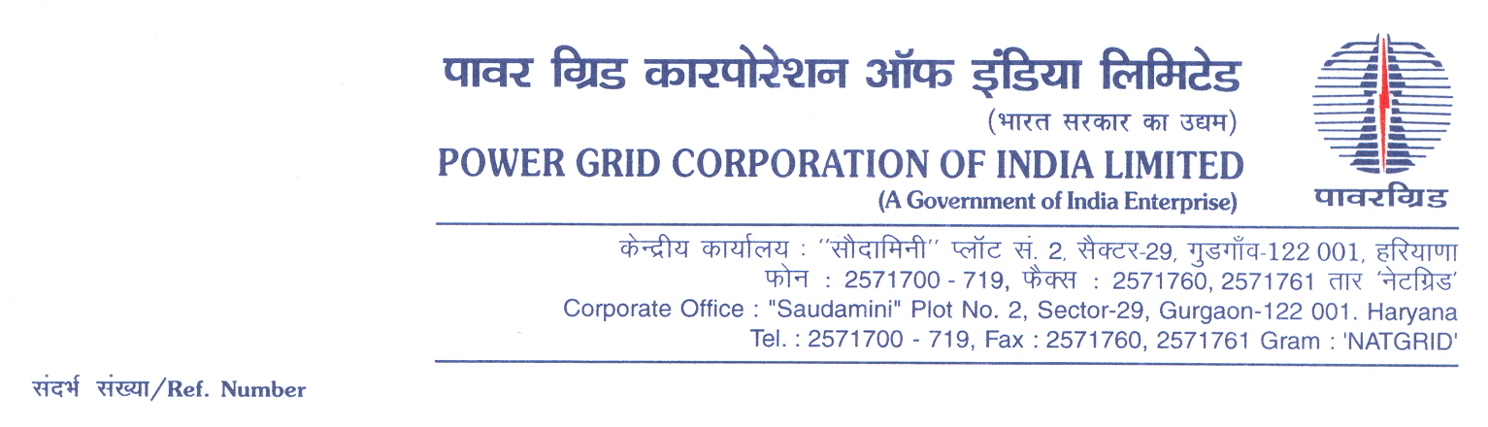

Ref No.: 5002001921/OTHERS/DOM/A04-CC CS -5/OBD Extn-2 **Date:** 16.11.2021

To,

*All prospective Bidders.*

Subject : Rural Electrification Work under Prime Minister’s Development Project (PMDP) in Phulwama, Sopian & Kulgam districts of UT of J&K

[Spec No.: 5002001921/OTHERS/DOM/A04-CC CS -5]

-***Regards OBD Extension-1***

It may be mentioned here that the subject package tender dates i.e. Bidding Documents downloading, Bids submission and opening dates have been extended as follows:

1) Bidding documents downloading is extended upto 1100hrs on 22.11.2021.

2) Last date for Soft copy part Submission is upto 1100hrs on 22.11.2021

Thanking You,

Yours Sincerely,

**(Charanya Ambati)**

**Ch. Manager (CS)**