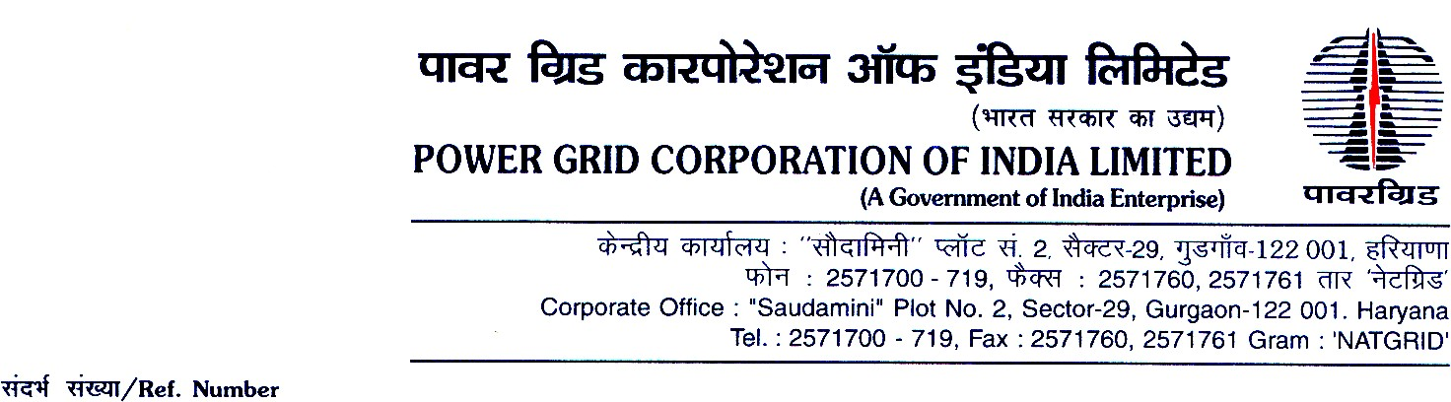



# Ref. No.: CC-CS/G3/OBD EX-I Date: 10/06/2020

**<< TO ALL THE PROSPECTIVE BIDDERS >>**

**Sub: Supply & Retro-fitment of 145KV DC Breakers at Rihand & Dadri HVDC Terminals under Add-cap for Rihand Dadri refurbishment;**

**Specification No.: CC-CS/762-NR1/MISC-4001/3/G3**

**(Domestic Competitive Bidding; Funding: Domestic) [Single Stage Two Envelope System (under e-Procurement)]**

***..Reg. Extension of date of downloading of Bidding Documents, Bid Submission & Bid Opening Date.***

Dear Sir(s),

1.0 This has reference to the bidding documents for the subject package uploaded alongwith IFB, on the portal https://pgcileps.buyjunction.in and subsequently issued amendments & clarifications.

1.1 The date of downloading of Bidding Documents and deadline for submission of Bids & the **date for Bid Opening are hereby extended** and rescheduled as per the following program:

|  |  |
| --- | --- |
| Existing Schedule | Revised Schedule |
| **Downloading of Bidding Documents:**  upto 10/06/2020, Time:11:00 hrs.  **Bid Submission**:  **For Soft Copy part of bids:**  Date: 10/06/2020, Time: upto 11:00 Hrs.  **For Hard Copy part of bids:**  Date: 12/06/2020, Time: upto 11:00 Hrs  **Bid Opening (1st Envelope):**  Date: 12/06/2020, Time: upto 11:30 Hrs | **Downloading of Bidding Documents:**  Extended till 01/07/2020, Time: upto 11:00 hrs.  **Bid Submission**:  **For Soft Copy part of bids:**  Date: 01/07/2020, Time: upto 11:00 Hrs.  **For Hard Copy part of bids:**  Date: 03/07/2020, Time: upto 11:00 Hrs  **Bid Opening (1st Envelope):**  Date: 03/07/2020, Time: upto 11:30 Hrs |

1.2 You are requested to ensure validity of Bid, to be submitted by you, based on the above revised dates.

2.0 Except for the above, all other terms and conditions of the Bidding Documents thereof remain unchanged.

Thanking you,

For and on behalf of Power Grid Corporation of India Limited,

X

Kaushalendra Singh DGM (CS-G3)

