 |  | 
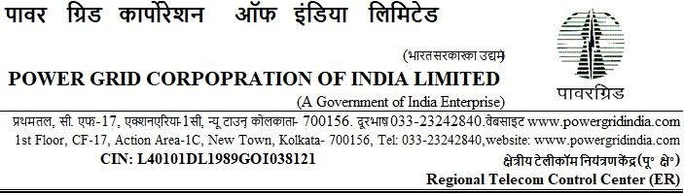
Ref: ERTCC/CS/19-20/I-210/T-166/AMC_LMC/Pkg-C/Bid Sub-Extn Date: 29.03.2020

To

<< All the bidders issued through https://pgcileps.buyjunction.in>>

Subject: Annual Maintenance Contract (AMC) for POWERGRID OFC Network (Bhubaneswar & Cuttack intracity and Talcher-Bhubaneswar intercity) and Last Mile Connectivity to various customers in various cities of Odisha (Pkg-C) for a period of 03 years(Tender Specification ref: ERTCC/CS/19-20/I-210/T-166/AMC_LMC/Pkg-C.)

(Open Tendering under e-procurement)
[Single Stage Two Envelope System]

...Reg. Extension of deadline of Submission of Bids.

Dear Sir(s),

1.0 This has reference to the RfP documents for the subject package uploaded on the portal https://pgcileps.buyjunction.in.

1.1 The deadline for submission of Bids are hereby extended and rescheduled as per the following program:

Bid Submission:
Soft Copy Part of bids:
extended upto: Date: 28.04.2020, Time: 1100 Hrs (IST)
Hard Copy part of bids:
Date: 30.04.2020, Time: upto 11:00 Hrs (IST)

Bid Opening (First Envelope):
Date: 30.04.2020, Time: at 11:30 Hrs (IST)

1.2 You are requested to ensure validity of Bid, to be submitted by you, based on the above revised schedule.

2.0 Except for the above, all other terms and conditions of the RfP Documents shall remain unaltered.

Thanking you,
Yours faithfully,

(Nand Jee)
Ch. Manager (CS), ERTCC, Kolkata

