NOTICE FOR PRE-BID CONFERENCE

Ref. No.: CC/T/W-MISC/DOM/A00/25/15325/Pre-Bid Conference Date: 19/11/2025

<< To all prospective bidders >>

Sub: Pre-Bid Tie up for Package BESS-06 for Setting up of 25 MW/ 50 MWh Battery Energy Storage System (BESS) at Simhachalam, Andhra Pradesh associated with “Setting up of 1,000 MW/ 2,000 MWh Battery Energy Storage System (BESS) in Andhra Pradesh Under Tariff-Based Competitive Bidding with Viability Gap Funding supported through PSDF”; Spec. No. CC/T/W-MISC/DOM/A00/25/15325

(Domestic Competitive Bidding; Funding: Domestic)
[Single Stage Two Envelope System (under e-Procurement)]

...Reg. link for joining Pre-bid Meeting.

Dear Sir(s),

- This has reference to the IFB for the subject package, as per which a Pre-Bid Meeting will be held at POWERGRID’s Corporate Office, Gurgaon (Haryana), India, on 20/11/2025 at 11:30 Hrs (IST).
- In addition to the above, prospective bidders who wish to join the pre-bid meeting online may do so using the following MS Teams link as per above schedule:
Pre-Bid Meeting for BESS Packages Battery Energy Storage System (BESS) packages of Andhra Pradesh and Rajasthan Projects | Meeting-Join | Microsoft Teams

Thanking you,
For and on behalf of
M/s. Power Grid Corporation of India Limited

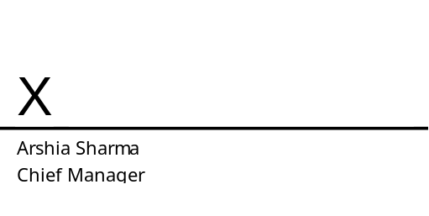
Arshia Sharma
Ch Manager (CS)

